
COMSATS University Islamabad (CUI)

Project Report
for
PropBot
AI-Powered RFP & Proposal Automation Platform
Chapter 1 and Chapter 2
By
Alina Raza | CIIT/FA23-BSE-015/ISB
Anna Munir | CIIT/FA23-BSE-019/ISB
Ayesha Noor | CIIT/FA23-BSE-025/ISB
Supervisor
Dr. Memoona Malik
Bachelor of Science in Computer Science (2023-2027)

PropBot
AI-Powered RFP & Proposal Automation Platform
A project presented to
COMSATS University, Islamabad
In partial fulfillment
of the requirement for the degree of
Bachelor of Science in Computer Science (2023-2027)
By
Alina Raza CIIT/FA23-BSE-015/ISB
Anna Munir CIIT/FA23-BSE-019/ISB
Ayesha Noor CIIT/FA23-BSE-025/ISB

Abstract
Preparing responses to Requests for Proposals (RFPs) is one of the most time-consuming responsibilities of presales engineers in telecom-focused IT companies. At present, engineers read lengthy RFP documents manually and prepare submission checklists, compliance sheets, Bills of Quantities (BOQs), network diagrams and proposals by hand, managing the work through personal laptops, email threads and scattered files rather than a dedicated system. As a result, a single response can take several days, mandatory submission documents can be missed, and proposal quality varies from one engineer to another. Handling several active RFPs at once makes closing dates harder to meet, and valuable proposal knowledge is lost when experienced staff leave. Existing tools address only parts of this process and are not designed around telecom RFP structures, compliance matrices or submission packaging. PropBot is an AI-powered web platform with a companion mobile application that reads and classifies uploaded RFPs and generates submission checklists, compliance matrices, BOQs, responsibility matrices and High-Level Design (HLD) diagrams. It drafts technical proposals using Retrieval-Augmented Generation (RAG) over the company's own approved past proposals, requires every generated section to be reviewed and approved before export, and blocks the submission package from being built while a readiness check reports open issues. All projects are retained in a centralised, searchable project vault, and the mobile application supports reviewer approvals, checklist document capture, task tracking and deadline alerts. PropBot aims to reduce the time needed to prepare an RFP response from 3–7 days to less than 8 hours while preserving organisational knowledge for future bids.

Abbreviations
Abbreviation | Meaning
API | Application Programming Interface
BO | Business Objective
BOQ | Bill of Quantities
CI | Communications Interface (requirement identifier)
CON | Design and Implementation Constraint (requirement identifier)
CSV | Comma-Separated Values
F1 | Harmonic mean of precision and recall (classification quality measure)
FC / PC / NC | Fully Compliant / Partially Compliant / Non-Compliant
FE | Feature
FR / NFR | Functional Requirement / Non-Functional Requirement
FYP | Final Year Project
HI | Hardware Interface (requirement identifier)
HLD | High-Level Design
HS256 | HMAC with SHA-256 (JWT signing algorithm)
HTTPS | Hypertext Transfer Protocol Secure
JWT | JSON Web Token
LI | Limitation
LAN | Local Area Network
LLM | Large Language Model
NER | Named Entity Recognition
OE | Operating Environment (requirement identifier)
OEM | Original Equipment Manufacturer
OGDCL | Oil and Gas Development Company Limited
ORM | Object-Relational Mapping
OPS | Operability requirement identifier
p95 | 95th percentile (at least 95 of every 100 measurements meet the limit)
PER / REL / SEC / USE | Performance / Reliability / Security / Usability requirement identifiers
PKT | Pakistan Standard Time
QUA | AI Output Quality requirement identifier
PTCL | Pakistan Telecommunication Company Limited
RAG | Retrieval-Augmented Generation
RAGAS | Retrieval Augmented Generation Assessment (evaluation framework)
RBAC | Role-Based Access Control
REST | Representational State Transfer
RPO / RTO | Recovery Point Objective / Recovery Time Objective
RFP | Request for Proposal
SDLC | Software Development Life Cycle
SI | Software Interface (requirement identifier)
TLS | Transport Layer Security
UI | User Interface
VPN | Virtual Private Network
W-xx / M-xx | Web / Mobile mockup screen identifier
WBS | Work Breakdown Structure

Table of Contents
Abstract ii
Abbreviations iii
Table of Contents v
List of Figures vii
List of Tables ix
Chapter 1: Introduction and Problem Definition 1
1.1 Overview of the Project 1
1.2 Vision Statement 1
1.3 Problem Statement 2
1.4 Problem Solution 2
1.5 Objectives of the Proposed System 3
1.6 Scope 4
1.6.1 Limitations/Constraints 5
1.7 Modules 5
1.8 Related System Analysis/Literature Review 14
1.8.1 Literature Review 14
1.8.2 Related System Analysis 15
1.9 Tools and Technologies 16
1.10 Project Contribution 19
1.11 Relevance to Course Modules 20
Chapter 2: Requirement Analysis 22
2.1 User Classes and Characteristics 22
2.2 Operating Environment 22
2.3 Design and Implementation Constraints 23
2.4 Use case Diagram 24
2.4.1 Use Case List 26
2.5 Requirement Identifying Technique 28
2.5.1 Mockup-Based Requirement Analysis 28
2.5.2 Event–Response Table Technique 95
2.5.3 Requirement-to-Screen Traceability Matrix 103
2.6 Functional Requirements 107
2.6.1 Module 1: RFP Parser and Classifier 107
2.6.2 Module 2: Submission Checklist Generator 108
2.6.3 Module 3: Compliance Matrix Generator 109
2.6.4 Module 4: Technical Evaluation Criteria Analyser 111
2.6.5 Module 5: HLD Diagram Generator 111
2.6.6 Module 6: Technical Proposal Generator 112
2.6.7 Module 7: BOQ Generator 113
2.6.8 Module 8: Responsibility Matrix Generator 114
2.6.9 Module 9: Project Vault and Centralised Storage 114
2.6.10 Module 10: Submission Package Builder 115
2.6.11 Module 11: Knowledge Base and Past Project Reuse 116
2.6.12 Module 12: Company and Organisation Management 117
2.6.13 Module 13: User and Role Management 117
2.6.14 Module 14: Template Library Management 118
2.6.15 Module 15: Audit Log and Activity Tracking 118
2.6.16 Module 16: Analytics Dashboard 119
2.6.17 Module 17: Bid Tasks and Deadlines 120
2.6.18 Module 18: Mobile Application 120
2.7 Non-Functional Requirements 121
2.7.1 Reliability 121
2.7.2 Usability 122
2.7.3 Performance 123
2.7.4 Security 123
2.7.5 AI Output Quality 124
2.7.6 Maintainability and Operability 124
2.8 External Interface Requirements 125
2.8.1 User Interfaces Requirements 125
2.8.2 Software interfaces 125
2.8.3 Hardware interfaces 126
2.8.4 Communications interfaces 126
References 127

List of Figures
Figure 2.1: System Use Case Diagram of PropBot 25
Figure 2.2: W-01 – Login 30
Figure 2.3: W-02 – Forgot Password 31
Figure 2.4: W-03 – Reset Password (signed 1-hour link) 32
Figure 2.5: W-04 – Activate Account (48-hour invitation) 33
Figure 2.6: W-05 – Projects Dashboard 34
Figure 2.7: W-06 – RFP Upload & Parsing 35
Figure 2.8: W-07 – Re-label Section Modal 37
Figure 2.9: W-08 – Bid Closing Date Confirmation 38
Figure 2.10: W-09 – Requirement Registry 39
Figure 2.11: W-10 – Upload Error / Unsupported File 40
Figure 2.12: W-11 – Submission Checklist 41
Figure 2.13: W-12 – Add Custom Checklist Item Modal 42
Figure 2.14: W-13 – Specification Retrieval & Datasheet Confirmation 43
Figure 2.15: W-14 – Compliance Matrix 44
Figure 2.16: W-15 – Override Compliance Rating Modal 46
Figure 2.17: W-16 – Technical Evaluation Criteria Analyser 47
Figure 2.18: W-17 – HLD Network Device Input 48
Figure 2.19: W-18 – HLD Diagram & Connectivity Description 49
Figure 2.20: W-19 – Proposal Generation Progress 50
Figure 2.21: W-20 – Proposal Review Editor 52
Figure 2.22: W-21 – Proposal Export 53
Figure 2.23: W-22 – Self-Approval Blocked Dialog 54
Figure 2.24: W-23 – BOQ Editor 55
Figure 2.25: W-24 – Responsibility Matrix 56
Figure 2.26: W-25 – Project Vault Dashboard 57
Figure 2.27: W-26 – Project Vault Folder View 58
Figure 2.28: W-27 – Requirement Traceability View 59
Figure 2.29: W-28 – Submission Package Builder 60
Figure 2.30: W-29 – Package Built & Submission Summary 62
Figure 2.31: W-30 – Knowledge Base Management 63
Figure 2.32: W-31 – Upload Past Proposal & Tag 64
Figure 2.33: W-32 – Knowledge Base Ingestion Status (incl. win/loss boost) 65
Figure 2.34: W-33 – Knowledge Base Coverage Dashboard 66
Figure 2.35: W-34 – Organisations List 67
Figure 2.36: W-35 – Create Company Workspace 68
Figure 2.37: W-36 – User Management 69
Figure 2.38: W-37 – Invite User Modal 70
Figure 2.39: W-38 – Deactivate User Confirmation 71
Figure 2.40: W-39 – BOQ Template Library 72
Figure 2.41: W-40 – Responsibility Matrix Template Editor 73
Figure 2.42: W-41 – Audit Log 74
Figure 2.43: W-42 – Project Timeline 75
Figure 2.44: W-43 – Analytics Dashboard 76
Figure 2.45: W-44 – Bid Tasks & Deadlines 78
Figure 2.46: W-45 – Assign / Edit Task Modal 79
Figure 2.47: W-46 – Notifications & Alerts Center 80
Figure 2.48: W-47 – Read-only User Vault View 81
Figure 2.49: M-01 – Mobile Login 82
Figure 2.50: M-02 – Mobile Projects List (role-based home) 83
Figure 2.51: M-03 – Mobile Approvals 84
Figure 2.52: M-04 – Mobile Request Changes Comment 85
Figure 2.53: M-05 – Mobile Self-Approval Blocked 86
Figure 2.54: M-06 – Mobile Submission Checklist 87
Figure 2.55: M-07 – Mobile Document Capture 88
Figure 2.56: M-08 – Mobile Attach Confirmation (photo or file) 89
Figure 2.57: M-09 – Mobile Tasks & Deadlines 90
Figure 2.58: M-10 – Mobile Task Detail 91
Figure 2.59: M-11 – Mobile Notifications List 92
Figure 2.60: M-12 – Push Notification Examples (lock screen) 93
Figure 2.61: M-13 – Mobile Project Status 94
Figure 2.62: M-14 – Web-only Function Notice 95

List of Tables
Table 1.1: Related System Analysis with Proposed Project Solution 15
Table 1.2: Tools and Technologies for PropBot 16
Table 2.1: User Classes and Characteristics 22
Table 2.2: PropBot Use Case List 26
Table 2.3: Requirements mapped to screen W-01 30
Table 2.4: Requirements mapped to screen W-02 31
Table 2.5: Requirements mapped to screen W-03 32
Table 2.6: Requirements mapped to screen W-04 33
Table 2.7: Requirements mapped to screen W-05 35
Table 2.8: Requirements mapped to screen W-06 36
Table 2.9: Requirements mapped to screen W-07 37
Table 2.10: Requirements mapped to screen W-08 38
Table 2.11: Requirements mapped to screen W-09 39
Table 2.12: Requirements mapped to screen W-10 40
Table 2.13: Requirements mapped to screen W-11 41
Table 2.14: Requirements mapped to screen W-12 43
Table 2.15: Requirements mapped to screen W-13 43
Table 2.16: Requirements mapped to screen W-14 44
Table 2.17: Requirements mapped to screen W-15 46
Table 2.18: Requirements mapped to screen W-16 47
Table 2.19: Requirements mapped to screen W-17 49
Table 2.20: Requirements mapped to screen W-18 49
Table 2.21: Requirements mapped to screen W-19 51
Table 2.22: Requirements mapped to screen W-20 52
Table 2.23: Requirements mapped to screen W-21 53
Table 2.24: Requirements mapped to screen W-22 54
Table 2.25: Requirements mapped to screen W-23 55
Table 2.26: Requirements mapped to screen W-24 56
Table 2.27: Requirements mapped to screen W-25 58
Table 2.28: Requirements mapped to screen W-26 59
Table 2.29: Requirements mapped to screen W-27 60
Table 2.30: Requirements mapped to screen W-28 61
Table 2.31: Requirements mapped to screen W-29 62
Table 2.32: Requirements mapped to screen W-30 63
Table 2.33: Requirements mapped to screen W-31 64
Table 2.34: Requirements mapped to screen W-32 65
Table 2.35: Requirements mapped to screen W-33 66
Table 2.36: Requirements mapped to screen W-34 67
Table 2.37: Requirements mapped to screen W-35 68
Table 2.38: Requirements mapped to screen W-36 69
Table 2.39: Requirements mapped to screen W-37 70
Table 2.40: Requirements mapped to screen W-38 71
Table 2.41: Requirements mapped to screen W-39 72
Table 2.42: Requirements mapped to screen W-40 73
Table 2.43: Requirements mapped to screen W-41 74
Table 2.44: Requirements mapped to screen W-42 76
Table 2.45: Requirements mapped to screen W-43 77
Table 2.46: Requirements mapped to screen W-44 78
Table 2.47: Requirements mapped to screen W-45 79
Table 2.48: Requirements mapped to screen W-46 80
Table 2.49: Requirements mapped to screen W-47 81
Table 2.50: Event–Response Table for Account Security and Session Management (Module 13) 96
Table 2.51: Functional Requirements Derived from the Account Security and Session Management (Module 13) Events 97
Table 2.52: Event–Response Table for Audit Logging (Module 15) 98
Table 2.53: Functional Requirements Derived from the Audit Logging (Module 15) Events 98
Table 2.54: Event–Response Table for Bid Deadlines and Notifications (Modules 17 and 18) 99
Table 2.55: Functional Requirements Derived from the Bid Deadlines and Notifications (Modules 17 and 18) Events 100
Table 2.56: Event–Response Table for the Submission Readiness Check (Module 10) 101
Table 2.57: Functional Requirements Derived from the the Submission Readiness Check (Module 10) Events 102
Table 2.58: Requirement-to-Screen Traceability Matrix (all 118 functional requirements) 103
Table 2.59: Functional Requirements — Module 1 (RFP Parser and Classifier) 107
Table 2.60: Functional Requirements — Module 2 (Submission Checklist Generator) 109
Table 2.61: Functional Requirements — Module 3 (Compliance Matrix Generator) 109
Table 2.62: Functional Requirements — Module 4 (Technical Evaluation Criteria Analyser) 111
Table 2.63: Functional Requirements — Module 5 (HLD Diagram Generator) 112
Table 2.64: Functional Requirements — Module 6 (Technical Proposal Generator) 112
Table 2.65: Functional Requirements — Module 7 (BOQ Generator) 113
Table 2.66: Functional Requirements — Module 8 (Responsibility Matrix Generator) 114
Table 2.67: Functional Requirements — Module 9 (Project Vault and Centralised Storage) 115
Table 2.68: Functional Requirements — Module 10 (Submission Package Builder) 115
Table 2.69: Functional Requirements — Module 11 (Knowledge Base and Past Project Reuse) 116
Table 2.70: Functional Requirements — Module 12 (Company and Organisation Management) 117
Table 2.71: Functional Requirements — Module 13 (User and Role Management) 117
Table 2.72: Functional Requirements — Module 14 (Template Library Management) 118
Table 2.73: Functional Requirements — Module 15 (Audit Log and Activity Tracking) 119
Table 2.74: Functional Requirements — Module 16 (Analytics Dashboard) 119
Table 2.75: Functional Requirements — Module 17 (Bid Tasks and Deadlines) 120
Table 2.76: Functional Requirements — Module 18 (Mobile Application) 120

Chapter 1: Introduction and Problem Definition
This chapter introduces PropBot, states the problem it addresses and the solution it proposes, lists the objectives, scope and limitations of the system, describes its eighteen functional modules, positions it against related systems and prior research, and outlines the tools, contributions and course relevance of the project.

1.1 Overview of the Project
PropBot is an AI-powered RFP (Request for Proposal) and proposal automation platform, consisting of a web application and a companion mobile application, developed for presales teams at telecom-focused IT companies. In organisations that regularly respond to client-issued RFPs such as those from PTCL, OGDCL, Zong, and Telenor, presales engineers currently rely on manual document review, scattered spreadsheets, email threads, and personal folders to prepare submissions. This process is slow, inconsistent, and causes valuable proposal knowledge to be lost when experienced staff leave the company. PropBot addresses this gap by automatically reading and classifying uploaded RFP documents, generating submission checklists, building compliance matrices against proposed equipment, drafting technical proposals using the company's own historical knowledge base, generating Bills of Quantities and High-Level Design diagrams, and assembling verified submission packages, all within a single connected platform with a permanent, centralised project vault.

1.2 Vision Statement
For presales engineers at telecom IT companies who spend 3 to 7 days manually processing every RFP they receive: reading requirements, building checklists, filling compliance matrices, drawing network diagrams, and writing proposals from scratch, Who need a faster, more consistent, and better-governed way to move from a received RFP to a verified, submission-ready proposal, The PropBot Is an AI-powered web and mobile platform That reads uploaded PDF and Word RFPs automatically, generates the submission checklist, compliance matrix, technical proposal, BOQ, HLD diagram, and responsibility matrix, and packages everything into a verified submission folder, aiming to turn a 3–7-day manual process into a guided workflow of under 8 hours, with a mobile application that lets reviewers and engineers approve, capture documents and track deadlines away from their desks. Unlike Jasper AI, Proposify, Microsoft Copilot, and ChatGPT, which each solve only a small piece of the problem and require engineers to do most of the work manually, Our product PropBot is designed to handle the complete RFP-to-submission workflow in one platform, retains every project in a central vault so institutional knowledge is preserved when staff leave, and is built specifically for the telecom sector with pre-loaded templates for PTCL, OGDCL, Zong, and Telenor.

1.3 Problem Statement
In telecom-focused IT companies, responding to RFPs is still a highly manual and time-consuming process. When organisations receive RFPs from clients such as PTCL, OGDCL, or Zong, presales engineers handle most of the work manually, without the support of a dedicated automation system, relying on personal folders, previous files, spreadsheets, and email conversations. A central difficulty is understanding the RFP document itself: these files are usually lengthy and mix technical, commercial, financial, and legal content, so engineers must spend hours identifying the sections relevant to their responsibilities.
Creating the submission checklist is another major challenge, since most RFPs require many mandatory supporting documents (certificates, purchase orders, affidavits, engineer profiles) and, because this is managed manually, an important document can easily be missed — a mistake that can result in outright bid rejection. Preparing the compliance matrix is similarly repetitive and error-prone: engineers must compare each client requirement with the proposed solution and manually assign a compliance status (Fully Compliant, Partially Compliant, or Non-Compliant), a task that can take many hours on a large-scale project and directly affects whether the company qualifies.
Proposal writing adds further workload, since engineers rewrite large portions of similar content for every submission, and supporting deliverables — BOQs, responsibility matrices, HLD network diagrams — must be separately recreated each time despite following repetitive formats. There is also no centralised knowledge management system in most organisations: proposal files live on personal devices or scattered email threads, so when experienced employees leave, valuable proposal knowledge and prior work are lost, forcing new engineers to restart similar work from scratch. Finally, presales teams typically handle several active RFPs at once under tight closing dates, while document collection and proposal review are tracked informally through email and messages — delaying approvals when reviewers are away from their desks and increasing the risk of missed deadlines.

1.4 Problem Solution
PropBot is proposed as a unified AI-powered platform that automates the complete RFP-to-submission workflow for telecom IT companies, reducing manual effort, improving proposal consistency, and centralising organisational knowledge. The workflow begins when a presales engineer uploads an RFP document: PropBot automatically analyses and classifies its sections and extracts the technical and presales-relevant information, letting engineers access structured content instead of manually reviewing the full document, while a bid-closing-date task is created automatically so the deadline is tracked from the start.
The platform then generates a submission checklist of mandatory supporting documents, which engineers tick off as they are collected, reducing the chance of a missed document. For compliance evaluation, once the engineer enters the proposed equipment models, PropBot converts RFP requirements into structured rules, compares them against the model's specification, and automatically produces a compliance matrix with FC/PC/NC ratings, each carrying a reason and supporting evidence, with non-compliant items highlighted for review.
Using a Retrieval-Augmented Generation approach over the company's own approved past proposals, PropBot drafts new technical proposal content for the engineer to review, edit and refine, which a reviewer must then verify before export. The system also auto-fills BOQs and responsibility matrices from standard templates and generates HLD diagrams and connectivity descriptions from structured network input. Before final packaging, uploaded submission files are cross-checked against the checklist and a readiness check lists any remaining blockers; once cleared, PropBot builds a structured ZIP submission package. Every RFP, proposal, diagram and submission package is permanently retained in a centralised project vault, and reviewers and engineers can approve sections, tick checklist items, attach documents by camera, and receive deadline alerts through the companion mobile application.

1.5 Objectives of the Proposed System
- BO-1: Reduce the average time required to prepare an RFP response from 3–7 days to less than 8 hours.
- BO-2: Automatically classify and extract technical requirements from uploaded RFP documents within 60 seconds.
- BO-3: Generate submission document checklists automatically, finding at least 90% of the required submission documents of each benchmark RFP (recall ≥ 0.90, QUA-2).
- BO-4: Automatically generate a compliance matrix with FC, PC and NC classifications after the engineer provides proposed equipment details, with a reason and supporting evidence shown for each rating.
- BO-5: Generate complete technical proposal drafts using a RAG-based pipeline with a mean RAGAS faithfulness score greater than 0.85 over a fixed evaluation set (QUA-4).
- BO-6: Automatically populate BOQ templates with every proposed equipment model from the compliance matrix, with no manual re-entry, and generate a responsibility matrix containing at least the 24 standard rows (FR-7.2, FR-8.1).
- BO-7: Generate a High-Level Design (HLD) network diagram that shows every device and connection entered by the engineer, together with a 2–4 paragraph connectivity description, without manual diagram creation in Visio (FR-5.3, FR-5.7).
- BO-8: Maintain a permanent centralised project vault searchable by client name, equipment type, and project date, returning search results within 3 seconds for up to 500 projects (FR-9.3).
- BO-9: Implement a human review and approval workflow so that zero proposals can be exported, and zero submission packages built, while any proposal section remains unapproved (FR-6.8, FR-10.7).
- BO-10: Assign a unique ID to each accepted RFP requirement and link it to its checklist item, compliance row, proposal section and BOQ line so that uncovered requirements can be identified.
- BO-11: Run a readiness check before packaging that lists every blocking issue (missing mandatory documents, unresolved NC items, unapproved sections) and prevents the submission package from being built until blockers are cleared.
- BO-12: Provide a mobile application on which a reviewer can complete every section approval or change request, and an engineer can capture checklist documents, view tasks and receive push notifications, using the same backend and role-based access as the web application (FR-18.1–FR-18.6).
- BO-13: Automatically generate bid tasks with due dates from the extracted RFP closing date and show overdue tasks and tasks per engineer.
- BO-14: Create our own benchmarks (labelled test data) from sample RFPs and OEM datasheets to verify the accuracy of RFP parsing, checklist extraction and compliance results.
BO-1, BO-2 and BO-8 will be verified by timing the workflow on the team's benchmark RFPs (BO-14), from RFP upload to submission package build; BO-3 and BO-5 by scoring the outputs against the same labelled benchmarks, under the measurement conditions and quality targets of Section 2.7 (QUA-1 to QUA-4).

1.6 Scope
PropBot is a web and mobile platform that automates the complete RFP response workflow for presales engineers at telecom IT companies. When an engineer uploads an RFP, the system reads it automatically, sorts every section into the right category (technical, commercial, financial, legal, or presales), and pulls out technical specifications, equipment requirements, and submission document requirements in one pass. It then builds a live checklist the engineer can tick off as documents are collected, and when the engineer enters their proposed equipment models, the system compares each one against the RFP requirements and generates a compliance matrix marked Fully Compliant, Partially Compliant, or Non-Compliant, exported as an Excel file. For document generation, PropBot uses the company's own past approved proposals as a knowledge base and drafts each section of a new technical proposal automatically; the engineer reviews and edits each section, a reviewer approves it, and only fully approved proposals can be exported as Word (.docx) files. The system also auto-fills the Bill of Quantities Excel template, generates the responsibility matrix from a standard template, and creates the High-Level Design network diagram from the engineer's description of the existing and proposed network. Every project and every document is stored permanently in a central vault on the company's own server, so that project knowledge is retained. When all final documents are ready, the submission package builder verifies them against the checklist and packages everything into a structured ZIP folder. The admin layer handles company setup, user roles, template management per telecom client, audit logging, and a management analytics dashboard. A companion mobile application lets reviewers and engineers approve proposal sections, capture checklist documents, view tasks and alerts, and check project status from their phones. The system also creates bid tasks with due dates from the extracted RFP closing date, and assigns a unique ID to each accepted requirement so that it can be traced to its checklist item, compliance row, proposal section and BOQ line. A readiness check before packaging lists any blocking issues and prevents the submission package from being built until they are cleared. Optional enhancements, implemented only if time permits, include detection of vague or duplicate requirements in Module 1, draw.io XML export in Module 5, a win/loss relevance boost in Module 11 and similar past project suggestion in Module 9. Things outside the scope of this project include CRM integration, automated cost calculations, multi-language support, cloud deployment, HR, payroll, staff timetabling or other ERP functions, live OEM vendor API integration, and offline mobile operation. The final deliverable is a fully working, locally deployed web application with a companion mobile application, demonstrated live.

1.6.1 Limitations/Constraints
- LI-1: Although the platform uses AI to generate proposal content and to assist compliance evaluation, every generated output still requires review and final approval by an engineer or reviewer.
- LI-2: The accuracy of RFP parsing depends on the format and quality of the uploaded document; results for scanned (image-only) documents may be significantly less accurate.
- LI-3: The solution is tailored to telecommunications and IT infrastructure proposals; use in other domains would require further modification.
- LI-4: Automatically generated HLD diagrams may require manual correction for large or complex enterprise network topologies.
- LI-5: The quality of generated proposal content depends on the number and relevance of past proposals available in the knowledge base.
- LI-6: The platform requires a stable connection to the company server, and AI features additionally require internet access to the OpenAI API.
- LI-7: The mobile application is Android-first, requires a network connection to the company server (same network or VPN) and does not support offline operation.
- LI-8: AI processing uses the OpenAI API, so RFP text sent for processing leaves the company server, and push notifications use an external notification service with minimal content; the on-premise claim therefore applies to storage of files and data, not to AI processing.
- LI-9: Compliance results depend on the completeness of the specification data available for the proposed model and must be confirmed by the engineer.

1.7 Modules
PropBot comprises eighteen functional modules spanning the web application, the companion mobile application, and shared backend services. Following the template, the modules are grouped by system type. Each module lists its features (FE-x); feature FE-y of Module x is specified as functional requirement FR-x.y in Chapter 2, Section 2.6, where it is also mapped to its mockup screen(s).
A. Web Application – Proposal Workflow (Presales Engineer, Reviewer, Read-only User)
Module 1: RFP Parser and Classifier
- FE-1: RFP File Upload – The system shall accept RFP files in .pdf and .docx formats up to 50 MB.
- FE-2: Raw Text Extraction – The system shall extract raw text from uploaded PDFs using the PyMuPDF library and from Word files using python-docx.
- FE-3: Section Classification – The system shall classify every extracted section into one of five categories (technical, commercial, financial, legal, presales) using a zero-shot classification pipeline built on the facebook/bart-large-mnli model.
- FE-4: Entity Extraction (NER) – The system shall apply Named Entity Recognition using spaCy's en_core_web_trf model to extract equipment names, quantities, protocol names, and specification values from the technical section.
- FE-5: Delivery Scope Detection – The system shall detect the delivery scope (supply, deploy, configure, migrate) using keyword pattern matching combined with dependency parsing on the extracted technical text.
- FE-6: Client Format Detection – The system shall detect the telecom client format (PTCL, OGDCL, Zong, Telenor) using string matching against a pre-defined client format dictionary and apply the corresponding parsing rules; if no supported format is detected, the system shall apply generic parsing rules and show the notice “Client format not recognised — please review the classification”.
- FE-7: Parsing Turnaround – For a text-based RFP of up to 100 pages, the system shall display the classified section output within 60 seconds of upload; entity extraction (FR-1.4, FR-1.5) may continue in the background with a visible progress indicator and shall complete within 180 seconds of upload.
- FE-8: Manual Re-classification – The engineer shall be able to manually correct or re-label any misclassified section through the UI.
- FE-9: Closing Date Extraction – The system shall extract the bid closing date and time from the parsed RFP text; if it is not detected, the engineer shall enter it manually.
- FE-10: Requirement Registry – The system shall assign a unique requirement ID to each extracted requirement and store it in a project-scoped requirement registry; the engineer shall be able to accept, edit, merge or reject extracted requirements.
- FE-11: Vague/Duplicate Requirement Flagging – The system shall flag an extracted requirement as possibly vague (no measurable value or acceptance criterion) or as a possible duplicate of another requirement in the registry, for the engineer to review.
Module 2: Submission Checklist Generator
- FE-1: Checklist Item Extraction – The system shall extract all submission document requirements from parsed RFP text using GPT-4o-mini with a structured JSON output prompt, returning document_name, mandatory (true/false), and responsible_team.
- FE-2: Mandatory/Optional Classification – The system shall classify each item as mandatory or optional using modal verb detection via the spaCy en_core_web_trf dependency parser.
- FE-3: Responsible Team Assignment – The system shall assign a responsible team (presales, sales, finance) inferred from surrounding RFP section context using the Module 1 classifier output.
- FE-4: Checklist Tick-Off – The system shall provide a live tick-off interface for engineers to mark items as collected and attach the corresponding document file.
- FE-5: Collected/Outstanding Counter – The system shall display a real-time counter of collected vs. outstanding items, updated on every tick-off event.
- FE-6: Submission Blocking – The system shall block submission package generation if any mandatory item remains uncollected, enforced at the API level in Module 10.
- FE-7: Custom Checklist Items – The engineer shall be able to manually add custom checklist items for requirements not detected automatically.
Module 3: Compliance Matrix Generator
- FE-1: Proposed Equipment Entry – The engineer shall input proposed OEM vendor names and model numbers for each equipment category extracted by Module 1.
- FE-2: Specification Retrieval – The system shall obtain the specification of each proposed model as a structured parameter table, either from the internal specification database or from an uploaded OEM datasheet, whose extracted parameters the engineer shall confirm before use.
- FE-3: Rule-Based Compliance Evaluation – The system shall convert each numeric or boolean RFP requirement into a structured constraint (parameter, operator, value, unit) and evaluate it against the model's specification using rule-based comparison with unit normalisation, assigning FC, PC or NC.
- FE-4: Overall Compliance Percentage – The system shall calculate and display the overall compliance percentage for each proposed model as (FC count + 0.5 × PC count) / total compliance rows evaluated for that model × 100, where each evaluated requirement produces one compliance row.
- FE-5: NC Highlighting – All NC items shall be highlighted in red with a disqualification risk label.
- FE-6: Manual Override – The engineer shall be able to manually override any compliance rating and enter a justification note.
- FE-7: Matrix Export – The system shall export the completed matrix as a formatted .xlsx file using openpyxl.
- FE-8: Multi-Model Comparison – The system shall support simultaneous comparison of up to three alternative OEM models for the same requirement set.
- FE-9: Descriptive Requirement Matching – For descriptive requirements that cannot be converted into constraints, the system shall retrieve candidate datasheet passages using text-embedding-3-small embeddings, rerank them with the cross-encoder, and assign a rating with the top-ranked passage as evidence.
- FE-10: Evidence & Review Flagging – The system shall store, for every compliance row, a short reason and the evidence reference, and shall mark low-confidence rows as “needs review”.
Module 4: Technical Evaluation Criteria Analyser
- FE-1: Scoring Table Extraction – The system shall extract the scoring table from the parsed RFP using GPT-4o-mini, returning structured JSON with criterion, marks_available, qualifying_threshold, and disqualification_threshold.
- FE-2: Marks Display – The system shall display marks available per document category and per compliance requirement in a sortable table.
- FE-3: Threshold Display – The system shall display the qualification threshold and disqualification score parsed directly from the RFP scoring section.
- FE-4: Running Score Computation – The system shall link each scoring criterion extracted in FR-4.1 to the checklist item that evidences it (suggested automatically by name matching and confirmed or changed by the engineer), and shall compute a real-time running score, updated on every checklist tick-off event via WebSocket push.
- FE-5: Below-Threshold Warning – The system shall trigger a warning notification when running_score falls below the qualifying_threshold.
- FE-6: No-Criteria Message – The system shall display the message “No technical evaluation criteria detected in this RFP” when no scoring table is found.
Module 5: HLD Diagram Generator
- FE-1: Network Device Input Form – The system shall provide a structured JSON input form for existing network devices with fields device_type, vendor, model, and connections_to[].
- FE-2: Proposed Equipment Import – The system shall import proposed equipment from the Module 3 compliance matrix output or allow manual entry.
- FE-3: Topology Diagram Rendering – The system shall convert device JSON into a Mermaid.js graph definition and render it as an HLD network topology diagram using the Mermaid rendering engine.
- FE-4: Standard Icon Set – The system shall use one fixed, consistent standard icon for each device type: switch, router, firewall, server, storage.
- FE-5: PNG Export – The system shall export the rendered diagram as a PNG using a Playwright headless-browser rendering pipeline.
- FE-6: Editable draw.io Export – The system shall export an editable draw.io XML file generated from the same device graph JSON.
- FE-7: Connectivity Description – The system shall generate a written connectivity description (2–4 paragraphs) using GPT-4o-mini, with the device graph JSON as input context.
Module 6: Technical Proposal Generator
- FE-1: Knowledge-Base Chunking – The system shall chunk all knowledge base documents into segments of 400 tokens with 50-token overlap using LangChain's RecursiveCharacterTextSplitter.
- FE-2: Chunk Embedding & Storage – The system shall embed all chunks using OpenAI's text-embedding-3-small model (1536 dimensions) and store the vectors in ChromaDB with metadata: source_file, section_type, telecom_client, year, win_loss.
- FE-3: Semantic Retrieval – At generation time, the system shall embed the engineer's input requirements and retrieve the top 5 most similar chunks from ChromaDB using cosine similarity search.
- FE-4: Reranking – The system shall rerank the retrieved chunks using the cross-encoder/ms-marco-MiniLM-L-6-v2 model before passing them to the generator.
- FE-5: Section Generation – The system shall generate each proposal section (Executive Summary, Technical Approach, Proposed Solution, Methodology) as a separate GPT-4o-mini call with a section-specific system prompt and the reranked chunks as context.
- FE-6: Structured Output Schema – All generated sections shall conform to a Pydantic v2 output schema with fields section_name, content, word_count, and source_chunks_used.
- FE-7: Section Editing – The engineer shall review and edit each section individually in the TipTap rich text editor before approval.
- FE-8: Reviewer Approval Gate – A reviewer shall approve or request changes on each section from the web or mobile application; the proposal cannot be exported until all sections are approved.
- FE-9: Proposal Export – The system shall export the approved proposal as a formatted .docx file using python-docx with the company's branded template.
- FE-10: Export Footer Stamp – Every exported document shall include the footer: “Generated using PropBot AI, Reviewed and approved by [approver name(s)] on [date].”
- FE-11: Requirement Linking – The system shall link each generated proposal section to the requirement IDs it addresses.
- FE-12: Coverage Check – The system shall run a rule-based coverage check that lists any accepted requirement ID not linked to at least one proposal section.
Module 7: BOQ Generator
- FE-1: BOQ Template Library – The system shall maintain a library of pre-loaded BOQ Excel templates per telecom company (PTCL, OGDCL, Zong, Telenor), stored as .xlsx files managed through Module 14.
- FE-2: Auto-Population – The system shall auto-populate the BOQ template with equipment model names, descriptions, and quantities extracted from the Module 3 compliance matrix output using openpyxl.
- FE-3: Costing Columns Left Blank – All costing, margin, and formula columns shall remain blank in the exported file for manual completion.
- FE-4: Line-Item Editing – The engineer shall be able to add, edit, or remove line items before export.
- FE-5: BOQ Export – The system shall export the completed BOQ as a formatted .xlsx file.
Module 8: Responsibility Matrix Generator
- FE-1: Standard Template – The system shall maintain a pre-loaded standard responsibility matrix template with at least 24 common rows covering kickoff, HLD sign-off, delivery, installation, configuration, testing, documentation, and handover.
- FE-2: Auto-Assignment – The system shall auto-assign each row to responsible parties (IT company, OEM vendor, customer, presales) using a rule-based mapping table stored in the database.
- FE-3: Row Editing – The engineer shall be able to add project-specific rows and modify any responsibility assignment before export.
- FE-4: Matrix Export – The system shall export the completed matrix as a formatted .xlsx file using openpyxl.
- FE-5: Template Maintenance – The Org Admin shall be able to update the standard template rows through Module 14.
Module 9: Project Vault and Centralised Storage
- FE-1: Per-Project Folder Structure – The system shall maintain a permanent per-project folder structure on the company server (/RFP, /Drafts, /Approved, /Submission), with paths scoped by org_id/project_id.
- FE-2: Automatic Vault Saving – The system shall automatically save all generated and uploaded documents to the correct vault folder on every export or upload event.
- FE-3: Full-Text Vault Search – The system shall provide full-text search across all projects using PostgreSQL tsvector/tsquery indexing, filterable by client name, telecom company, date range, equipment type, and project status.
- FE-4: Similar Past Project Suggestion – The system shall surface similar past projects on new RFP upload using cosine similarity search (threshold ≥ 0.70) on text-embedding-3-small embeddings of past project summaries stored in ChromaDB, surfacing the top-3 results.
- FE-5: On-Premise Storage – The system shall direct all file writes to local server paths for storage operations, with no external API calls for storage.
- FE-6: Project Status Field – The system shall maintain a project status field with values active, submitted, won, or lost, updated manually by the engineer or Org Admin.
- FE-7: Requirement Traceability View – The system shall provide a traceability view showing, for each requirement ID, its linked checklist item, compliance row, proposal section and BOQ line, together with a list of requirements that have no link.
Module 10: Submission Package Builder
- FE-1: Multi-File Upload – The system shall provide a multi-file upload interface for engineers to add all final submission documents to the project submission area.
- FE-2: Cross-Checking Against Checklist – The system shall cross-check uploaded files against the Module 2 mandatory checklist using filename normalisation and document-type classification via GPT-4o-mini, marking matched items as fulfilled automatically.
- FE-3: Blocking Error List – The system shall display a blocking error list for any unfulfilled mandatory checklist items before packaging is allowed.
- FE-4: ZIP Package Generation – The system shall generate a ZIP archive using the Python zipfile module with the standard folder structure /Technical_Proposal, /Commercial, /Annexures, /Reference_Documents.
- FE-5: Vault Persistence – The system shall permanently save the ZIP and all contents to the Module 9 project vault under the /Submission folder.
- FE-6: Submission Summary Document – The system shall auto-generate a submission summary .docx listing every included file with its name, size, and the checklist item it satisfies.
- FE-7: Readiness Check – The system shall run a readiness check before packaging and display the blocker and warning list.
Module 11: Knowledge Base and Past Project Reuse
- FE-1: Automatic Ingestion – The system shall automatically ingest the approved proposal into ChromaDB when the project status is changed to “submitted” (FR-9.6), chunked using RecursiveCharacterTextSplitter (400 tokens, 50-token overlap) and embedded using text-embedding-3-small (1536 dimensions).
- FE-2: Metadata Tagging – The system shall tag each ingested chunk with metadata: telecom_client, equipment_types, service_type, year, and win_loss.
- FE-3: Win/Loss Relevance Boost – The system shall apply a relevance boost of +0.15 to cosine similarity scores of chunks tagged win_loss = “won” during Module 6 retrieval ranking.
- FE-4: Manual Upload & Tagging – The engineer shall be able to manually upload past proposals with manual metadata tagging via an upload form.
- FE-5: Admin Knowledge-Base Management – The Org Admin shall be able to view, re-tag, and delete knowledge base documents via the admin panel.
- FE-6: Coverage Dashboard – The system shall show a knowledge base coverage dashboard with document count per telecom client and equipment category, queried from ChromaDB collection metadata.
Module 17: Bid Tasks and Deadlines
- FE-1: Automatic Task Creation – The system shall automatically create tasks from checklist items and proposal sections, with due dates set at predefined offsets before the RFP closing date (FR-1.9).
- FE-2: Manual Task Assignment – The engineer or Org Admin shall be able to assign tasks manually to users and edit task due dates and status.
- FE-3: Task Views – The system shall display tasks per project and per engineer, with overdue tasks highlighted.
- FE-4: Deadline Alerts – The system shall send deadline and overdue alerts through the Module 18 notification mechanism and in the web application.
- FE-5: Task Audit Logging – Task creation, assignment and status changes shall be written to the audit log (Module 15).
B. Web Application – Administration (Org Admin, Super Admin)
Module 12: Company and Organisation Management
- FE-1: Company Workspace Creation – The super admin shall create company workspaces with name, logo, and initial admin user, stored as an organisations table row in PostgreSQL.
- FE-2: Multi-Tenant Data Isolation – All database queries, ChromaDB collections, and file storage paths shall be scoped by org_id to ensure complete data isolation between companies.
- FE-3: Organisation Listing – The super admin shall view a list of all organisations with active user count.
Module 13: User and Role Management
- FE-1: Role-Based Access Control – The system shall support five roles — Super Admin, Org Admin, Presales Engineer, Reviewer, Read-only — enforced through a role-based access control (RBAC) middleware layer in FastAPI.
- FE-2: User Invitation – The Org Admin shall invite users by email; the invitation shall generate a time-limited JWT token (expiry: 48 hours) for account activation.
- FE-3: Self-Approval Prevention – The system shall prevent any engineer from approving a proposal they generated, enforced by comparing generated_by and approved_by fields at the API level.
- FE-4: Session Token Management – All user sessions shall use JWT tokens signed with HS256, with a 24-hour expiry, validated on every protected API endpoint; validation shall also check that the user is still active and that the token version matches the user's current token version.
- FE-5: Account Deactivation – The Org Admin shall be able to deactivate user accounts, immediately setting is_active = false and incrementing the user's token version, so that every previously issued token is rejected on its next use.
- FE-6: Password Reset – The system shall handle password reset via a time-limited (1-hour) signed reset link sent by email.
Module 14: Template Library Management
- FE-1: BOQ Template Upload – The Org Admin shall upload and replace BOQ Excel templates per telecom company; each uploaded template shall be stored as a new version with a created_at timestamp.
- FE-2: Responsibility Matrix Template Editing – The Org Admin shall add, edit, reorder, and delete rows in the responsibility matrix standard template, stored as a JSON array in PostgreSQL.
- FE-3: Version Pinning – Template updates shall apply only to new projects; documents already in progress shall retain the template version active at their creation time.
Module 15: Audit Log and Activity Tracking
- FE-1: Immutable Audit Record – The system shall write an immutable audit record to a dedicated audit_logs table for every significant action: RFP upload, parsing, checklist generation, compliance matrix creation, proposal generation, section approval, document export, and submission package build.
- FE-2: Audit Record Fields – Each audit record shall contain user_id, user_name, action_type, project_id, project_name, timestamp, and details_json.
- FE-3: Audit Log Filtering – The Org Admin shall be able to filter the audit log by user, project, action type, and date range via the admin dashboard.
- FE-4: Insert-Only Enforcement – The audit_logs table shall have no DELETE or UPDATE permissions granted to any application role, enforced at the database level.
- FE-5: CSV Export – The Org Admin shall be able to export the filtered audit log as a CSV file.
- FE-6: Project Timeline View – The system shall render a project timeline view showing all audit events for a selected project in chronological order.
Module 16: Analytics Dashboard
- FE-1: Summary Metrics – The dashboard shall display summary metrics — active projects, proposals generated this month, submission packages completed, and total knowledge base document count — queried from PostgreSQL aggregations.
- FE-2: Turnaround Time Chart – The dashboard shall display average project turnaround time (RFP upload timestamp to submission package build timestamp) as a monthly bar chart rendered using Recharts.
- FE-3: Client Breakdown Chart – The dashboard shall display a pie chart of project count broken down by telecom client.
- FE-4: Top NC Items – The dashboard shall display the top-5 most frequently occurring NC compliance items across all projects, aggregated from the compliance_matrix table.
C. Mobile Application (Reviewer, Presales Engineer)
Module 18: Mobile Application
- FE-1: Mobile Platform & Auth – The system shall provide an Android-first mobile application built with React Native (Expo) that uses the same FastAPI backend, JWT authentication and role-based access control as the web application.
- FE-2: Role-Based Screens – The mobile application shall support login and show screens according to the user's role.
- FE-3: Mobile Proposal Review – A reviewer shall be able to read a proposal section and approve it or request changes with a comment; the rule that an engineer cannot approve a proposal they generated (FR-13.3) shall apply.
- FE-4: Checklist Document Capture – An engineer shall be able to view the submission checklist, tick items and attach a document by taking a photo with the phone camera or selecting a file; the file shall be stored in the project vault (Module 9).
- FE-5: Mobile Tasks View – The mobile application shall show the user's assigned tasks and deadlines (Module 17).
- FE-6: Push Notifications – The system shall send push notifications for approval requests, upcoming and overdue deadlines, NC items after a compliance run, and a running evaluation score falling below the qualifying threshold.
- FE-7: Project Status Screen – The mobile application shall show a project status screen with stage, checklist progress, pending approvals and readiness status.
- FE-8: Web-Only Editing Scope – Editing of proposals, compliance matrices, HLD diagrams and BOQs, and all administration functions, shall remain on the web application only.

1.8 Related System Analysis/Literature Review

1.8.1 Literature Review
PropBot's AI components build on an established body of research in retrieval-grounded generation and automated compliance checking. Lewis et al. (2020) [1] introduced Retrieval-Augmented Generation (RAG), showing that conditioning a language model's output on retrieved supporting passages improves factual grounding and reduces hallucination compared with generation from parametric knowledge alone, the same principle PropBot applies by retrieving from the organisation's own approved proposals before drafting new sections. Es et al. (2023) [2] proposed RAGAS, a reference-free evaluation framework for RAG pipelines that scores outputs on faithfulness, answer relevance and context relevance; PropBot adopts RAGAS faithfulness scoring directly as its own quality gate for generated proposal content (BO-5).
For compliance evaluation, Amaral et al. (2023) [3] showed that natural-language processing can check documents against regulatory requirements automatically: their approach checks data processing agreements against requirements derived from the GDPR and reports about 85% accuracy on 30 real agreements, outperforming a baseline built from off-the-shelf NLP tools. Technical RFP requirements add a further difficulty, because a requirement and a datasheet value can use similar wording while differing in numeric thresholds, units or logical qualifiers, which plain lexical or embedding similarity cannot distinguish. PropBot's compliance engine is designed around this difficulty: numeric and boolean requirements are first converted into structured constraints (parameter, operator, value, unit) and evaluated through rule-based comparison with unit normalisation, while only descriptive, non-convertible requirements fall back to embedding-based retrieval with cross-encoder reranking, and every rating is required to carry a stored reason and evidence reference rather than a bare similarity score. This hybrid approach is intended to reduce the false-confidence failure mode of pure similarity-based compliance tools while still covering the free-text requirements that rule-based matching alone cannot handle.
Two further techniques used by PropBot come from prior work. Yin, Hay and Roth (2019) [4] recast zero-shot text classification as a textual entailment problem, so that a text can be tested against each candidate label without task-specific training data; PropBot's five-category section classifier (FR-1.3) follows this approach through the facebook/bart-large-mnli entailment model, which avoids the need for a labelled set of telecom RFP sections. Nogueira and Cho (2019) [5] showed that re-ranking retrieved passages with a BERT model that reads the query and the passage together improved MRR@10 on the MS MARCO passage-ranking benchmark by 27% relative to the previous best system; PropBot applies the same retrieve-then-rerank pattern (FR-3.9, FR-6.4) so that compliance evidence and proposal context come from the most relevant passages rather than the first similarity matches. Neither work addresses telecom bid documents: the gap PropBot targets is combining these techniques with requirement-level traceability and a readiness gate for a complete submission package.

1.8.2 Related System Analysis
Table 1.1: Related System Analysis with Proposed Project Solution
Application Name | Weakness | Proposed Project Solution
Jasper AI | Jasper AI is mainly designed for content writing and marketing purposes. It cannot understand telecom RFP structures or generate technical documents such as compliance matrices, BOQs, or HLDs. It also does not provide central project storage for long-term knowledge retention. | PropBot is designed specifically for telecom presales processes. It can automatically read RFP documents, generate compliance matrices, BOQs, and HLDs, while also storing all project data in a centralised repository for future reuse.
Proposify | Proposify helps teams create proposal documents, but engineers still need to manually prepare technical content and compliance details. The platform does not automate proposal generation using past company knowledge or RFP analysis. | PropBot automates major proposal generation tasks using Retrieval Augmented Generation (RAG). It retrieves information from previous proposals and generates technical documents automatically, reducing manual effort and saving significant time.
Microsoft Copilot | Microsoft Copilot is a general-purpose assistant that can summarise and draft from documents, but it is not designed for telecom presales workflows. It does not produce structured FC/PC/NC compliance matrices against equipment specifications, client-specific BOQs or HLD diagrams. | PropBot uses the uploaded RFP as the foundation for the entire proposal process. The system automatically analyses requirements and generates technical documents such as compliance sheets, BOQs, and proposal content in a structured workflow.
ChatGPT (OpenAI) | ChatGPT can read uploaded files and generate text, but it is a general-purpose assistant rather than a bid-management system. It has no section-level approval gate before export, no readiness check tied to a submission package, and no organisation-scoped vault of past RFPs and proposals. | PropBot combines AI-powered proposal generation with centralised storage and governance features. All generated documents are stored permanently, reviewed by humans before approval, and managed within a single secure platform.

1.9 Tools and Technologies
Table 1.2 lists each tool with its purpose and the reason it was selected; each reason refers to the constraint (CON-x) or functional requirement (FR-x.y) that it satisfies.
Table 1.2: Tools and Technologies for PropBot
Tools and Technologies | Tool/Technology | Purpose | Rationale
Development | Python (3.11) | Primary language for all backend and AI code | Mandated by CON-1; the AI, NLP and document libraries named in the FRs (LangChain, spaCy, PyMuPDF, python-docx, openpyxl) are Python libraries.
Development | VS Code | Code editor with Python, Pylance, GitLens, Thunder Client extensions | Supports the Python and React work in one editor; a team-tooling choice with no effect on the delivered system.
Development | Git + GitHub | Version control and team code sharing | Lets three team members work on one code base with tracked changes.
Development | Jupyter Notebook | Interactive testing environment for AI pipeline experiments | Allows the AI pipeline (classification, retrieval, RAGAS scoring) to be tested step by step before it is wired into the backend.
AI / RAG | LangChain [6] | Core RAG framework — connects loaders, splitters, embeddings, vector store, and LLM | Provides the document loaders, text splitter (FR-6.1), embedding and vector-store connectors required by the RAG pipeline.
AI / RAG | LangGraph | Multi-stage workflow graph: parse → retrieve → rerank → generate → handoff | Expresses the multi-stage generation workflow (parse → retrieve → rerank → generate) as an explicit graph.
AI / RAG | ChromaDB [7] | Local vector database for storing and searching proposal embeddings | Required by CON-4; runs locally on the company server, which keeps knowledge-base storage on premises (FR-9.5).
AI / RAG | OpenAI API — GPT-4o-mini [8] | Main LLM for text generation | Required by CON-3 for structured extraction and text generation (FR-2.1, FR-4.1, FR-5.7, FR-6.5, FR-10.2).
AI / RAG | text-embedding-3-small | OpenAI embedding model for converting text to vectors | Required by CON-3; produces the 1536-dimension embeddings specified in FR-6.2 and FR-11.1.
AI / RAG | RAGAS | Automated evaluation of RAG pipeline quality | Provides the faithfulness score used as the measurable target of BO-5 (> 0.85).
AI / RAG | Pydantic (v2) | Enforces a structured JSON output schema from the LLM | Enforces the output schema required by FR-6.6, so every generated section has the same fields.
Backend | FastAPI [9] | Python REST API framework with auto-generated /docs | Required by CON-1; one Python API serves both the web and the mobile client (FR-18.1) and hosts the RBAC middleware (FR-13.1).
Backend | Uvicorn | ASGI server that runs FastAPI | Required by CON-1 as the server that runs FastAPI.
Backend | PostgreSQL (15) [10] | Relational database for users, projects, proposals, and audit logs | Required by CON-2; also provides the tsvector/tsquery full-text search required by FR-9.3.
Backend | SQLAlchemy + Alembic | ORM for database access; Alembic for schema migrations | Required by CON-2 for database access and versioned schema migrations.
Backend | python-jose | JWT token creation and validation | Creates and validates the HS256 JWT tokens required by FR-13.4 and FR-13.2.
Backend | python-docx | Read source Word files; export proposals as .docx | Named in FR-1.2 (reading Word RFPs) and FR-6.9 (exporting the proposal as .docx).
Backend | PyMuPDF | Extract text from PDF RFP files | Named in FR-1.2 for extracting text from PDF RFPs.
Backend | openpyxl | Generate BOQ and compliance matrix Excel files | Named in FR-3.7, FR-7.2 and FR-8.4 for reading and writing Excel templates and exports.
Backend | Python zipfile (standard library) (3.11) | Build the submission ZIP package (FR-10.4) | Named in FR-10.4; part of the Python standard library, so no extra dependency is needed.
Backend | ClamAV | Malware scan of every uploaded file before it is stored (SEC-9) | Open-source malware scanner that runs locally as a Docker container, so uploaded files are checked on the company server before storage (SEC-9).
NLP / ML models | Hugging Face Transformers — facebook/bart-large-mnli | Zero-shot classification of RFP sections (FR-1.3) | Named in FR-1.3; zero-shot classification assigns the five categories without a labelled training set, and the model runs locally.
NLP / ML models | spaCy — en_core_web_trf | Named Entity Recognition and modal-verb dependency parsing (FR-1.4, FR-2.2) | Named in FR-1.4 and FR-2.2 for entity extraction and modal-verb (shall/must/may) dependency parsing; runs locally.
NLP / ML models | sentence-transformers — cross-encoder/ms-marco-MiniLM-L-6-v2 | Reranking of retrieved passages (FR-3.9, FR-6.4) | Named in FR-3.9 and FR-6.4 to rerank retrieved passages before they are used as evidence or context.
Frontend | React + Vite (React 18 / Vite 5) | UI framework with fast hot-reload development | Required by CON-5 for the web client.
Frontend | TailwindCSS (v3) | Utility CSS framework for professional UI without custom stylesheets | Required by CON-5; gives one consistent visual language across all screens (Section 2.8.1).
Frontend | shadcn/ui [11] | Pre-built accessible React components | Required by CON-5; supplies ready-made form, table and dialog components.
Frontend | TipTap [12] | Rich text editor for reviewing and editing proposal sections | Provides the rich-text section editor required by FR-6.7.
Frontend | Axios | HTTP client for React-to-FastAPI API calls | HTTP client for calls from the React client to the FastAPI backend (CI-1).
Frontend | React Router (v6) | Client-side page routing | Client-side routing between the web application's screens.
Frontend | Recharts | Analytics dashboard charts (FR-16.2, FR-16.3) | Named in FR-16.2 for the analytics dashboard charts.
Diagramming | draw.io / Mermaid.js | Network diagram generation and export for HLD module | Mermaid is named in FR-5.3 for rendering the HLD diagram; draw.io XML is the optional editable export of FR-5.6.
Diagramming | Playwright (headless browser) | PNG export of rendered HLD diagrams (FR-5.5) | Named in FR-5.5 for rendering the HLD diagram to PNG.
Deployment | Docker + Docker Compose | Containerised on-premises deployment on company server | Required by CON-7 for on-premises deployment of the backend, database and vector store.
Mobile | React Native + Expo | Android-first mobile application for approvals, checklist capture, tasks and alerts | Required by CON-6 for the Android-first mobile application (FR-18.1).
Mobile | Expo Push / Firebase Cloud Messaging | Push notifications to the mobile app | Delivers the push notifications required by FR-18.6 (SI-4).

1.10 Project Contribution
PropBot introduces several practical and technical contributions that distinguish it from existing RFP and proposal management tools currently available in the market. Rather than solving only one small part of the presales process, the platform combines automation, AI-driven generation, structured compliance evaluation, requirement traceability, deadline tracking, a companion mobile application, and knowledge centralisation into a single connected system.
End-to-End RFP Workflow Automation
Existing tools generally focus on only one area; document management, proposal writing, or template handling. PropBot instead supports the entire process, from RFP upload to the generation of the final submission ZIP package, assisting engineers with RFP analysis, checklist generation, compliance evaluation, proposal drafting, BOQ creation, HLD generation, document verification, and submission packaging within one integrated workflow, reducing manual coordination across separate tools and disconnected folders.
RAG-Based Proposal Generation Using Organisational Knowledge
Rather than generating proposal content from generic internet sources, PropBot retrieves information from the company's own previously approved proposals. This lets new proposals follow the company's actual writing style, approved technical terminology, and project formatting standards, and because every submitted proposal is added to the knowledge base, the pool of material available for retrieval grows over time.
Structured Compliance Evaluation
RFP requirements are converted into structured constraints made up of a parameter, operator, value and unit. Numeric requirements are compared by rule-based evaluation with unit normalisation, while descriptive requirements are matched to datasheet evidence through embedding retrieval and reranking, with every rating showing its reason and evidence so the engineer can review or override it.
Automatic HLD Diagram Generation
HLD diagrams are traditionally created manually in tools such as Microsoft Visio, taking several hours depending on complexity. PropBot generates these diagrams automatically from structured network input, modelling both existing and proposed components with standard networking representations, saving time and improving visual consistency across proposals.
Structured Human Review and Approval Workflow
Although PropBot uses AI for content generation and automation, each proposal section must still be reviewed and approved individually before the final document can be exported — ensuring AI-generated content is always validated by engineers or reviewers and preventing incomplete or unverified sections from reaching the submission package.
Centralised Project Vault and Organisational Knowledge Retention
Every RFP, generated proposal, supporting document, compliance matrix, and submission package is stored in one searchable system accessible to authorised team members, addressing the common industry problem of files scattered across personal devices and email, and retaining institutional knowledge even when employees leave.
Requirement Traceability and Readiness Validation
PropBot assigns a unique ID to every accepted RFP requirement and links it to its checklist item, compliance row, proposal section and BOQ line, so the team can see which requirements are not yet covered. Before packaging, a readiness check lists blockers and warnings and prevents the submission package from being built until blockers are cleared.
Bid Task and Deadline Management
PropBot generates tasks with due dates from the closing date extracted from the RFP. Tasks can be assigned to engineers and are shown per project and per engineer, with overdue tasks highlighted, helping teams working on several RFPs at once track overdue work.
Companion Mobile Application
PropBot includes a companion mobile application for reviewers and engineers, who can approve proposal sections, capture checklist documents with the phone camera and receive alerts on their phones — removing the approval bottleneck caused by reviewers who are not available at a desk.

1.11 Relevance to Course Modules
Software Engineering: The project applies complete Software Development Life Cycle (SDLC) practices throughout development. Requirements were gathered through discussions and interviews with real presales engineers working in the telecom IT industry. The system follows a layered architecture and is being developed incrementally using iterative milestones.
Software Requirement Engineering: Formal requirement engineering techniques were used, including structured interviews, workflow analysis, and the study of real RFP documents. Functional and non-functional requirements are documented in the university FYP report template format with unique identifiers (FR-x.x and NFR-x.x) across all eighteen system modules.
Software Design and Architecture: The platform is designed using a multi-layer architecture — frontend, backend API, AI processing, export, and database layers — with clearly defined responsibilities and communication interfaces, including RAG workflow orchestration and multi-tenant organisational isolation.
Artificial Intelligence: Core AI components include Retrieval-Augmented Generation (RAG), semantic search, vector embeddings, Large Language Model prompting, and LangGraph-based workflow orchestration, with section-specific prompting techniques used to generate different parts of the proposal.
Machine Learning Fundamentals: Machine learning concepts are applied in the compliance analysis and retrieval pipeline: embedding models convert proposal text into dense vector representations for semantic similarity matching, and cross-encoder reranking models improve retrieval relevance.
Database Systems: PostgreSQL stores structured application data (users, projects, proposals, audit logs) via SQLAlchemy ORM, with Alembic managing schema migrations; ChromaDB serves as the vector database for semantic storage and retrieval.
Web Technologies: PropBot is a full-stack web application: FastAPI with Python on the backend, React with TailwindCSS and shadcn/ui on the frontend, Axios for API communication, and React Router for client-side navigation.
Mobile Application Development: The project includes a cross-platform mobile client built with React Native and Expo that consumes the FastAPI backend using JWT authentication, camera access and push notifications.
Information Security: The project incorporates JWT-based authentication, role-based access control, secure API key handling via environment variables, immutable audit logging, and organisation-level data isolation, with access permissions enforced through multiple user roles.
Computer Networks: Networking concepts are directly applied in the HLD Diagram Generator and compliance analysis modules, which model telecom network environments involving switches, routers, firewalls, and servers, requiring knowledge of networking protocols and Layer 2/3 concepts.
Software Project Management: The project follows a structured project management plan covering planning, design, development, testing and deployment, organised using a Work Breakdown Structure (WBS), milestone tracking, task dependencies, and defined team responsibilities, with risk management and buffer periods built into the schedule.

Chapter 2: Requirement Analysis
This chapter documents the requirement analysis carried out for PropBot. It identifies the user classes that interact with the system, describes the operating environment and design constraints, presents the Use Case Diagram, explains the Mockup-Based Requirement Analysis and Event–Response Table techniques used to elicit requirements, and specifies the complete functional, non-functional and external interface requirements of the system.

2.1 User Classes and Characteristics
Table 2.1: User Classes and Characteristics
User Class | Description
Super Admin | The platform-level administrator who onboards new company workspaces. Creates company workspaces with name, logo, and initial admin user, and can view a list of all organisations together with their active user count (FR-12.1, FR-12.3). Infrequent, platform-level use; technically proficient.
Org Admin | The company-level administrator for a single organisation. Invites and deactivates users, manages the BOQ and responsibility matrix templates per telecom client, manages the knowledge base, assigns bid tasks, updates project status, reviews the audit log, and views the analytics dashboard (FR-13.2, FR-13.5, FR-11.5, FR-17.2, FR-9.6, Modules 14–16). Regular, administrative use within one organisation.
Presales Engineer | The primary, day-to-day user of the platform. Uploads RFPs, manages the submission checklist, enters proposed equipment and reviews the compliance matrix, analyses the RFP's technical evaluation criteria, drafts and edits technical proposals, uploads past proposals to the knowledge base, generates BOQs, responsibility matrices and HLD diagrams, manages bid tasks, and searches the project vault, using both the web application and the mobile application. May also review (approve or request changes on) a proposal section generated by another engineer, but never one they generated (FR-13.3). Frequent, hands-on use across nearly all modules.
Reviewer | Verifies generated proposal sections and approves them or requests changes before export, on the web or the mobile application (FR-6.8, FR-18.3), and can never approve a proposal they generated (FR-13.3). In FR-6.8 and FR-18.3, "reviewer" means whoever reviews a section: a Reviewer, or a Presales Engineer reviewing another engineer's section. Periodic use, concentrated around proposal approval cycles.
Read-only User | A user with view-only access to the centralised project vault — able to search and browse past RFPs, proposals and submission packages for reference, without the ability to create, edit or export documents. Occasional, reference-only use (Module 9).

2.2 Operating Environment
- OE-1: The PropBot web application shall run as a containerised service accessible from the company's internal network via the latest two major versions of Google Chrome, Mozilla Firefox, and Microsoft Edge.
- OE-2: The backend (FastAPI/Uvicorn), PostgreSQL 15 database, and ChromaDB vector store shall be deployed as Docker containers, orchestrated with Docker Compose, on the company's own on-premises server infrastructure.
- OE-3: The companion mobile application shall be Android-first, shall run on Android 10 or later, and shall require connectivity to the company server over the same network or a VPN; it does not support offline operation (LI-7).
- OE-4: The AI processing components (GPT-4o-mini generation and text-embedding-3-small embedding calls) require outbound HTTPS connectivity from the server to the OpenAI API; all other platform data and files remain on the on-premises server (LI-8, FR-9.5).
- OE-5: The server shall have access to an SMTP email service for invitation and password-reset emails (CI-2) and to the push notification service for mobile alerts (SI-4).

2.3 Design and Implementation Constraints
- CON-1: The backend shall be implemented in Python 3.11 using the FastAPI framework, served by Uvicorn. Rationale: the AI and document libraries the FRs name are Python libraries, so one language serves the API and the AI pipeline.
- CON-2: PostgreSQL 15 shall be the relational database engine, accessed through the SQLAlchemy ORM with Alembic-managed schema migrations. Rationale: relational integrity for users, projects and audit records, and built-in full-text search (FR-9.3).
- CON-3: AI generation and embedding functionality shall use the OpenAI GPT-4o-mini model for text generation and the text-embedding-3-small model for embeddings. Rationale: one provider for generation and embeddings keeps the 1536-dimension embeddings (FR-6.2) consistent across the knowledge base.
- CON-4: Semantic storage and retrieval of proposal and knowledge-base content shall use ChromaDB as the vector database. Rationale: it runs locally, so knowledge-base storage stays on the company server (FR-9.5).
- CON-5: The web frontend shall be built with React 18 and Vite 5, styled with TailwindCSS v3 and shadcn/ui components. Rationale: ready-made, consistent components give every screen the same visual language (Section 2.8.1).
- CON-6: The mobile application shall be built with React Native and Expo, targeting Android devices first. Rationale: one JavaScript code base, with the camera and push-notification access the mobile FRs need (FR-18.4, FR-18.6).
- CON-7: The platform shall be deployed using Docker and Docker Compose on the company's own premises; cloud deployment is explicitly outside the project scope. Rationale: client RFPs and company files stay on company infrastructure.
- CON-8: All file storage operations shall write to local server paths only (FR-9.5); the single permitted exception is outbound calls to the OpenAI API for AI processing (LI-8). Rationale: keeps stored documents on premises while allowing the AI features.

2.4 Use case Diagram
Figure 2.1 is the single, system-wide use case diagram of PropBot. It shows all six actors and 41 use cases: 21 main use cases and 20 sub-use cases, in the notation of the university template: a labelled system boundary, actors outside it, solid association lines, dashed <<include>> and <<extend>> arrows, and hollow-triangle generalisation. Each use case has a short name of two or three words, a verb followed by its object; sub-use cases are drawn in a lighter shade beside the use case they belong to.
The extraction and generation use cases are expanded into sub-use cases that state exactly what the system extracts or generates:
- Upload RFP includes Classify Sections, Extract Requirements, Extract Specifications (equipment names, quantities and values) and Extract Closing Date.
- Manage Checklist includes Extract Checklist Items (the required submission documents), and Track Evaluation Score includes Extract Scoring Criteria.
- Generate Compliance Matrix includes Retrieve Specifications, Rate Compliance (FC, PC or NC) and Calculate Score; Override Rating extends it, because the engineer overrides a rating only when they disagree with it.
- Generate Proposal includes Retrieve Past Content (from the knowledge base), Generate Sections and Link Requirements.
- Generate BOQ includes Import Equipment and Apply BOQ Template; Generate HLD Diagram includes Render Topology and Describe Connectivity.
- Build Submission Package includes Match Files (to the checklist) and Check Readiness. Request Changes extends Approve Proposal.
User Authentication and Receive Notifications belong to the Registered User, which every role specialises. The Presales Engineer specialises the Reviewer, because an engineer may approve a section generated by another engineer, but never one they generated (FR-13.3). The Org Admin also assigns bid tasks (FR-17.2) and searches the vault and sets project status (FR-9.6), so it is associated with Manage Tasks and Search Project Vault. The mobile application adds no use cases; it gives access to User Authentication, Receive Notifications, Manage Checklist, Manage Tasks, Search Project Vault and Approve Proposal (FR-18.1–FR-18.8).

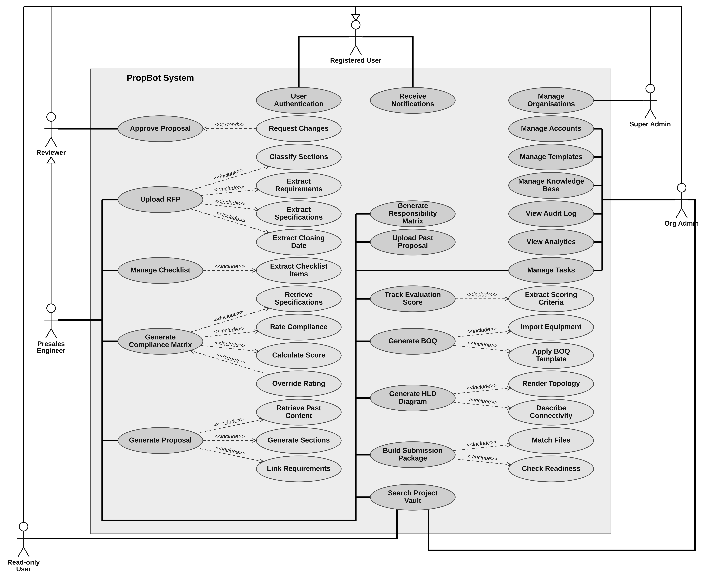
Figure 2.1: System Use Case Diagram of PropBot

2.4.1 Use Case List
Table 2.2 lists every use case in Figure 2.1, each main use case followed by its sub-use cases, with its actor, its relationship to its parent use case, the functional requirements it covers (Section 2.6) and the mockup screens that show it (Section 2.5.1). Each of the 118 functional requirements belongs to at least one use case.
Table 2.2: PropBot Use Case List
Use Case | Actor(s) | Relationship | Functional Requirements | Screens
User Authentication | Registered User (all five roles) | — | FR-13.1, FR-13.4, FR-13.6, FR-18.1, FR-18.2 | W-01–W-04, M-01, M-02
Receive Notifications | Registered User (all five roles) | — | FR-4.5, FR-17.4, FR-18.6 | W-16, W-46, M-11, M-12
Upload RFP | Presales Engineer | — | FR-1.1, FR-1.2, FR-1.5, FR-1.6, FR-1.7 | W-06, W-10
Classify Sections | — | «include» of Upload RFP | FR-1.3, FR-1.8 | W-06, W-07
Extract Requirements | — | «include» of Upload RFP | FR-1.10, FR-1.11 | W-06, W-09
Extract Specifications | — | «include» of Upload RFP | FR-1.4 | W-06
Extract Closing Date | — | «include» of Upload RFP | FR-1.9 | W-06, W-08
Manage Checklist | Presales Engineer | — | FR-2.4, FR-2.5, FR-2.6, FR-2.7, FR-18.4 | W-11, W-12, M-06–M-08
Extract Checklist Items | — | «include» of Manage Checklist | FR-2.1, FR-2.2, FR-2.3 | W-11
Track Evaluation Score | Presales Engineer | — | FR-4.2, FR-4.3, FR-4.4, FR-4.6 | W-16
Extract Scoring Criteria | — | «include» of Track Evaluation Score | FR-4.1 | W-16
Generate Compliance Matrix | Presales Engineer | — | FR-3.1, FR-3.5, FR-3.7, FR-3.8 | W-14
Retrieve Specifications | — | «include» of Generate Compliance Matrix | FR-3.2 | W-13
Rate Compliance | — | «include» of Generate Compliance Matrix | FR-3.3, FR-3.9, FR-3.10 | W-14
Calculate Score | — | «include» of Generate Compliance Matrix | FR-3.4 | W-14
Override Rating | — | «extend» of Generate Compliance Matrix (when the engineer disagrees with a rating) | FR-3.6 | W-14, W-15
Generate Proposal | Presales Engineer | — | FR-6.6, FR-6.7, FR-6.9, FR-6.10 | W-19, W-20, W-21
Retrieve Past Content | — | «include» of Generate Proposal | FR-6.1, FR-6.2, FR-6.3, FR-6.4, FR-11.3 | W-19, W-32
Generate Sections | — | «include» of Generate Proposal | FR-6.5 | W-19
Link Requirements | — | «include» of Generate Proposal | FR-6.11, FR-6.12 | W-20
Generate BOQ | Presales Engineer | — | FR-7.3, FR-7.4, FR-7.5 | W-23
Import Equipment | — | «include» of Generate BOQ | FR-7.2 | W-23
Apply BOQ Template | — | «include» of Generate BOQ | FR-7.1 | W-23, W-39
Generate HLD Diagram | Presales Engineer | — | FR-5.1, FR-5.2, FR-5.5, FR-5.6 | W-17, W-18
Render Topology | — | «include» of Generate HLD Diagram | FR-5.3, FR-5.4 | W-18
Describe Connectivity | — | «include» of Generate HLD Diagram | FR-5.7 | W-18
Generate Responsibility Matrix | Presales Engineer | — | FR-8.1, FR-8.2, FR-8.3, FR-8.4 | W-24
Build Submission Package | Presales Engineer | — | FR-10.1, FR-10.4, FR-10.5, FR-10.6 | W-28, W-29
Match Files | — | «include» of Build Submission Package | FR-10.2 | W-28
Check Readiness | — | «include» of Build Submission Package | FR-10.3, FR-10.7 | W-28
Manage Tasks | Presales Engineer, Org Admin | — | FR-17.1, FR-17.2, FR-17.3, FR-17.5, FR-18.5 | W-05, W-44, W-45, M-09, M-10
Upload Past Proposal | Presales Engineer | — | FR-11.4 | W-31
Search Project Vault | Presales Engineer, Read-only User, Org Admin | — | FR-9.1, FR-9.2, FR-9.3, FR-9.4, FR-9.5, FR-9.6, FR-9.7, FR-18.7 | W-05, W-25, W-26, W-27, W-47, M-13
Approve Proposal | Reviewer (and Presales Engineer by generalisation) | — | FR-6.8, FR-13.3, FR-18.3, FR-18.8 | W-20, W-22, M-02, M-03, M-05, M-14
Request Changes | — | «extend» of Approve Proposal (when a section needs revision) | FR-6.8, FR-18.3 | W-20, M-04
Manage Accounts | Org Admin | — | FR-13.1, FR-13.2, FR-13.5 | W-04, W-36, W-37, W-38
Manage Templates | Org Admin | — | FR-8.5, FR-14.1, FR-14.2, FR-14.3 | W-39, W-40
Manage Knowledge Base | Org Admin | — | FR-11.1, FR-11.2, FR-11.5, FR-11.6 | W-30, W-32, W-33
View Audit Log | Org Admin | — | FR-15.1, FR-15.2, FR-15.3, FR-15.4, FR-15.5, FR-15.6 | W-41, W-42
View Analytics | Org Admin | — | FR-16.1, FR-16.2, FR-16.3, FR-16.4 | W-43
Manage Organisations | Super Admin | — | FR-12.1, FR-12.2, FR-12.3 | W-34, W-35

2.5 Requirement Identifying Technique
Two complementary techniques were used to identify and document PropBot's functional requirements. Mockup-Based Requirement Analysis was used for the system's user-facing screens on both the web and mobile applications, while the Event–Response Table technique was used for backend and non-UI processes, account security and session management, audit logging, deadline notifications, and the submission readiness check, that have no corresponding screen of their own.
The requirements were derived from the approved project scope, which was elicited through discussions with presales engineers in the telecom IT industry and the study of real RFP documents (Section 1.11). They were then refined screen by screen through the mockups and, for backend processes, through the event–response analysis below.

2.5.1 Mockup-Based Requirement Analysis
Sixty-one annotated UI mockups were designed for PropBot, 47 screens for the web application (IDs W-01 to W-47) and 14 screens for the companion mobile application (IDs M-01 to M-14). The screens use one common visual design (the same header, role-based sidebar, button styles and colour convention) so that every requirement is shown in the context in which a user will meet it. Each mockup was used to derive feature-level functional requirements, following the steps below:
- Identify key features and break them down into individual screens.
- Assign a Screen ID to each screen (W-xx for the web application, M-xx for the mobile application).
- Design the mockup for each screen, using the sidebar that belongs to the logged-in role.
- Identify the interactive elements on each screen (buttons, forms, tables, menus).
- Derive a functional requirement from each element, describing the system's expected response.
- Map every requirement (FR-x.y) to the screen or screens that show it, and organise the result in the table format shown below.
The role-based sidebar follows the five fixed roles: the Presales Engineer sees Projects, Knowledge Base and Tasks; the Reviewer sees Projects and Tasks; the Read-only User sees Projects; the Org Admin additionally sees Templates, Analytics, Audit Log and Users; and the Super Admin sees Organisations. Mockups M1–M6 of the approved scope document correspond to screens W-06, W-11, W-14, W-20, W-25 and W-28, and mockups M7–M9 correspond to the mobile screens M-03, M-07 and M-09. All 118 functional requirements in Section 2.6 are shown on at least one screen; the complete requirement-to-screen matrix is given in Section 2.5.3.
The “+ New Project” button on the engineer's screens opens the RFP upload screen (W-06), because a project is created by uploading its RFP (FR-1.1). All companies, people, equipment models and specification values in the mockups are illustrative sample data, not real customer data or vendor specifications; the screens are printed at page width, and full-resolution copies of all screens accompany this report.
A. Web Application Screens
W-01 – Login
Application: Web · User role(s): All
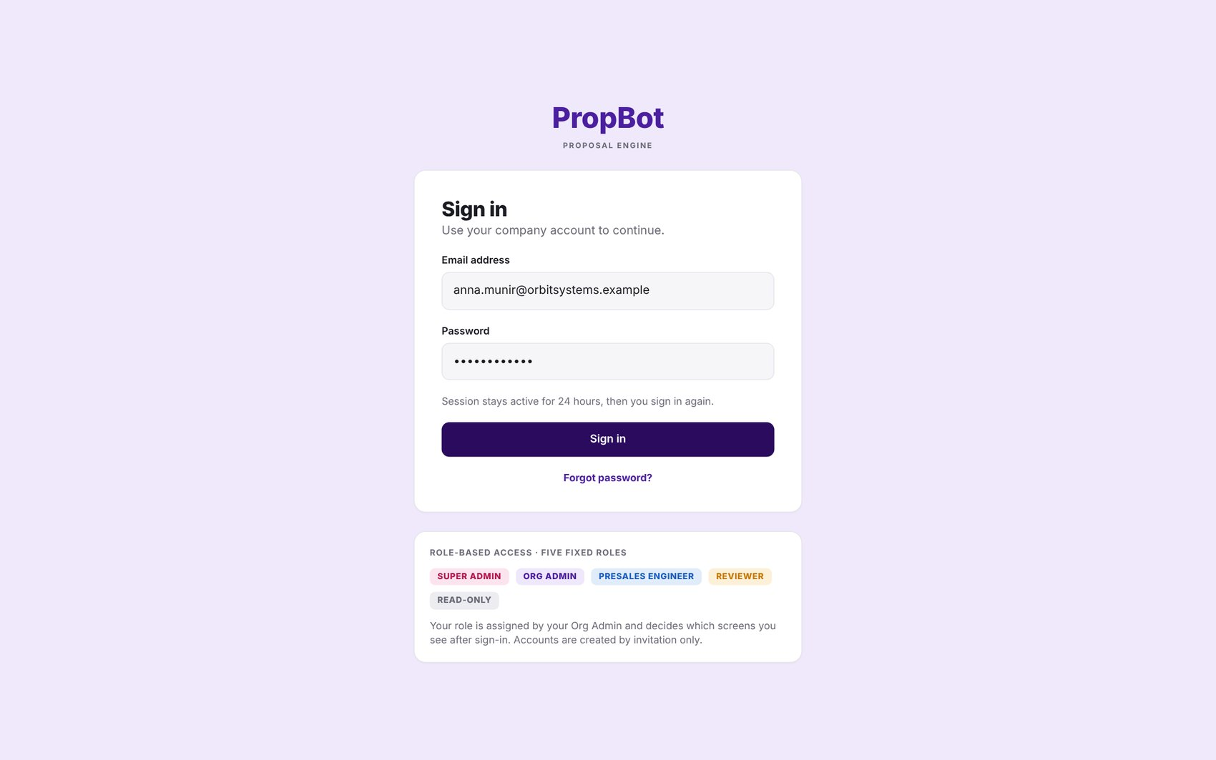
Figure 2.2: W-01 – Login
Table 2.3: Requirements mapped to screen W-01
Feature (derived from UI) | Functional Requirement (FR-ID: Statement) | Business Rule
Role-Based Access Control | FR-13.1: The system shall support five roles — Super Admin, Org Admin, Presales Engineer, Reviewer, Read-only — enforced through a role-based access control (RBAC) middleware layer in FastAPI. | Exactly five fixed roles.
Session Token Management | FR-13.4: All user sessions shall use JWT tokens signed with HS256, with a 24-hour expiry, validated on every protected API endpoint; validation shall also check that the user is still active and that the token version matches the user's current token version. | Token expiry: 24 hours; tokens with an outdated version are rejected.

W-02 – Forgot Password
Application: Web · User role(s): All
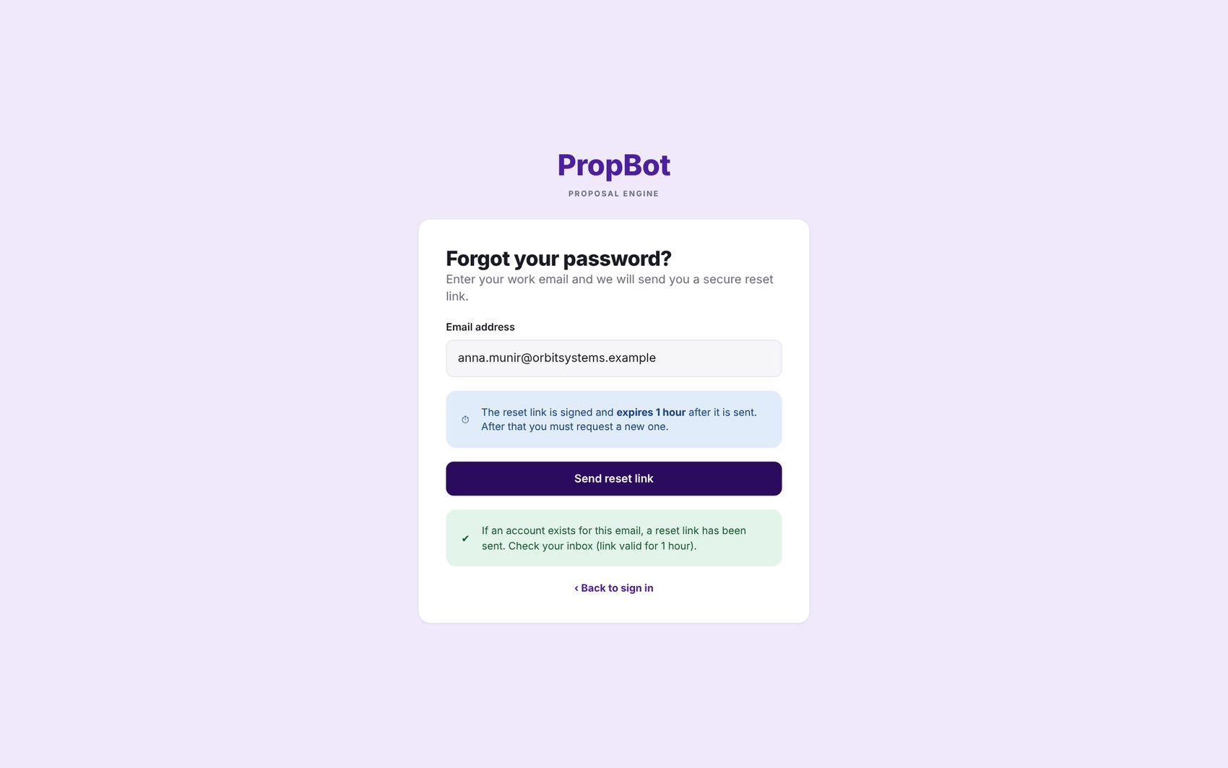
Figure 2.3: W-02 – Forgot Password
Table 2.4: Requirements mapped to screen W-02
Feature (derived from UI) | Functional Requirement (FR-ID: Statement) | Business Rule
Password Reset | FR-13.6: The system shall handle password reset via a time-limited (1-hour) signed reset link sent by email. | Reset link expires after 1 hour.

W-03 – Reset Password (signed 1-hour link)
Application: Web · User role(s): All
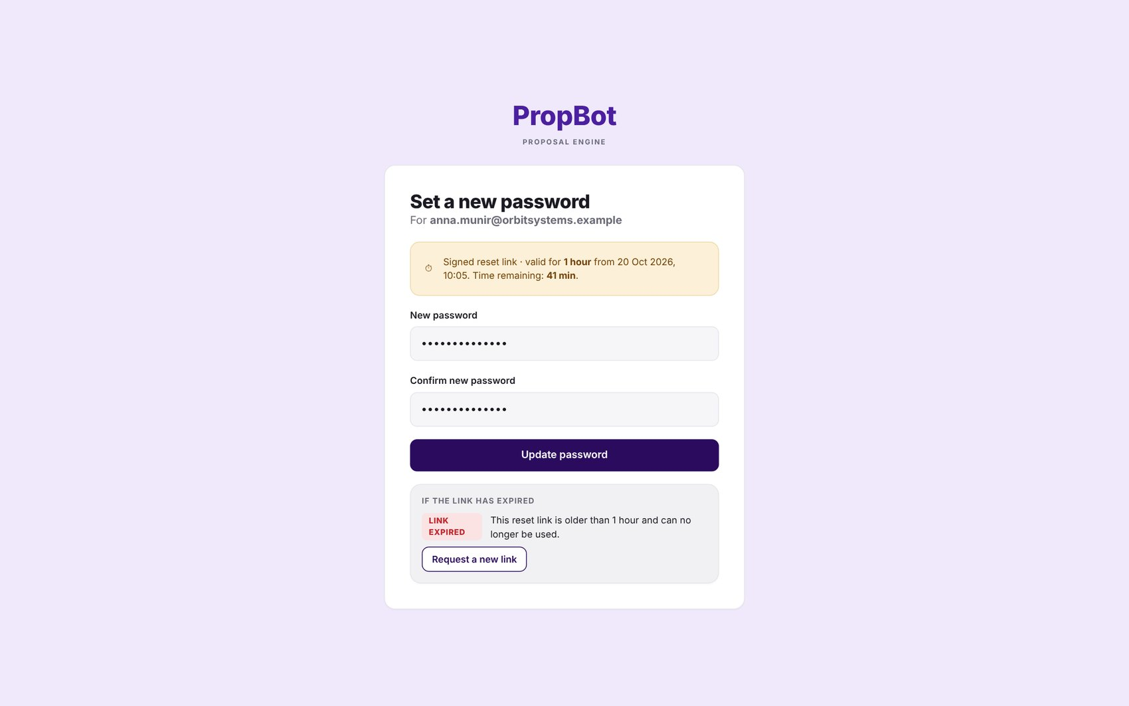
Figure 2.4: W-03 – Reset Password (signed 1-hour link)
Table 2.5: Requirements mapped to screen W-03
Feature (derived from UI) | Functional Requirement (FR-ID: Statement) | Business Rule
Password Reset | FR-13.6: The system shall handle password reset via a time-limited (1-hour) signed reset link sent by email. | Reset link expires after 1 hour.

W-04 – Activate Account (48-hour invitation)
Application: Web · User role(s): Invited user
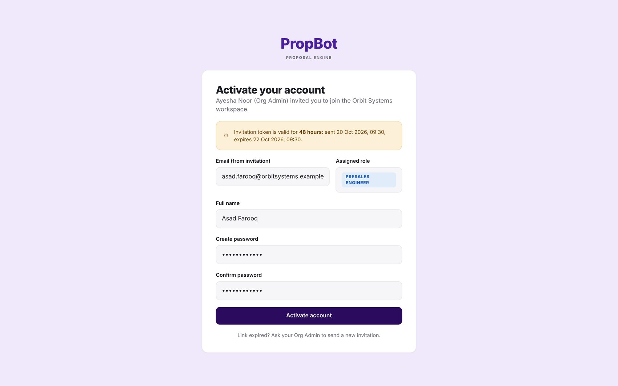
Figure 2.5: W-04 – Activate Account (48-hour invitation)
Table 2.6: Requirements mapped to screen W-04
Feature (derived from UI) | Functional Requirement (FR-ID: Statement) | Business Rule
User Invitation | FR-13.2: The Org Admin shall invite users by email; the invitation shall generate a time-limited JWT token (expiry: 48 hours) for account activation. | Invitation token expires after 48 hours.

W-05 – Projects Dashboard
Application: Web · User role(s): Engineer, Reviewer, Org Admin
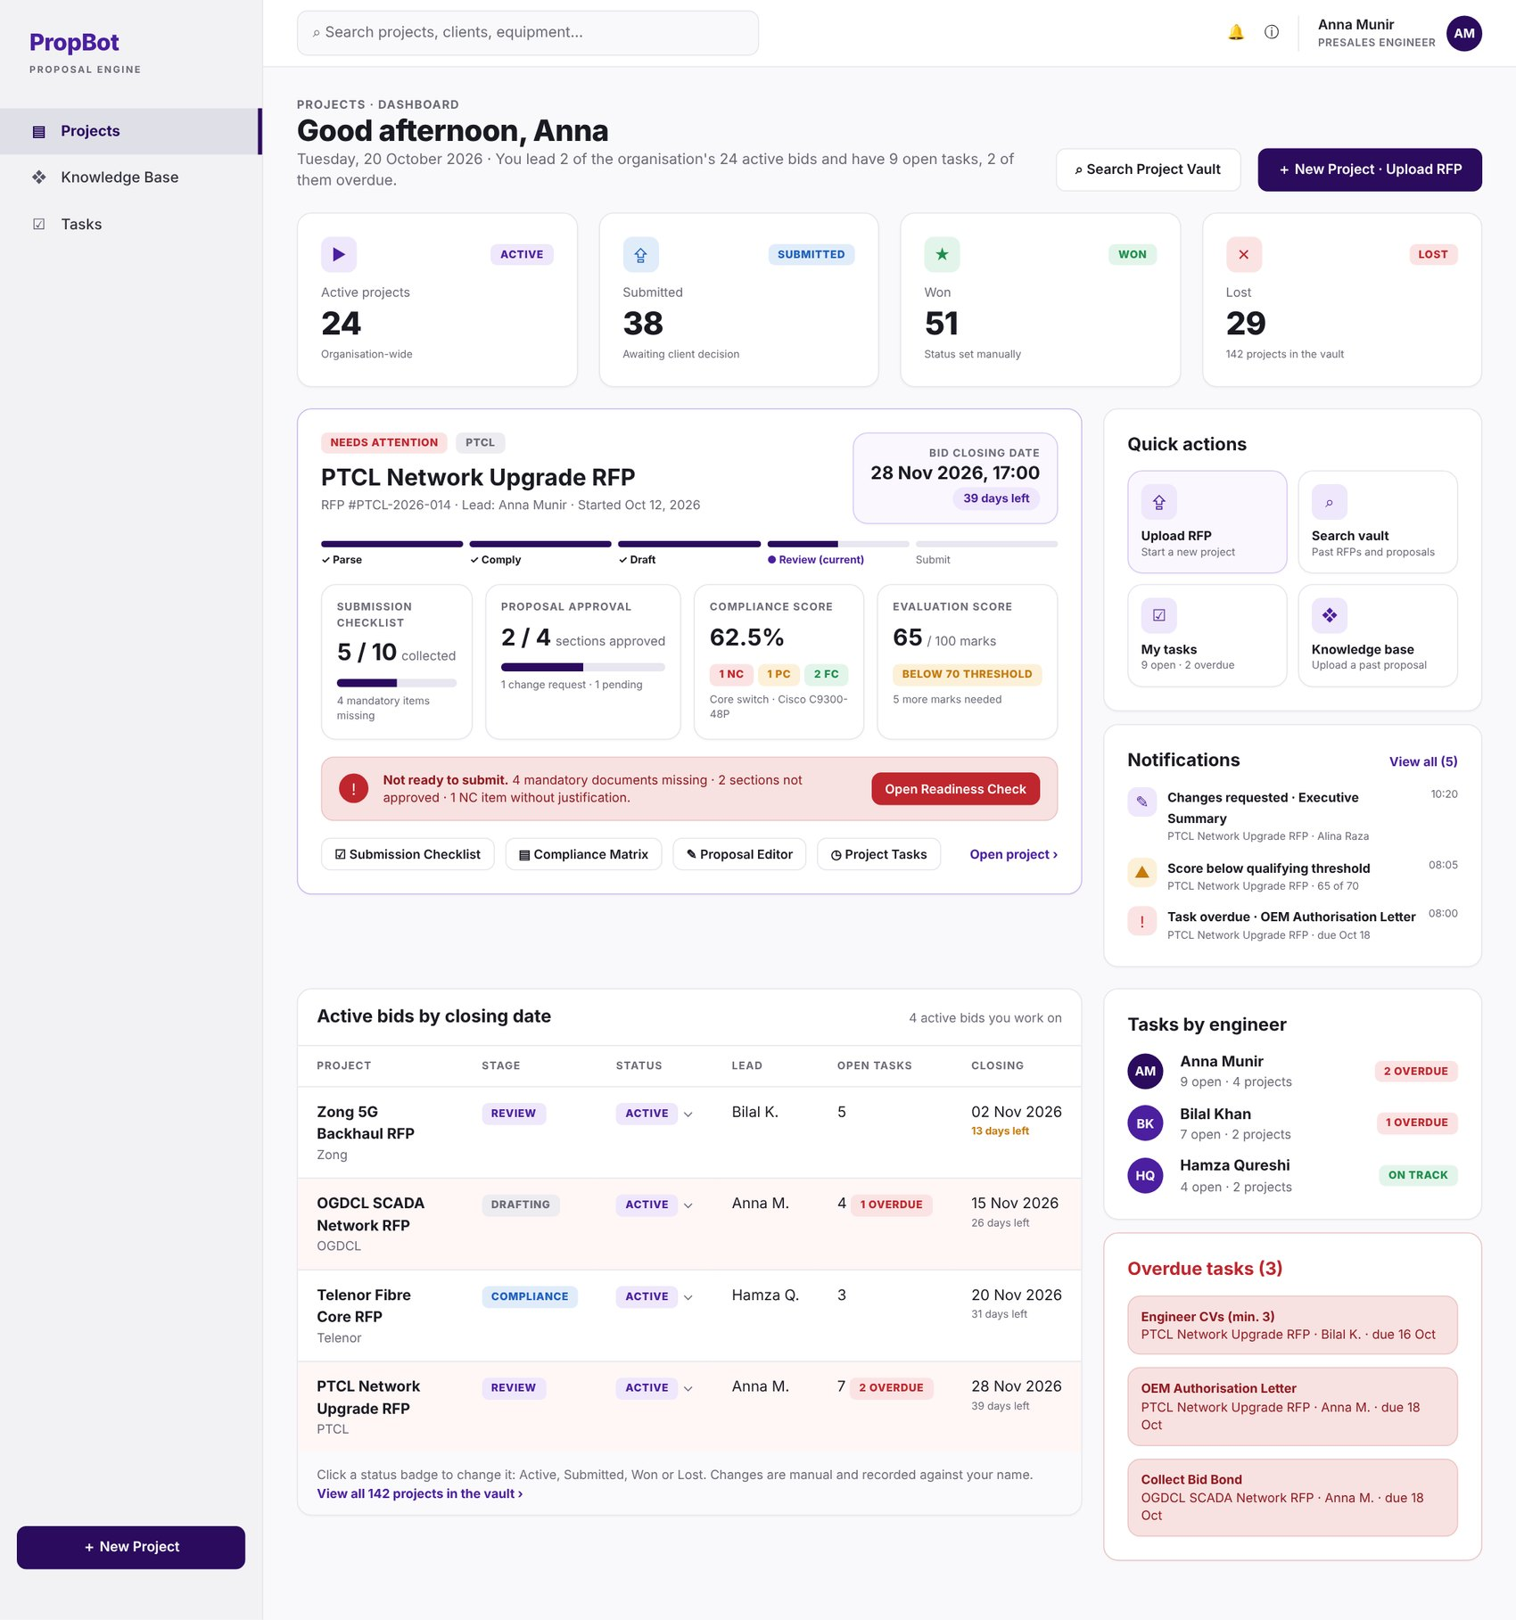
Figure 2.6: W-05 – Projects Dashboard
Table 2.7: Requirements mapped to screen W-05
Feature (derived from UI) | Functional Requirement (FR-ID: Statement) | Business Rule
Project Status Field | FR-9.6: The system shall maintain a project status field with values active, submitted, won, or lost, updated manually by the engineer or Org Admin. | —
Task Views | FR-17.3: The system shall display tasks per project and per engineer, with overdue tasks highlighted. | —

W-06 – RFP Upload & Parsing
Application: Web · User role(s): Engineer
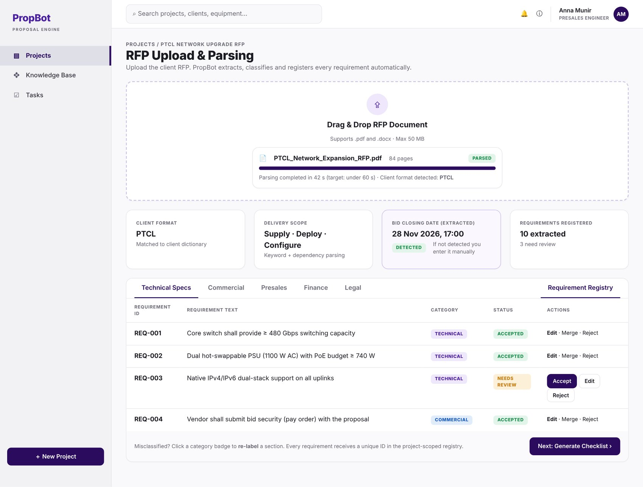
Figure 2.7: W-06 – RFP Upload & Parsing
Table 2.8: Requirements mapped to screen W-06
Feature (derived from UI) | Functional Requirement (FR-ID: Statement) | Business Rule
RFP File Upload | FR-1.1: The system shall accept RFP files in .pdf and .docx formats up to 50 MB. | File formats limited to PDF/DOCX; maximum size 50 MB.
Raw Text Extraction | FR-1.2: The system shall extract raw text from uploaded PDFs using the PyMuPDF library and from Word files using python-docx. | —
Section Classification | FR-1.3: The system shall classify every extracted section into one of five categories (technical, commercial, financial, legal, presales) using a zero-shot classification pipeline built on the facebook/bart-large-mnli model. | Exactly five fixed classification categories.
Entity Extraction (NER) | FR-1.4: The system shall apply Named Entity Recognition using spaCy's en_core_web_trf model to extract equipment names, quantities, protocol names, and specification values from the technical section. | —
Delivery Scope Detection | FR-1.5: The system shall detect the delivery scope (supply, deploy, configure, migrate) using keyword pattern matching combined with dependency parsing on the extracted technical text. | —
Client Format Detection | FR-1.6: The system shall detect the telecom client format (PTCL, OGDCL, Zong, Telenor) using string matching against a pre-defined client format dictionary and apply the corresponding parsing rules; if no supported format is detected, the system shall apply generic parsing rules and show the notice “Client format not recognised — please review the classification”. | Supported client formats limited to PTCL, OGDCL, Zong and Telenor; any other client is parsed with the generic rules.
Parsing Turnaround | FR-1.7: For a text-based RFP of up to 100 pages, the system shall display the classified section output within 60 seconds of upload; entity extraction (FR-1.4, FR-1.5) may continue in the background with a visible progress indicator and shall complete within 180 seconds of upload. | Classified output ≤ 60 s; full extraction ≤ 180 s (95th percentile, reference server; PER-1).
Manual Re-classification | FR-1.8: The engineer shall be able to manually correct or re-label any misclassified section through the UI. | —
Closing Date Extraction | FR-1.9: The system shall extract the bid closing date and time from the parsed RFP text; if it is not detected, the engineer shall enter it manually. | Manual entry required as fallback when automatic extraction fails.
Requirement Registry | FR-1.10: The system shall assign a unique requirement ID to each extracted requirement and store it in a project-scoped requirement registry; the engineer shall be able to accept, edit, merge or reject extracted requirements. | —

W-07 – Re-label Section Modal
Application: Web · User role(s): Engineer
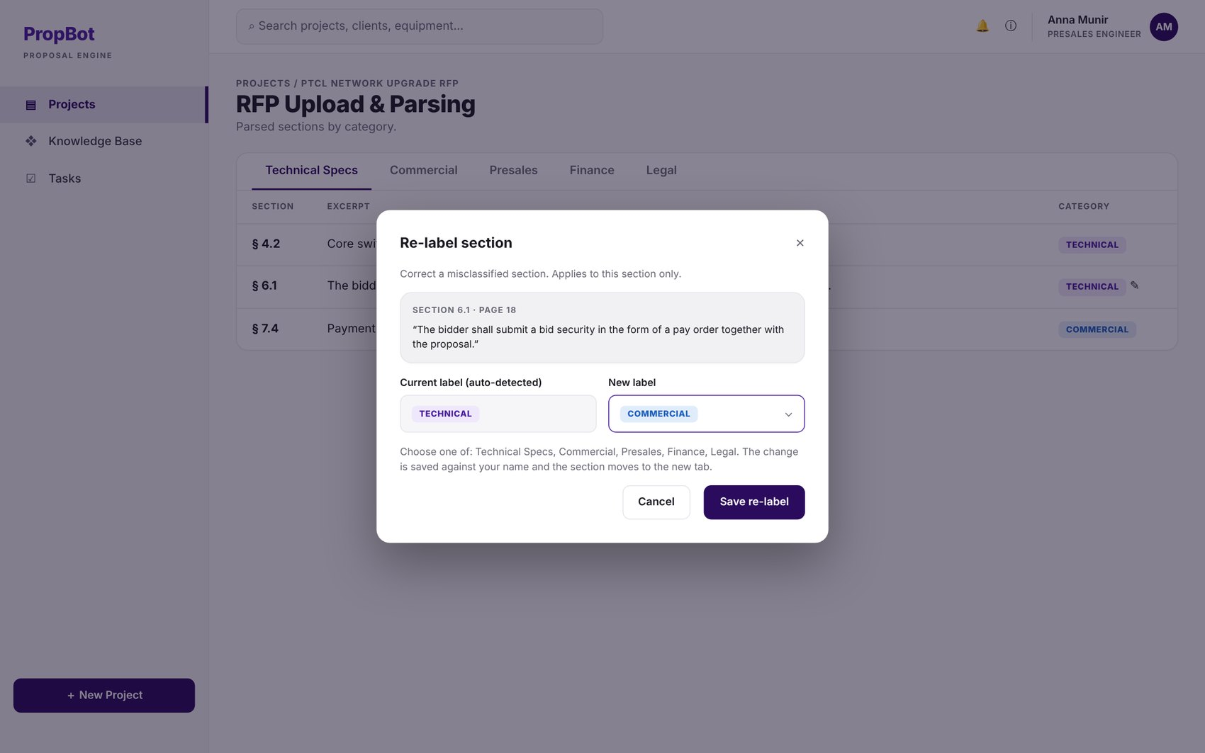
Figure 2.8: W-07 – Re-label Section Modal
Table 2.9: Requirements mapped to screen W-07
Feature (derived from UI) | Functional Requirement (FR-ID: Statement) | Business Rule
Manual Re-classification | FR-1.8: The engineer shall be able to manually correct or re-label any misclassified section through the UI. | —

W-08 – Bid Closing Date Confirmation
Application: Web · User role(s): Engineer
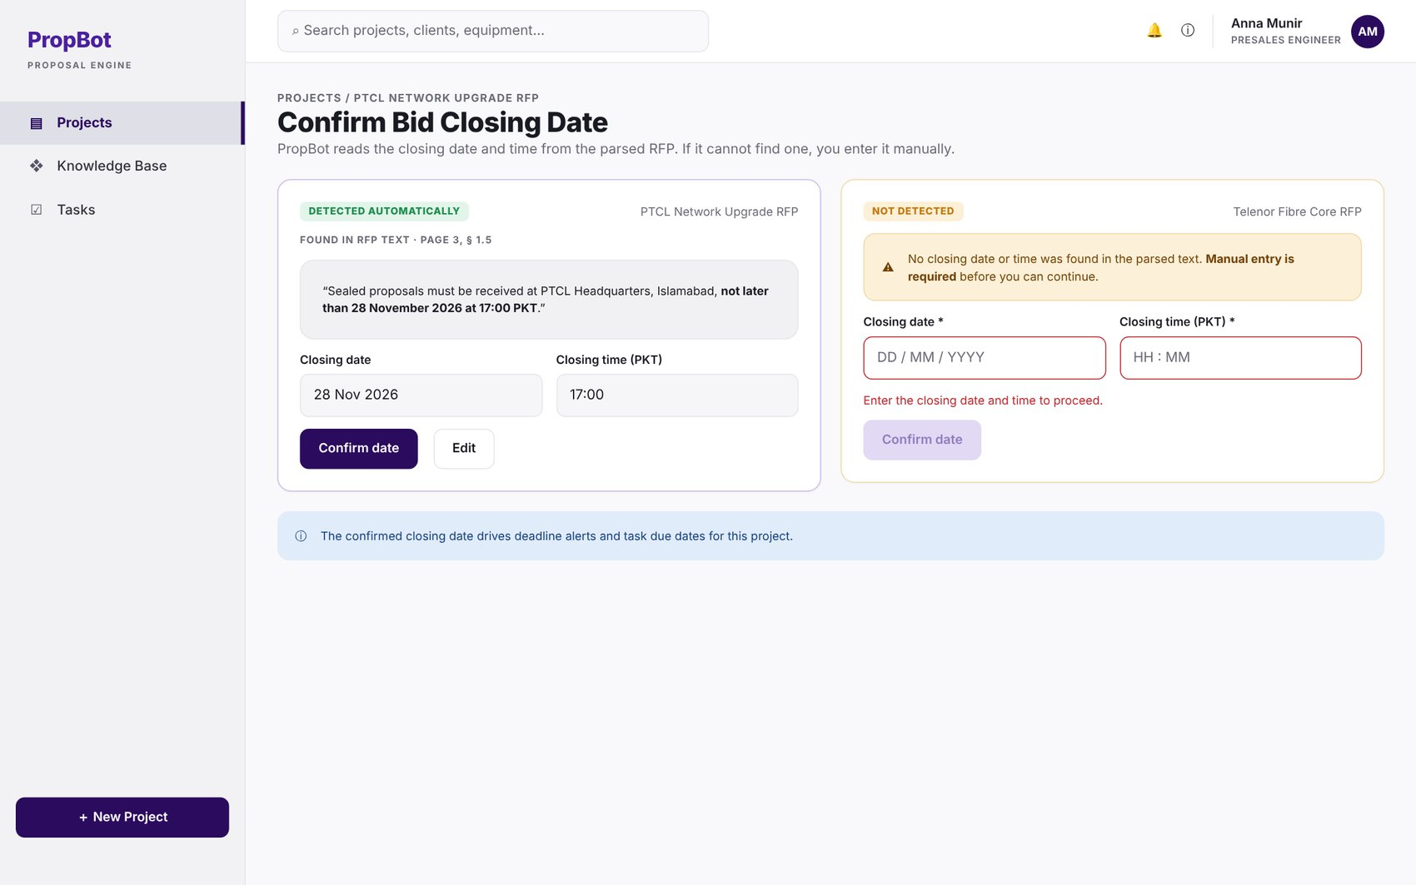
Figure 2.9: W-08 – Bid Closing Date Confirmation
Table 2.10: Requirements mapped to screen W-08
Feature (derived from UI) | Functional Requirement (FR-ID: Statement) | Business Rule
Closing Date Extraction | FR-1.9: The system shall extract the bid closing date and time from the parsed RFP text; if it is not detected, the engineer shall enter it manually. | Manual entry required as fallback when automatic extraction fails.

W-09 – Requirement Registry
Application: Web · User role(s): Engineer
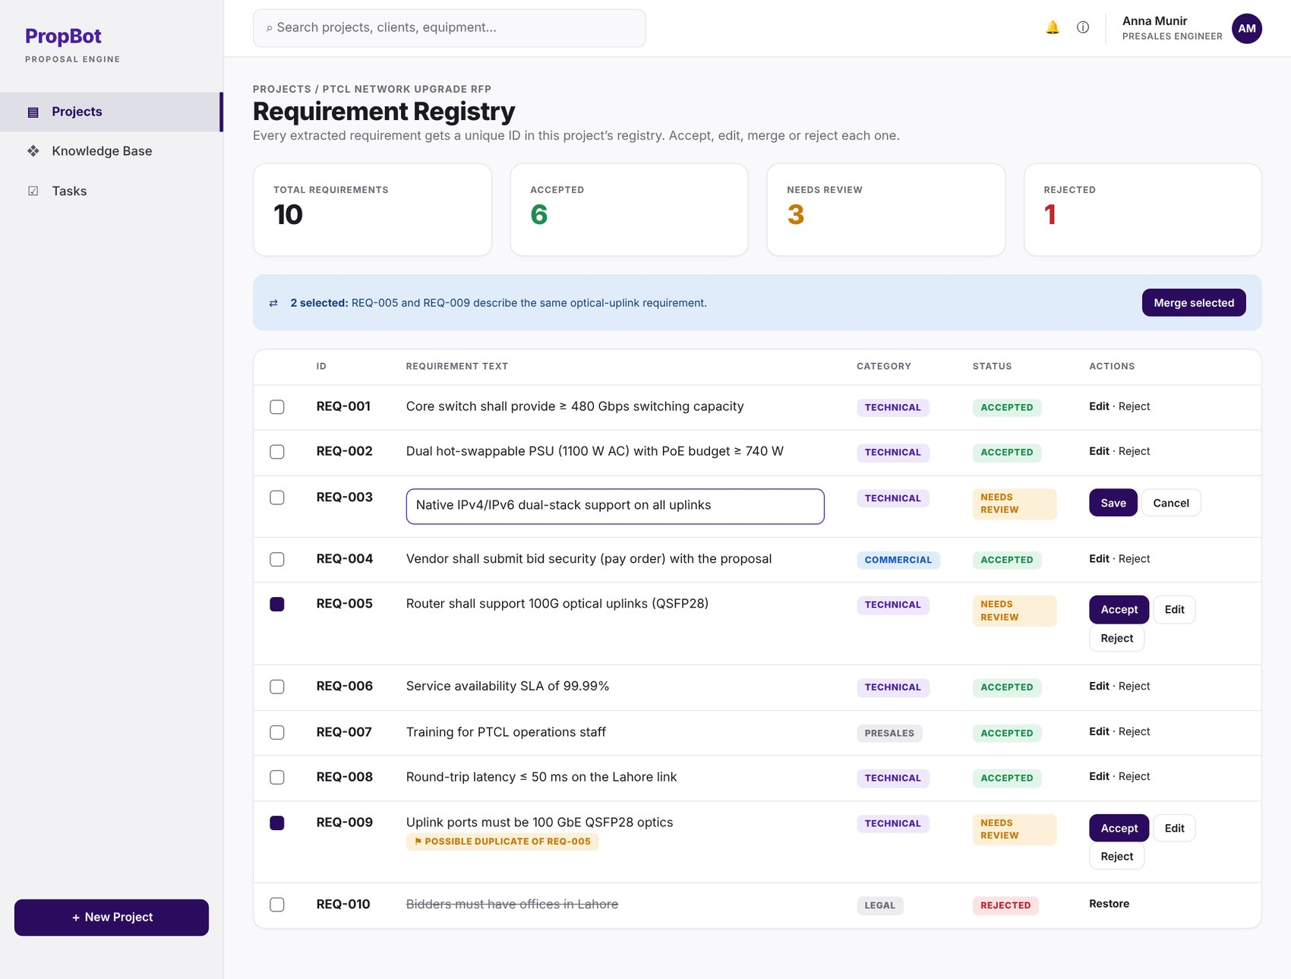
Figure 2.10: W-09 – Requirement Registry
Table 2.11: Requirements mapped to screen W-09
Feature (derived from UI) | Functional Requirement (FR-ID: Statement) | Business Rule
Requirement Registry | FR-1.10: The system shall assign a unique requirement ID to each extracted requirement and store it in a project-scoped requirement registry; the engineer shall be able to accept, edit, merge or reject extracted requirements. | —
Vague/Duplicate Requirement Flagging | FR-1.11: The system shall flag an extracted requirement as possibly vague (no measurable value or acceptance criterion) or as a possible duplicate of another requirement in the registry, for the engineer to review. | Optional enhancement — implemented only if time permits. Flags are advisory; the engineer decides (FR-1.10).

W-10 – Upload Error / Unsupported File
Application: Web · User role(s): Engineer
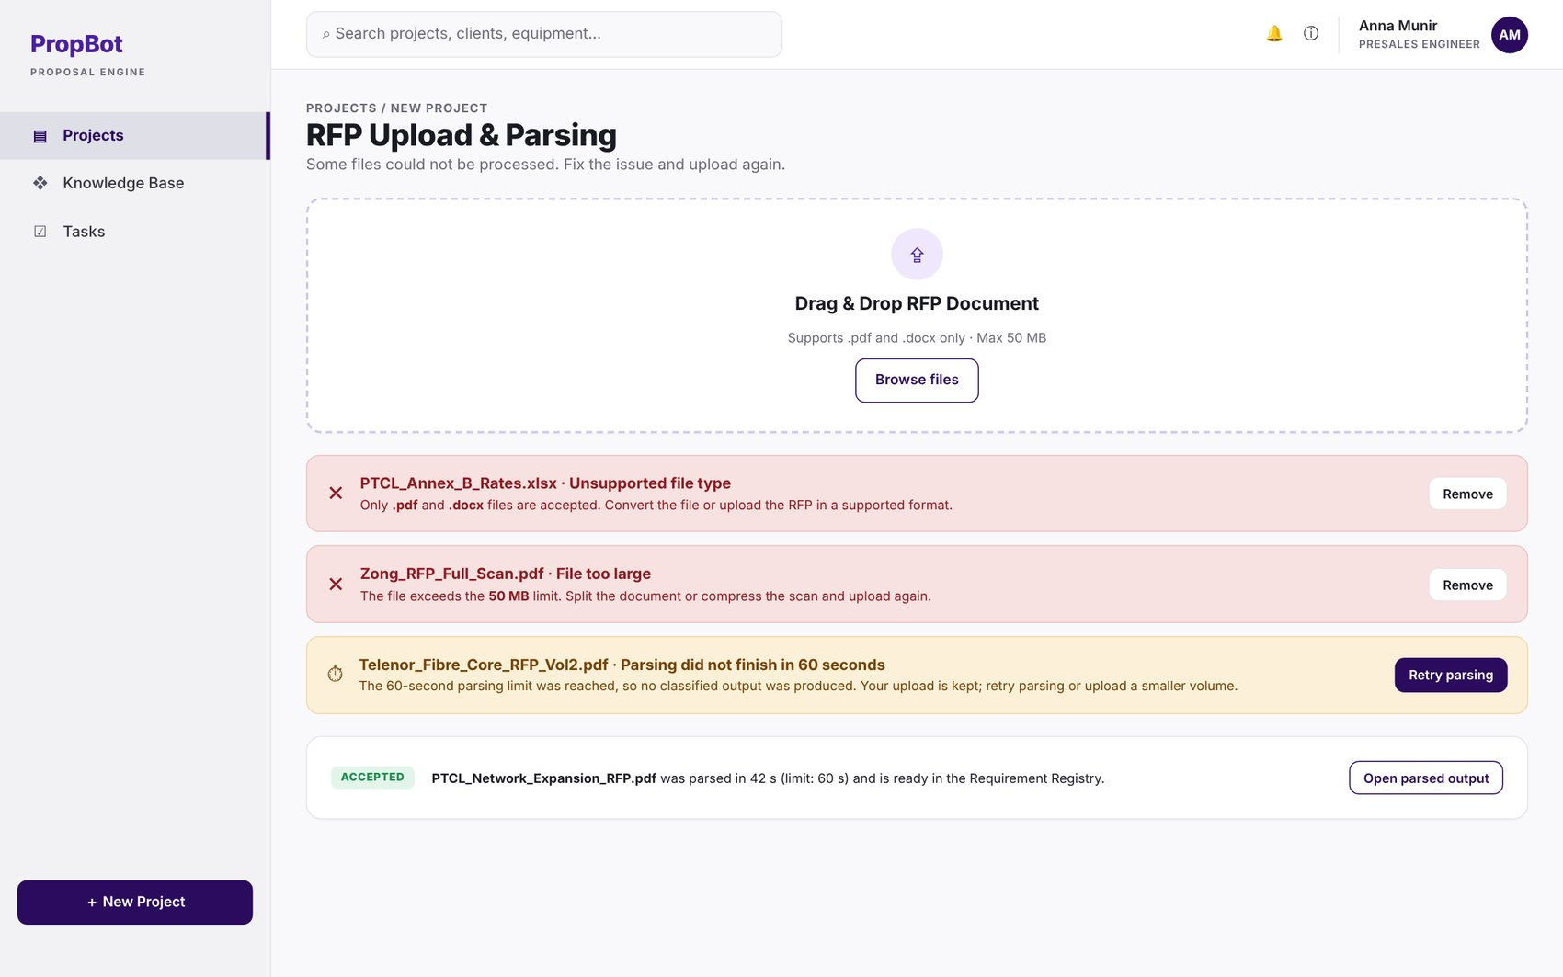
Figure 2.11: W-10 – Upload Error / Unsupported File
Table 2.12: Requirements mapped to screen W-10
Feature (derived from UI) | Functional Requirement (FR-ID: Statement) | Business Rule
RFP File Upload | FR-1.1: The system shall accept RFP files in .pdf and .docx formats up to 50 MB. | File formats limited to PDF/DOCX; maximum size 50 MB.
Parsing Turnaround | FR-1.7: For a text-based RFP of up to 100 pages, the system shall display the classified section output within 60 seconds of upload; entity extraction (FR-1.4, FR-1.5) may continue in the background with a visible progress indicator and shall complete within 180 seconds of upload. | Classified output ≤ 60 s; full extraction ≤ 180 s (95th percentile, reference server; PER-1).

W-11 – Submission Checklist
Application: Web · User role(s): Engineer
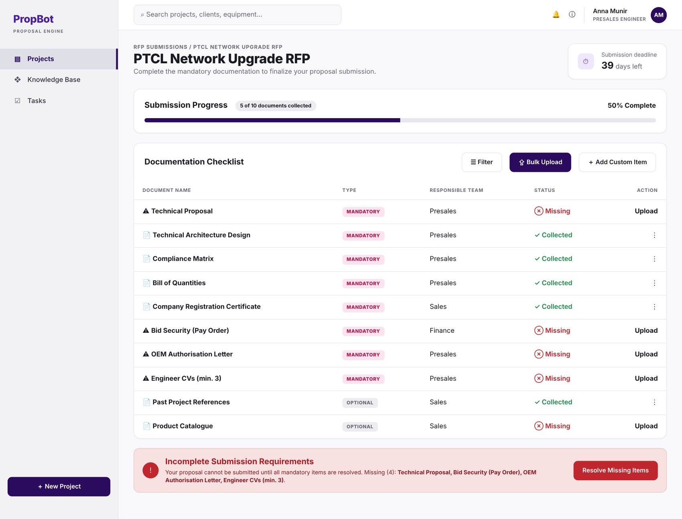
Figure 2.12: W-11 – Submission Checklist
Table 2.13: Requirements mapped to screen W-11
Feature (derived from UI) | Functional Requirement (FR-ID: Statement) | Business Rule
Checklist Item Extraction | FR-2.1: The system shall extract all submission document requirements from parsed RFP text using GPT-4o-mini with a structured JSON output prompt, returning document_name, mandatory (true/false), and responsible_team. | —
Mandatory/Optional Classification | FR-2.2: The system shall classify each item as mandatory or optional using modal verb detection via the spaCy en_core_web_trf dependency parser. | “shall” / “must” map to mandatory; “may” maps to optional; “should” maps to mandatory by default, because a missing expected document can cost marks or lead to rejection. The engineer can change the classification of any item.
Responsible Team Assignment | FR-2.3: The system shall assign a responsible team (presales, sales, finance) inferred from surrounding RFP section context using the Module 1 classifier output. | —
Checklist Tick-Off | FR-2.4: The system shall provide a live tick-off interface for engineers to mark items as collected and attach the corresponding document file. | —
Collected/Outstanding Counter | FR-2.5: The system shall display a real-time counter of collected vs. outstanding items, updated on every tick-off event. | —
Submission Blocking | FR-2.6: The system shall block submission package generation if any mandatory item remains uncollected, enforced at the API level in Module 10. | Blocking enforced server-side, not only in the UI.

W-12 – Add Custom Checklist Item Modal
Application: Web · User role(s): Engineer
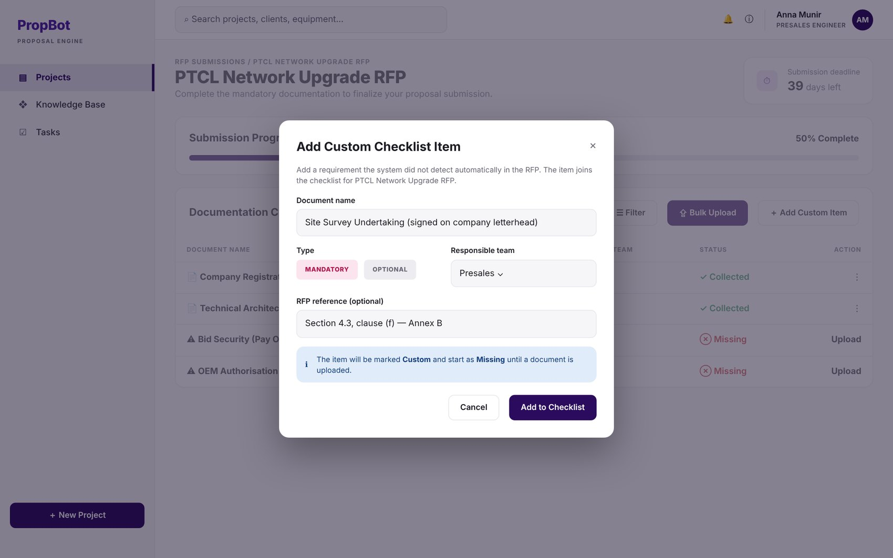
Figure 2.13: W-12 – Add Custom Checklist Item Modal
Table 2.14: Requirements mapped to screen W-12
Feature (derived from UI) | Functional Requirement (FR-ID: Statement) | Business Rule
Custom Checklist Items | FR-2.7: The engineer shall be able to manually add custom checklist items for requirements not detected automatically. | —

W-13 – Specification Retrieval & Datasheet Confirmation
Application: Web · User role(s): Engineer
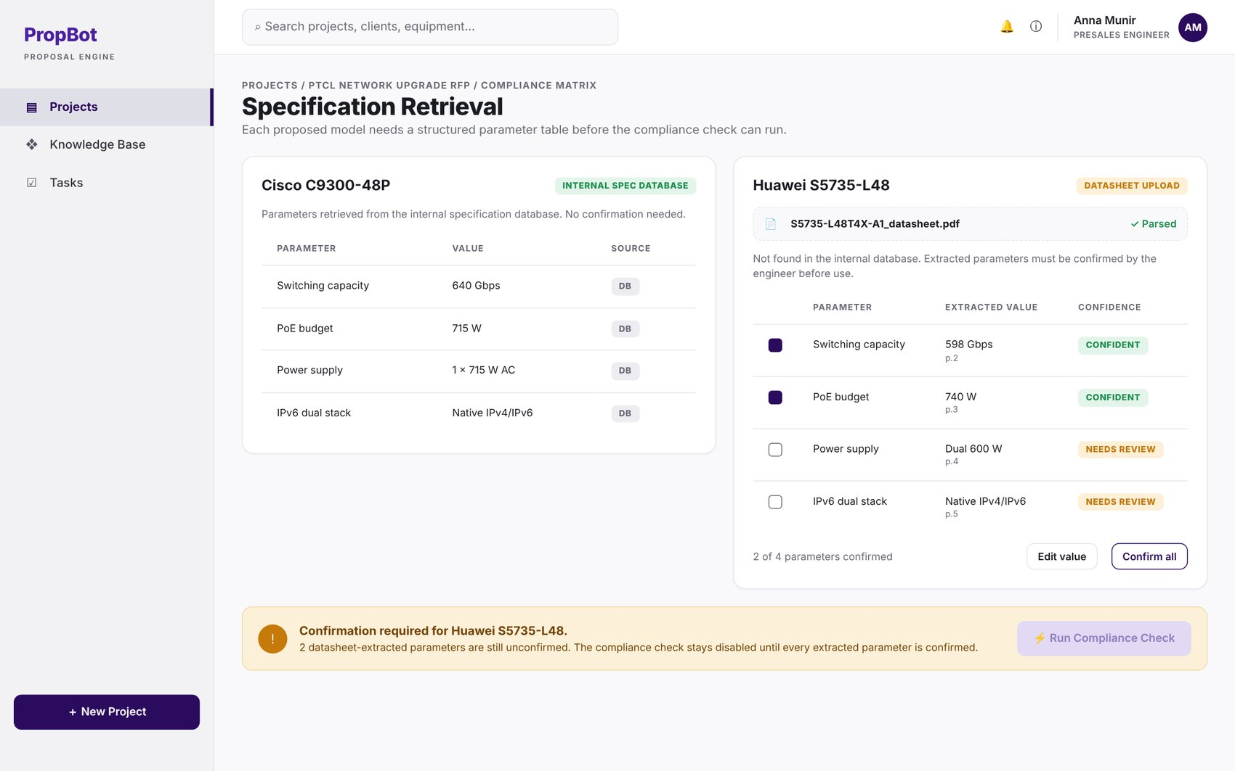
Figure 2.14: W-13 – Specification Retrieval & Datasheet Confirmation
Table 2.15: Requirements mapped to screen W-13
Feature (derived from UI) | Functional Requirement (FR-ID: Statement) | Business Rule
Specification Retrieval | FR-3.2: The system shall obtain the specification of each proposed model as a structured parameter table, either from the internal specification database or from an uploaded OEM datasheet, whose extracted parameters the engineer shall confirm before use. | Engineer confirmation required for datasheet-extracted parameters.

W-14 – Compliance Matrix
Application: Web · User role(s): Engineer
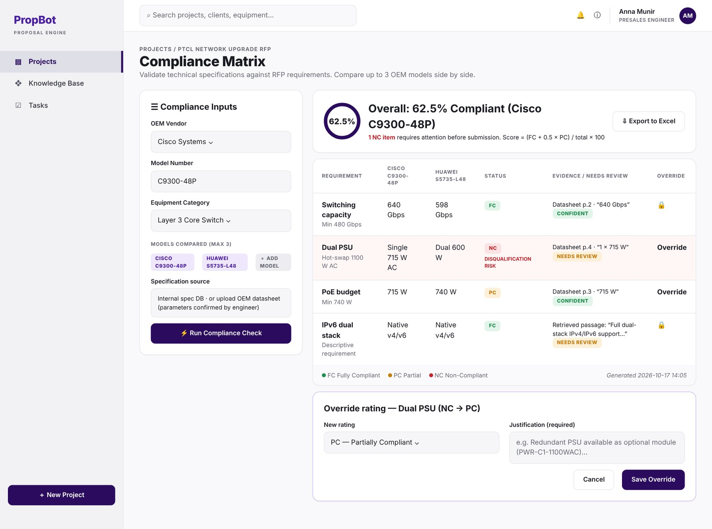
Figure 2.15: W-14 – Compliance Matrix
Table 2.16: Requirements mapped to screen W-14
Feature (derived from UI) | Functional Requirement (FR-ID: Statement) | Business Rule
Proposed Equipment Entry | FR-3.1: The engineer shall input proposed OEM vendor names and model numbers for each equipment category extracted by Module 1. | —
Rule-Based Compliance Evaluation | FR-3.3: The system shall convert each numeric or boolean RFP requirement into a structured constraint (parameter, operator, value, unit) and evaluate it against the model's specification using rule-based comparison with unit normalisation, assigning FC, PC or NC. | FC if the constraint is fully satisfied. PC if a numeric value falls short of the required value by no more than a tolerance (default 10%, configurable in system settings), or if the requirement is met only through an optional module or licence. NC if unsatisfied beyond the tolerance or if the parameter is missing from the specification.
Overall Compliance Percentage | FR-3.4: The system shall calculate and display the overall compliance percentage for each proposed model as (FC count + 0.5 × PC count) / total compliance rows evaluated for that model × 100, where each evaluated requirement produces one compliance row. | Fixed scoring formula; calculated separately for each compared model (FR-3.8).
NC Highlighting | FR-3.5: All NC items shall be highlighted in red with a disqualification risk label. | —
Manual Override | FR-3.6: The engineer shall be able to manually override any compliance rating and enter a justification note. | Justification note mandatory on override.
Matrix Export | FR-3.7: The system shall export the completed matrix as a formatted .xlsx file using openpyxl. | —
Multi-Model Comparison | FR-3.8: The system shall support simultaneous comparison of up to three alternative OEM models for the same requirement set. | Maximum of three models compared at once.
Descriptive Requirement Matching | FR-3.9: For descriptive requirements that cannot be converted into constraints, the system shall retrieve candidate datasheet passages using text-embedding-3-small embeddings, rerank them with the cross-encoder, and assign a rating with the top-ranked passage as evidence. | —
Evidence & Review Flagging | FR-3.10: The system shall store, for every compliance row, a short reason and the evidence reference, and shall mark low-confidence rows as “needs review”. | A row is low-confidence when its rating comes from descriptive matching (FR-3.9) and the top-ranked passage scores below a threshold (default 0.5 on a 0–1 scale, configurable in system settings), or when no evidence passage is found.

W-15 – Override Compliance Rating Modal
Application: Web · User role(s): Engineer
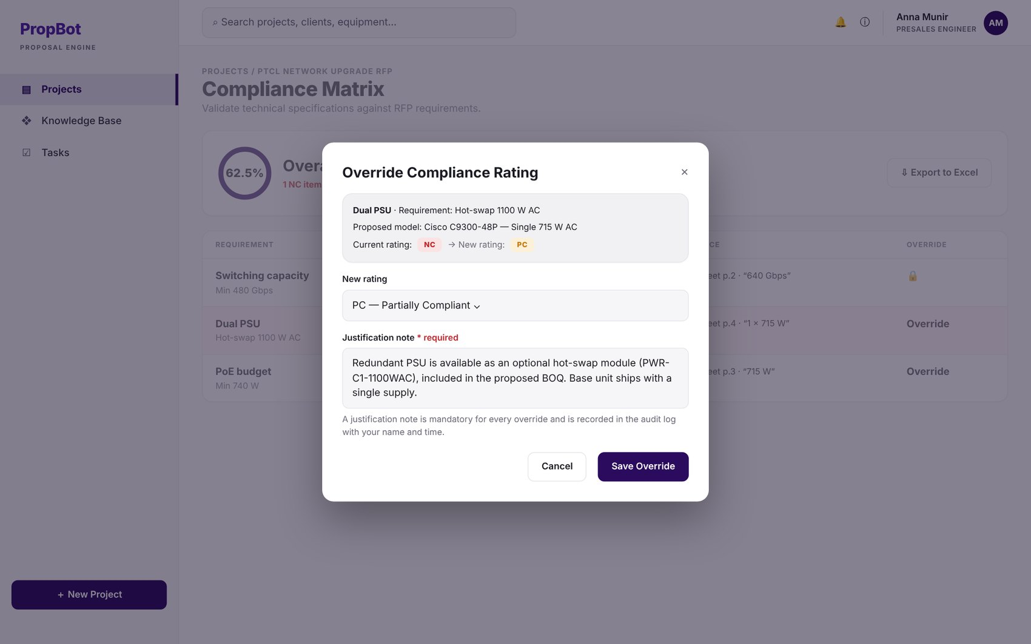
Figure 2.16: W-15 – Override Compliance Rating Modal
Table 2.17: Requirements mapped to screen W-15
Feature (derived from UI) | Functional Requirement (FR-ID: Statement) | Business Rule
Manual Override | FR-3.6: The engineer shall be able to manually override any compliance rating and enter a justification note. | Justification note mandatory on override.

W-16 – Technical Evaluation Criteria Analyser
Application: Web · User role(s): Engineer
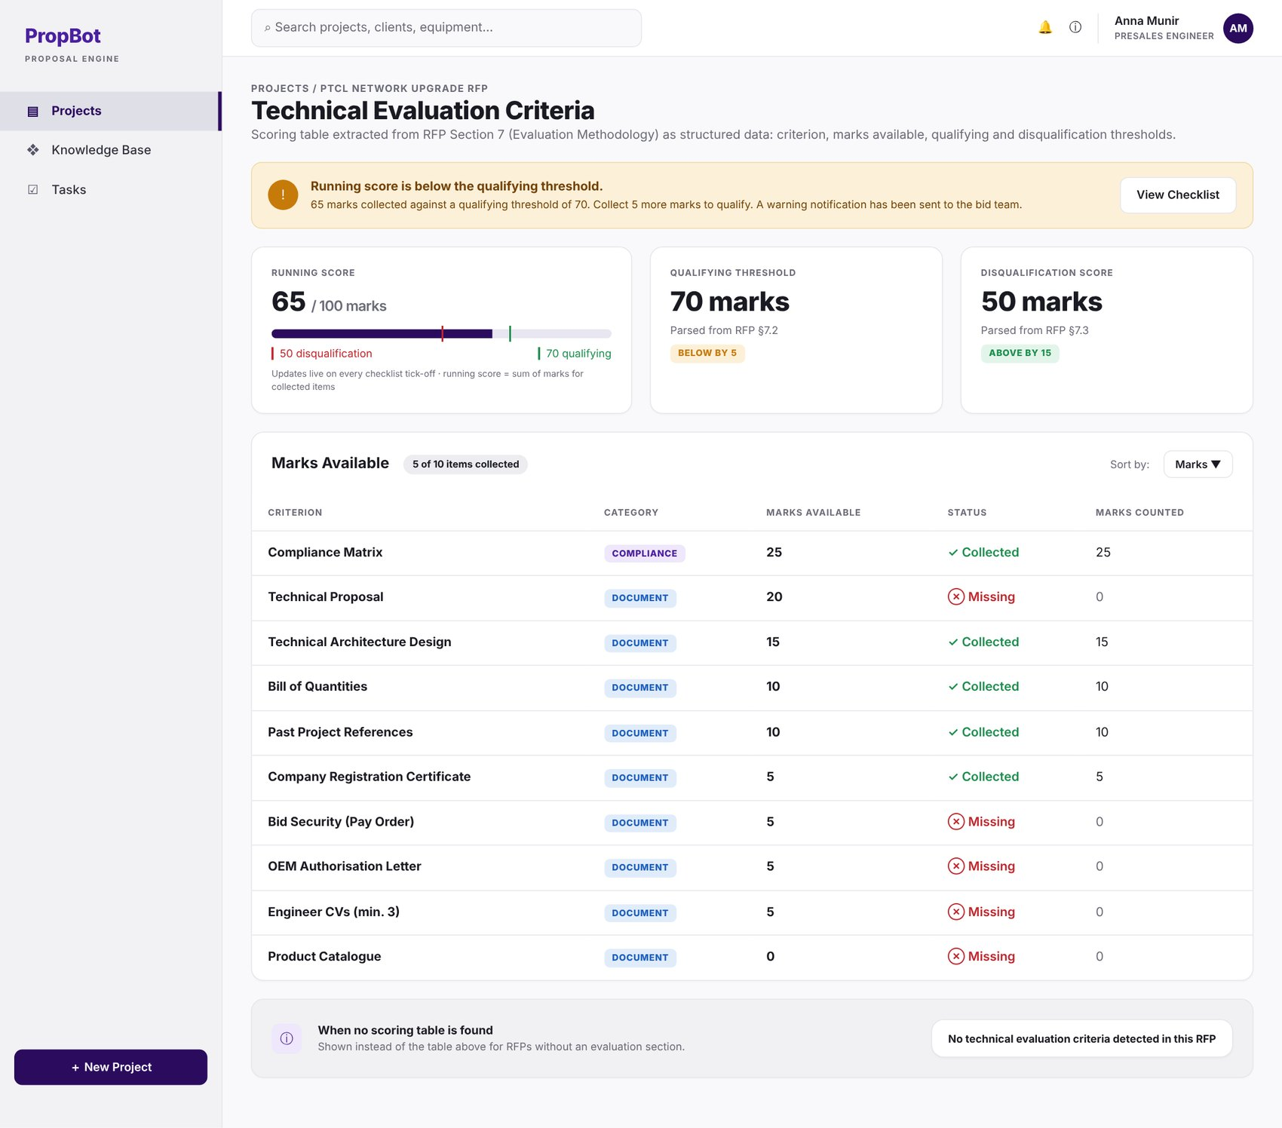
Figure 2.17: W-16 – Technical Evaluation Criteria Analyser
Table 2.18: Requirements mapped to screen W-16
Feature (derived from UI) | Functional Requirement (FR-ID: Statement) | Business Rule
Scoring Table Extraction | FR-4.1: The system shall extract the scoring table from the parsed RFP using GPT-4o-mini, returning structured JSON with criterion, marks_available, qualifying_threshold, and disqualification_threshold. | —
Marks Display | FR-4.2: The system shall display marks available per document category and per compliance requirement in a sortable table. | —
Threshold Display | FR-4.3: The system shall display the qualification threshold and disqualification score parsed directly from the RFP scoring section. | —
Running Score Computation | FR-4.4: The system shall link each scoring criterion extracted in FR-4.1 to the checklist item that evidences it (suggested automatically by name matching and confirmed or changed by the engineer), and shall compute a real-time running score, updated on every checklist tick-off event via WebSocket push. | Formula: running_score = Σ marks_available of every criterion whose linked checklist item is collected; criteria with no linked item are listed separately and not counted.
Below-Threshold Warning | FR-4.5: The system shall trigger a warning notification when running_score falls below the qualifying_threshold. | —
No-Criteria Message | FR-4.6: The system shall display the message “No technical evaluation criteria detected in this RFP” when no scoring table is found. | —

W-17 – HLD Network Device Input
Application: Web · User role(s): Engineer
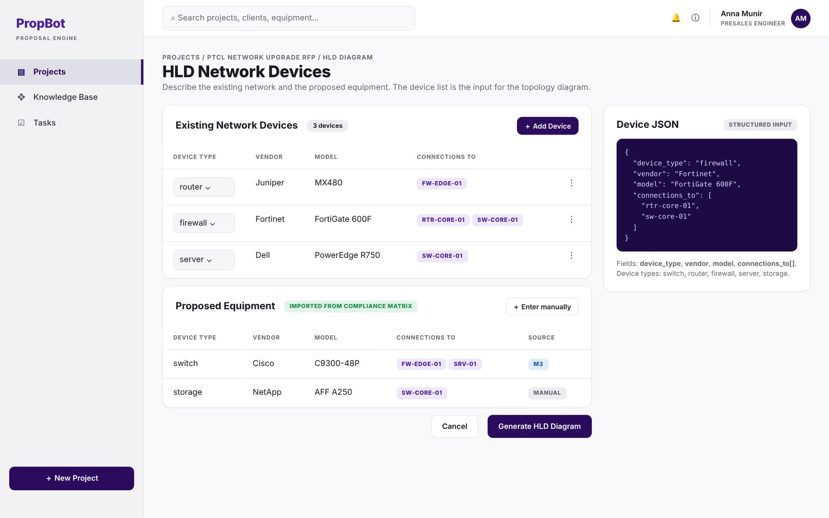
Figure 2.18: W-17 – HLD Network Device Input
Table 2.19: Requirements mapped to screen W-17
Feature (derived from UI) | Functional Requirement (FR-ID: Statement) | Business Rule
Network Device Input Form | FR-5.1: The system shall provide a structured JSON input form for existing network devices with fields device_type, vendor, model, and connections_to[]. | —
Proposed Equipment Import | FR-5.2: The system shall import proposed equipment from the Module 3 compliance matrix output or allow manual entry. | —

W-18 – HLD Diagram & Connectivity Description
Application: Web · User role(s): Engineer
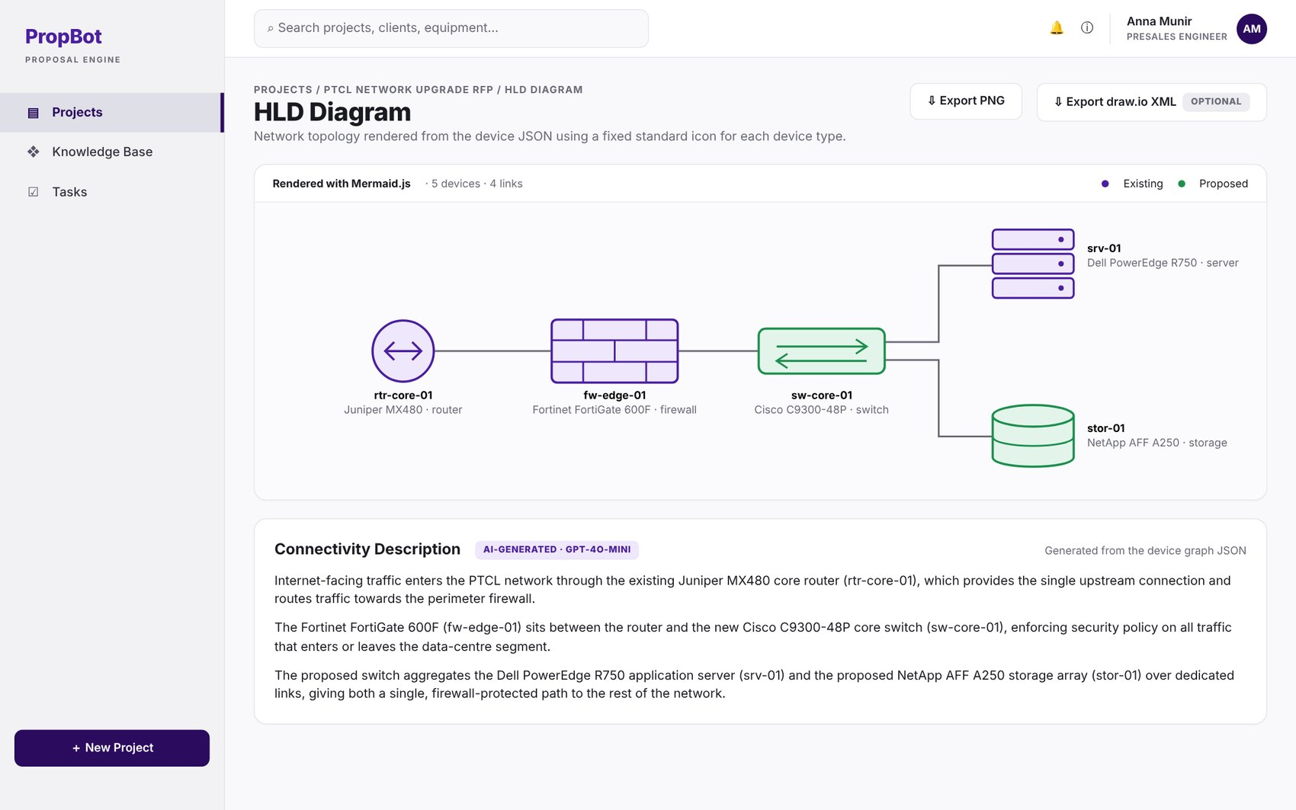
Figure 2.19: W-18 – HLD Diagram & Connectivity Description
Table 2.20: Requirements mapped to screen W-18
Feature (derived from UI) | Functional Requirement (FR-ID: Statement) | Business Rule
Topology Diagram Rendering | FR-5.3: The system shall convert device JSON into a Mermaid.js graph definition and render it as an HLD network topology diagram using the Mermaid rendering engine. | —
Standard Icon Set | FR-5.4: The system shall use one fixed, consistent standard icon for each device type: switch, router, firewall, server, storage. | —
PNG Export | FR-5.5: The system shall export the rendered diagram as a PNG using a Playwright headless-browser rendering pipeline. | —
Editable draw.io Export | FR-5.6: The system shall export an editable draw.io XML file generated from the same device graph JSON. | Optional enhancement — implemented only if time permits.
Connectivity Description | FR-5.7: The system shall generate a written connectivity description (2–4 paragraphs) using GPT-4o-mini, with the device graph JSON as input context. | —

W-19 – Proposal Generation Progress
Application: Web · User role(s): Engineer
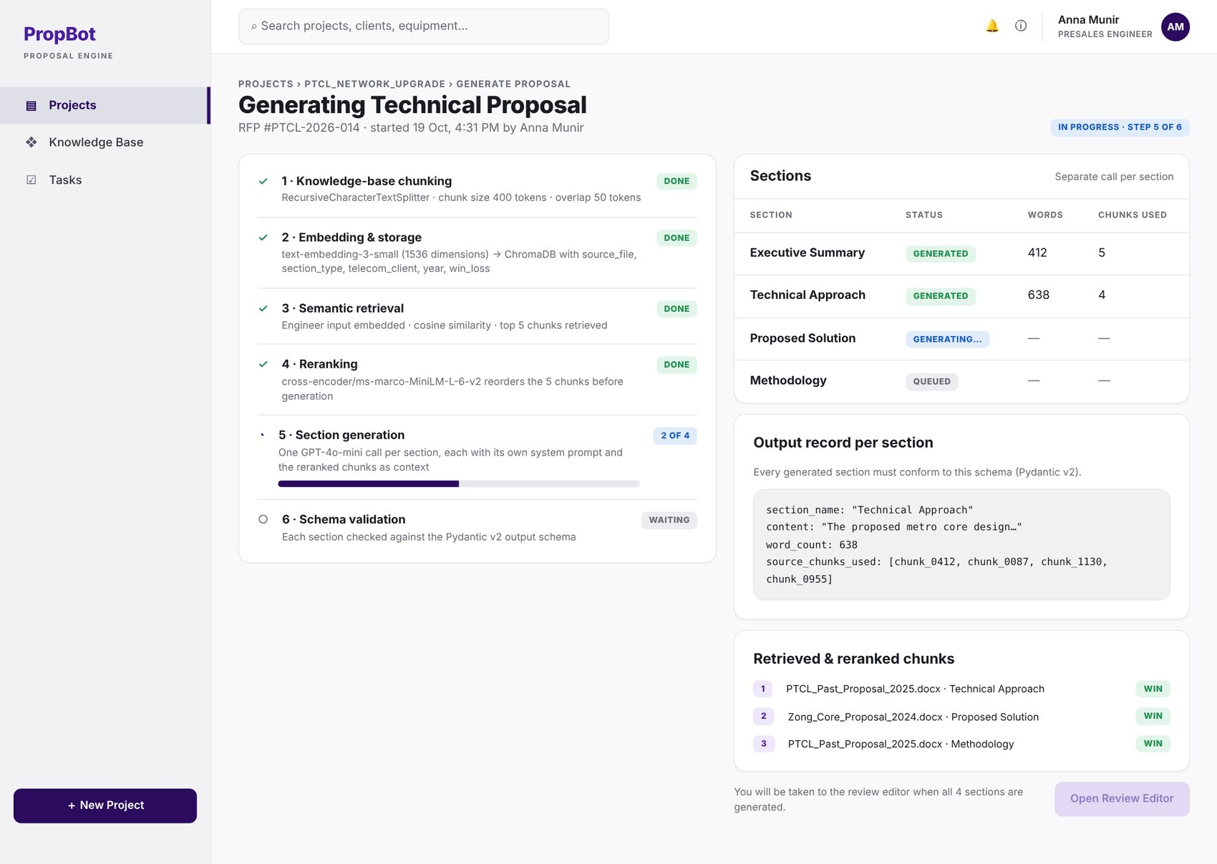
Figure 2.20: W-19 – Proposal Generation Progress
Table 2.21: Requirements mapped to screen W-19
Feature (derived from UI) | Functional Requirement (FR-ID: Statement) | Business Rule
Knowledge-Base Chunking | FR-6.1: The system shall chunk all knowledge base documents into segments of 400 tokens with 50-token overlap using LangChain's RecursiveCharacterTextSplitter. | Chunk size 400 tokens, overlap 50 tokens.
Chunk Embedding & Storage | FR-6.2: The system shall embed all chunks using OpenAI's text-embedding-3-small model (1536 dimensions) and store the vectors in ChromaDB with metadata: source_file, section_type, telecom_client, year, win_loss. | —
Semantic Retrieval | FR-6.3: At generation time, the system shall embed the engineer's input requirements and retrieve the top 5 most similar chunks from ChromaDB using cosine similarity search. | Top-5 chunks retrieved per generation request.
Reranking | FR-6.4: The system shall rerank the retrieved chunks using the cross-encoder/ms-marco-MiniLM-L-6-v2 model before passing them to the generator. | —
Section Generation | FR-6.5: The system shall generate each proposal section (Executive Summary, Technical Approach, Proposed Solution, Methodology) as a separate GPT-4o-mini call with a section-specific system prompt and the reranked chunks as context. | The four section calls are made concurrently (PER-3).
Structured Output Schema | FR-6.6: All generated sections shall conform to a Pydantic v2 output schema with fields section_name, content, word_count, and source_chunks_used. | —

W-20 – Proposal Review Editor
Application: Web · User role(s): Engineer, Reviewer
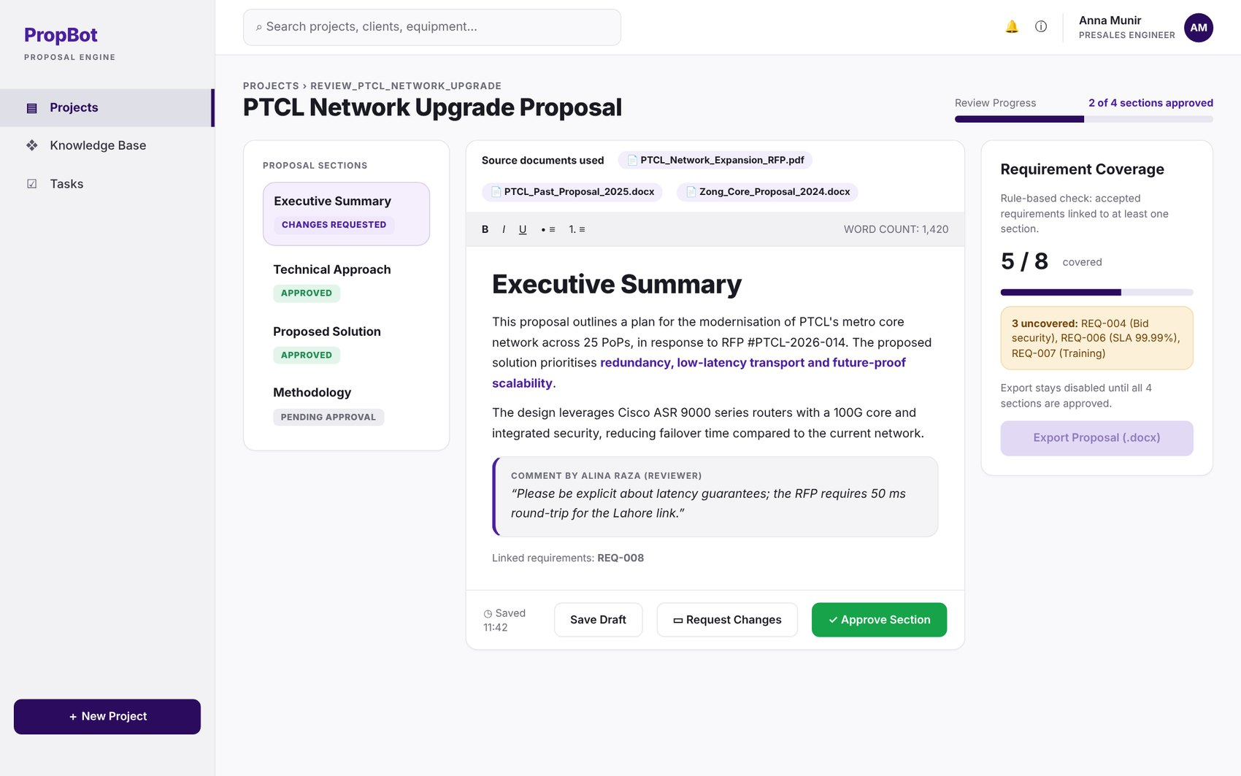
Figure 2.21: W-20 – Proposal Review Editor
Table 2.22: Requirements mapped to screen W-20
Feature (derived from UI) | Functional Requirement (FR-ID: Statement) | Business Rule
Section Editing | FR-6.7: The engineer shall review and edit each section individually in the TipTap rich text editor before approval. | —
Reviewer Approval Gate | FR-6.8: A reviewer shall approve or request changes on each section from the web or mobile application; the proposal cannot be exported until all sections are approved. | Export blocked until every section is approved.
Requirement Linking | FR-6.11: The system shall link each generated proposal section to the requirement IDs it addresses. | —
Coverage Check | FR-6.12: The system shall run a rule-based coverage check that lists any accepted requirement ID not linked to at least one proposal section. | —
Self-Approval Prevention | FR-13.3: The system shall prevent any engineer from approving a proposal they generated, enforced by comparing generated_by and approved_by fields at the API level. | Enforced server-side, not only in the UI.

W-21 – Proposal Export
Application: Web · User role(s): Engineer
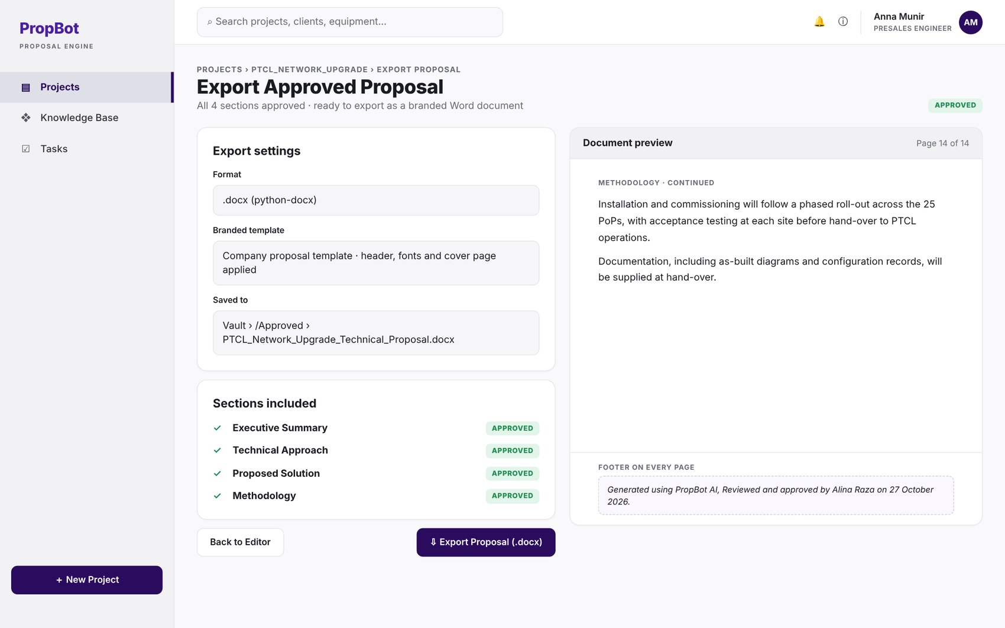
Figure 2.22: W-21 – Proposal Export
Table 2.23: Requirements mapped to screen W-21
Feature (derived from UI) | Functional Requirement (FR-ID: Statement) | Business Rule
Proposal Export | FR-6.9: The system shall export the approved proposal as a formatted .docx file using python-docx with the company's branded template. | —
Export Footer Stamp | FR-6.10: Every exported document shall include the footer: “Generated using PropBot AI, Reviewed and approved by [approver name(s)] on [date].” | Approver name(s) = the reviewer(s) who approved the sections (FR-6.8); date = date of the final section approval.

W-22 – Self-Approval Blocked Dialog
Application: Web · User role(s): Engineer, Reviewer
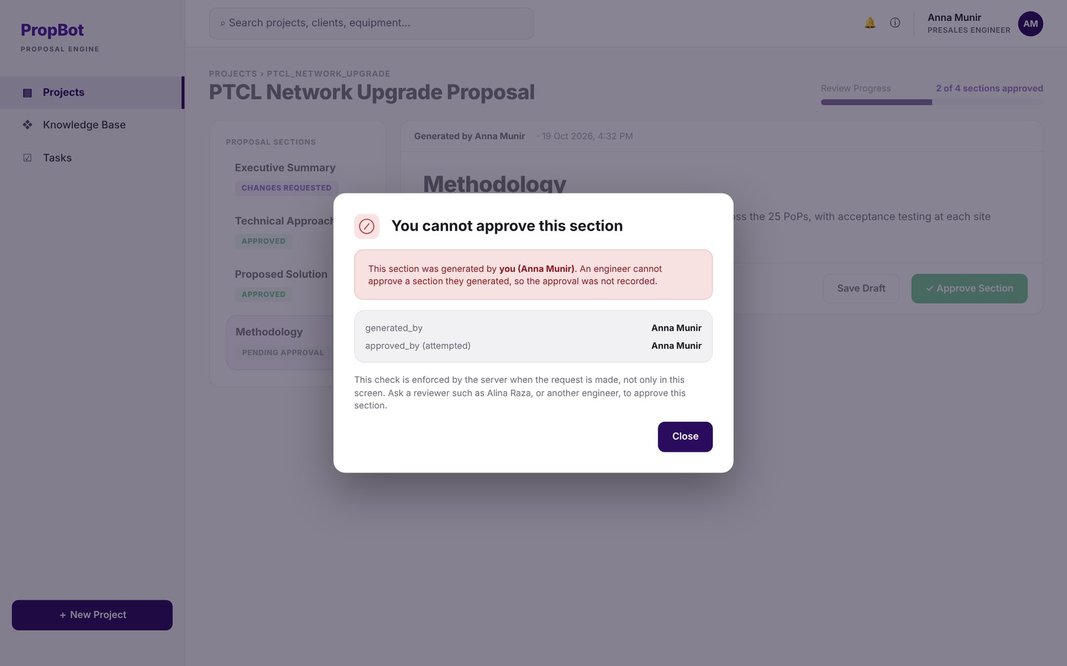
Figure 2.23: W-22 – Self-Approval Blocked Dialog
Table 2.24: Requirements mapped to screen W-22
Feature (derived from UI) | Functional Requirement (FR-ID: Statement) | Business Rule
Self-Approval Prevention | FR-13.3: The system shall prevent any engineer from approving a proposal they generated, enforced by comparing generated_by and approved_by fields at the API level. | Enforced server-side, not only in the UI.

W-23 – BOQ Editor
Application: Web · User role(s): Engineer
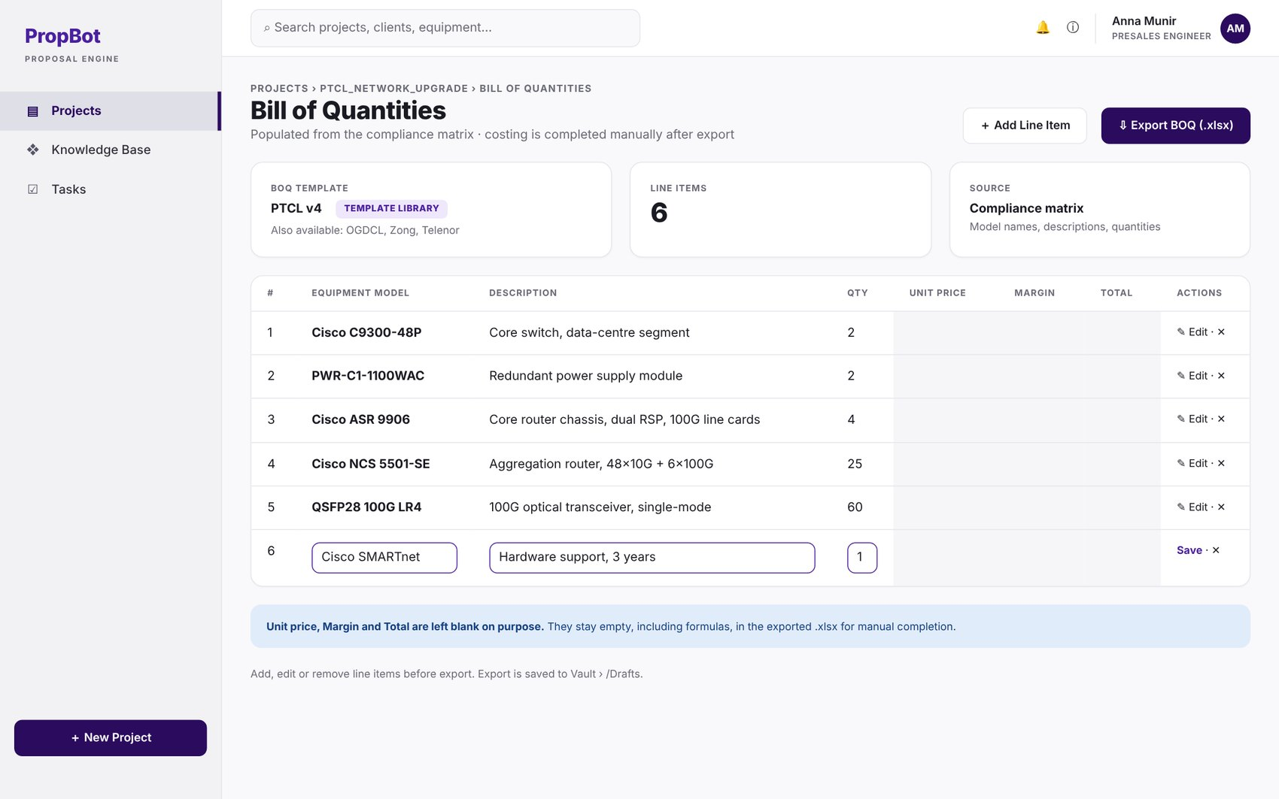
Figure 2.24: W-23 – BOQ Editor
Table 2.25: Requirements mapped to screen W-23
Feature (derived from UI) | Functional Requirement (FR-ID: Statement) | Business Rule
BOQ Template Library | FR-7.1: The system shall maintain a library of pre-loaded BOQ Excel templates per telecom company (PTCL, OGDCL, Zong, Telenor), stored as .xlsx files managed through Module 14. | —
Auto-Population | FR-7.2: The system shall auto-populate the BOQ template with equipment model names, descriptions, and quantities extracted from the Module 3 compliance matrix output using openpyxl. | —
Costing Columns Left Blank | FR-7.3: All costing, margin, and formula columns shall remain blank in the exported file for manual completion. | —
Line-Item Editing | FR-7.4: The engineer shall be able to add, edit, or remove line items before export. | —
BOQ Export | FR-7.5: The system shall export the completed BOQ as a formatted .xlsx file. | —

W-24 – Responsibility Matrix
Application: Web · User role(s): Engineer
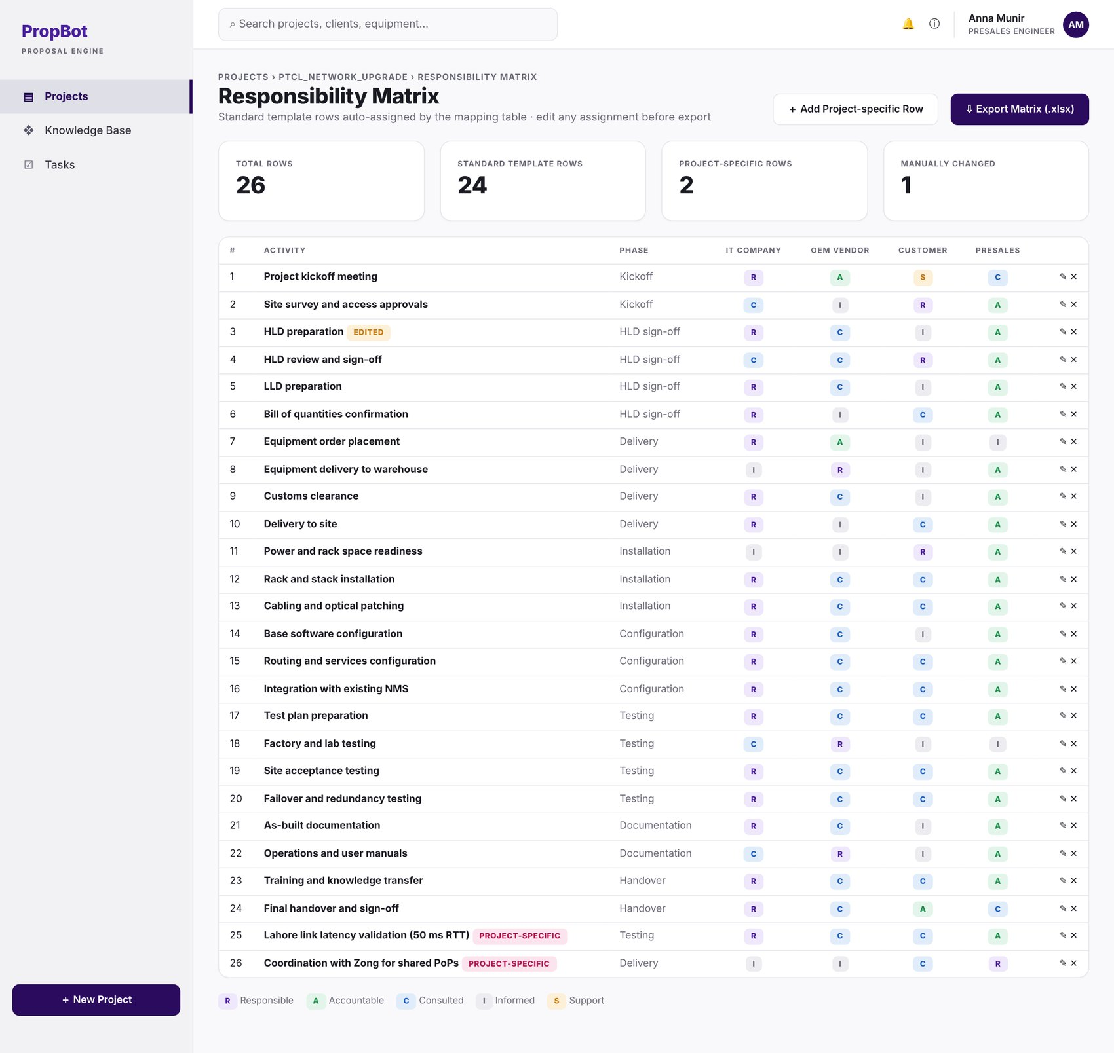
Figure 2.25: W-24 – Responsibility Matrix
Table 2.26: Requirements mapped to screen W-24
Feature (derived from UI) | Functional Requirement (FR-ID: Statement) | Business Rule
Standard Template | FR-8.1: The system shall maintain a pre-loaded standard responsibility matrix template with at least 24 common rows covering kickoff, HLD sign-off, delivery, installation, configuration, testing, documentation, and handover. | Minimum 24 standard rows.
Auto-Assignment | FR-8.2: The system shall auto-assign each row to responsible parties (IT company, OEM vendor, customer, presales) using a rule-based mapping table stored in the database. | —
Row Editing | FR-8.3: The engineer shall be able to add project-specific rows and modify any responsibility assignment before export. | —
Matrix Export | FR-8.4: The system shall export the completed matrix as a formatted .xlsx file using openpyxl. | —

W-25 – Project Vault Dashboard
Application: Web · User role(s): Engineer, Org Admin, Read-only
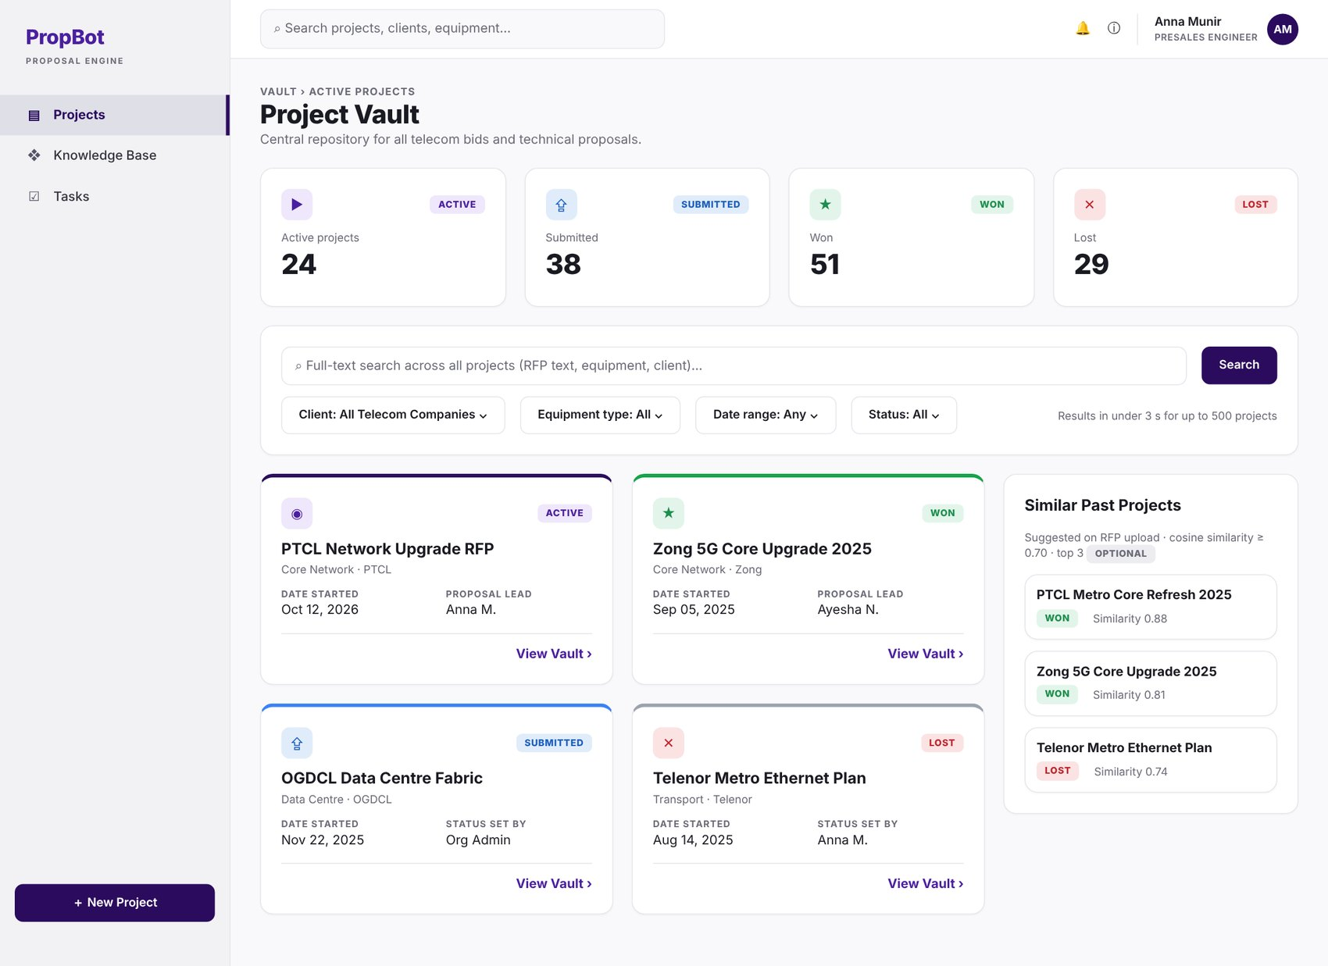
Figure 2.26: W-25 – Project Vault Dashboard
Table 2.27: Requirements mapped to screen W-25
Feature (derived from UI) | Functional Requirement (FR-ID: Statement) | Business Rule
Full-Text Vault Search | FR-9.3: The system shall provide full-text search across all projects using PostgreSQL tsvector/tsquery indexing, filterable by client name, telecom company, date range, equipment type, and project status. | Results returned within 3 seconds (95th percentile) for up to 500 projects (PER-5).
Similar Past Project Suggestion | FR-9.4: The system shall surface similar past projects on new RFP upload using cosine similarity search (threshold ≥ 0.70) on text-embedding-3-small embeddings of past project summaries stored in ChromaDB, surfacing the top-3 results. | Optional enhancement — implemented only if time permits.
Project Status Field | FR-9.6: The system shall maintain a project status field with values active, submitted, won, or lost, updated manually by the engineer or Org Admin. | —

W-26 – Project Vault Folder View
Application: Web · User role(s): Engineer, Org Admin, Read-only
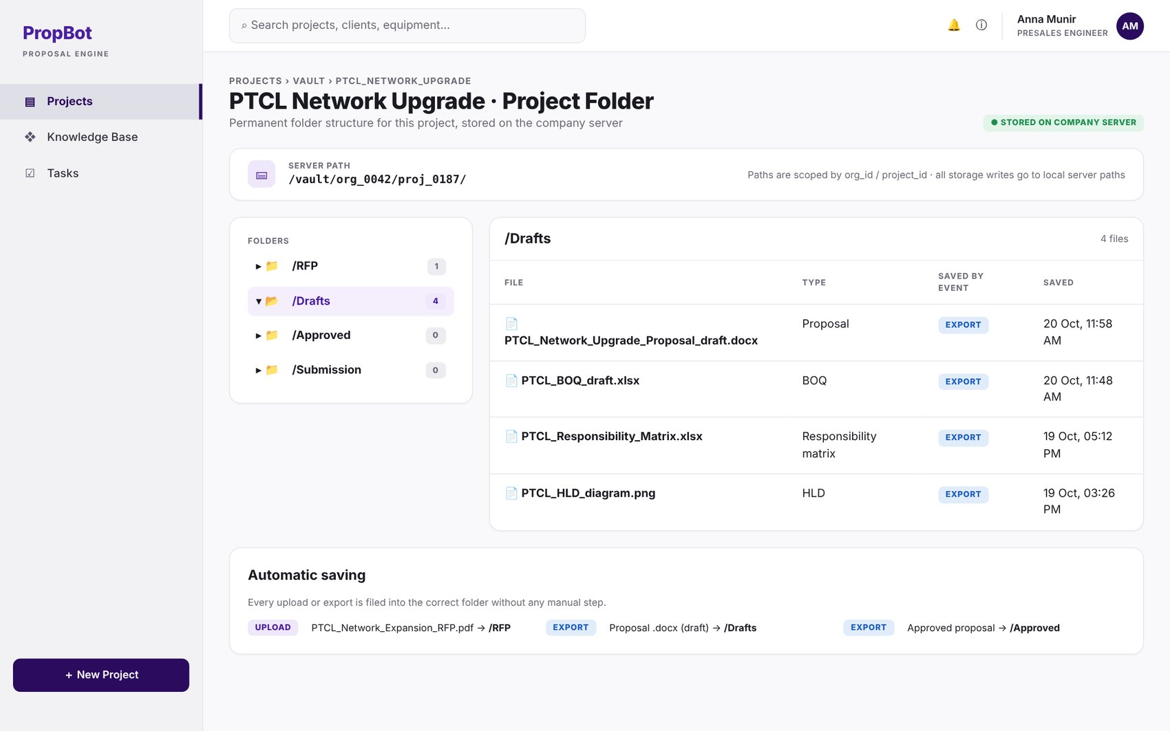
Figure 2.27: W-26 – Project Vault Folder View
Table 2.28: Requirements mapped to screen W-26
Feature (derived from UI) | Functional Requirement (FR-ID: Statement) | Business Rule
Per-Project Folder Structure | FR-9.1: The system shall maintain a permanent per-project folder structure on the company server (/RFP, /Drafts, /Approved, /Submission), with paths scoped by org_id/project_id. | —
Automatic Vault Saving | FR-9.2: The system shall automatically save all generated and uploaded documents to the correct vault folder on every export or upload event. | —
On-Premise Storage | FR-9.5: The system shall direct all file writes to local server paths for storage operations, with no external API calls for storage. | Applies to storage only; AI processing calls remain external (see LI-8).

W-27 – Requirement Traceability View
Application: Web · User role(s): Engineer, Org Admin
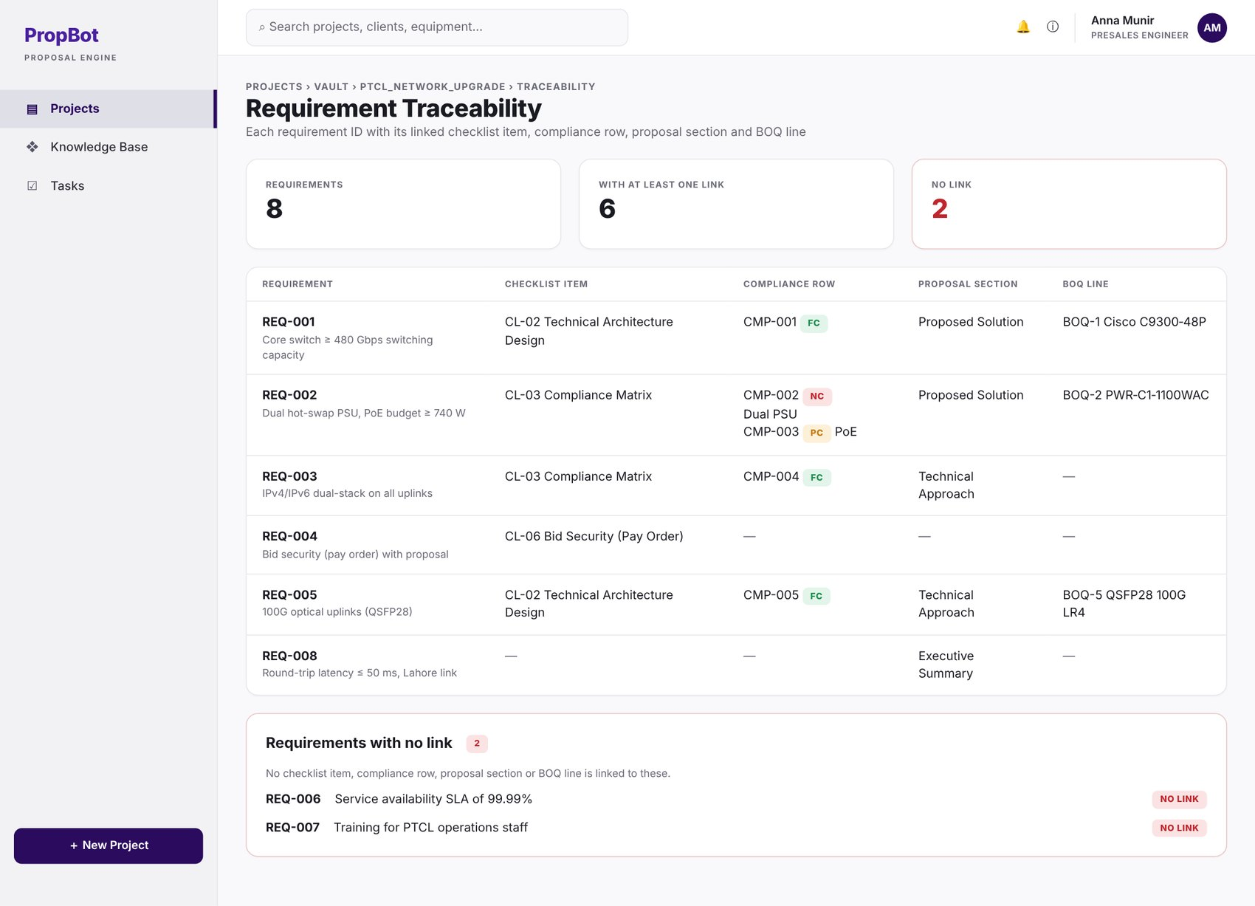
Figure 2.28: W-27 – Requirement Traceability View
Table 2.29: Requirements mapped to screen W-27
Feature (derived from UI) | Functional Requirement (FR-ID: Statement) | Business Rule
Requirement Traceability View | FR-9.7: The system shall provide a traceability view showing, for each requirement ID, its linked checklist item, compliance row, proposal section and BOQ line, together with a list of requirements that have no link. | —

W-28 – Submission Package Builder
Application: Web · User role(s): Engineer
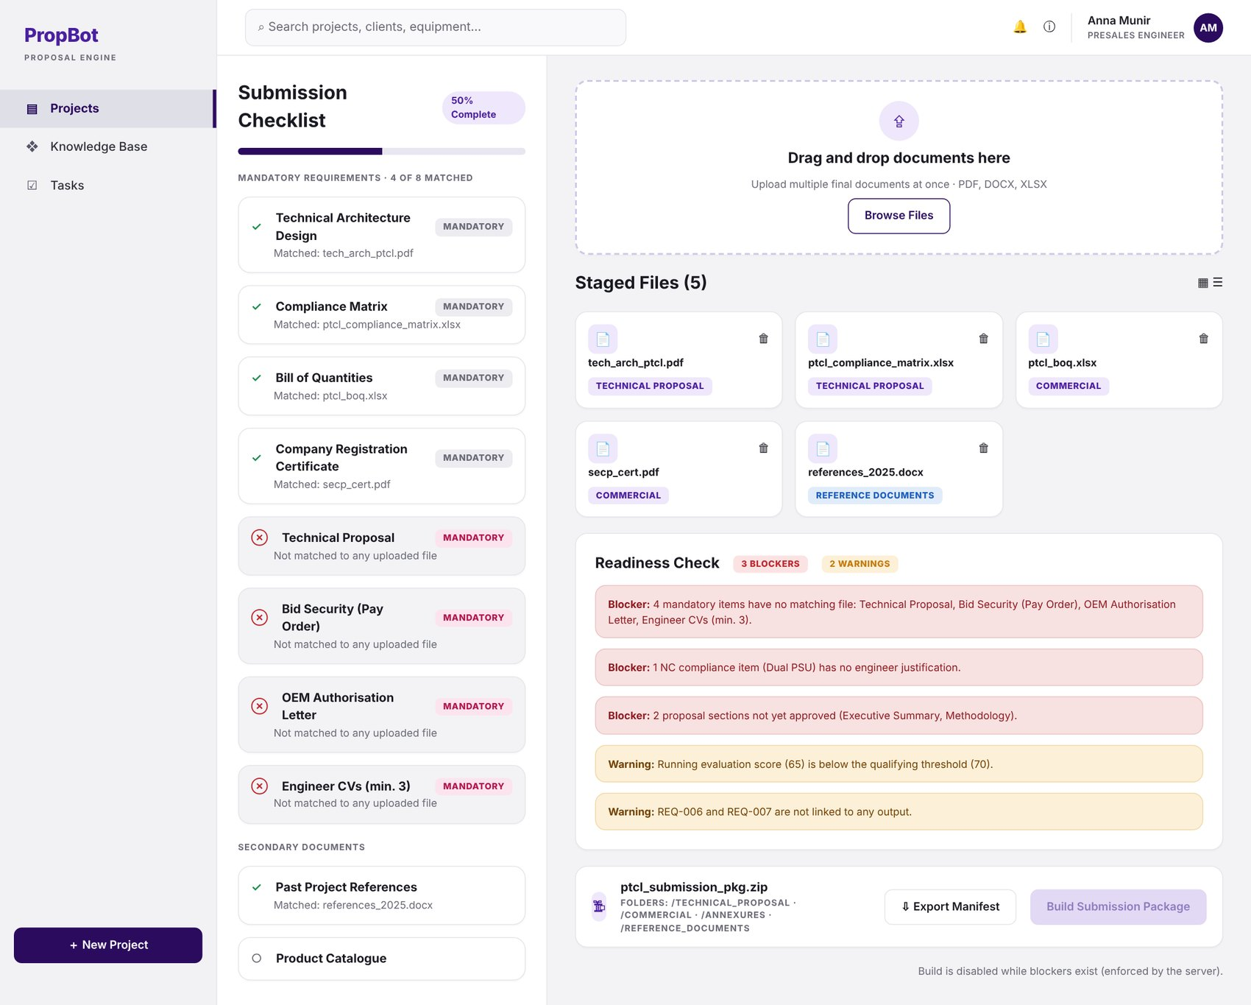
Figure 2.29: W-28 – Submission Package Builder
Table 2.30: Requirements mapped to screen W-28
Feature (derived from UI) | Functional Requirement (FR-ID: Statement) | Business Rule
Multi-File Upload | FR-10.1: The system shall provide a multi-file upload interface for engineers to add all final submission documents to the project submission area. | —
Cross-Checking Against Checklist | FR-10.2: The system shall cross-check uploaded files against the Module 2 mandatory checklist using filename normalisation and document-type classification via GPT-4o-mini, marking matched items as fulfilled automatically. | —
Blocking Error List | FR-10.3: The system shall display a blocking error list for any unfulfilled mandatory checklist items before packaging is allowed. | —
ZIP Package Generation | FR-10.4: The system shall generate a ZIP archive using the Python zipfile module with the standard folder structure /Technical_Proposal, /Commercial, /Annexures, /Reference_Documents. | —
Readiness Check | FR-10.7: The system shall run a readiness check before packaging and display the blocker and warning list. | Blockers (prevent packaging): unfulfilled mandatory checklist items; NC items without justification; unapproved proposal sections. Warnings (shown, non-blocking): running score below qualifying threshold; requirements not linked to any output.

W-29 – Package Built & Submission Summary
Application: Web · User role(s): Engineer
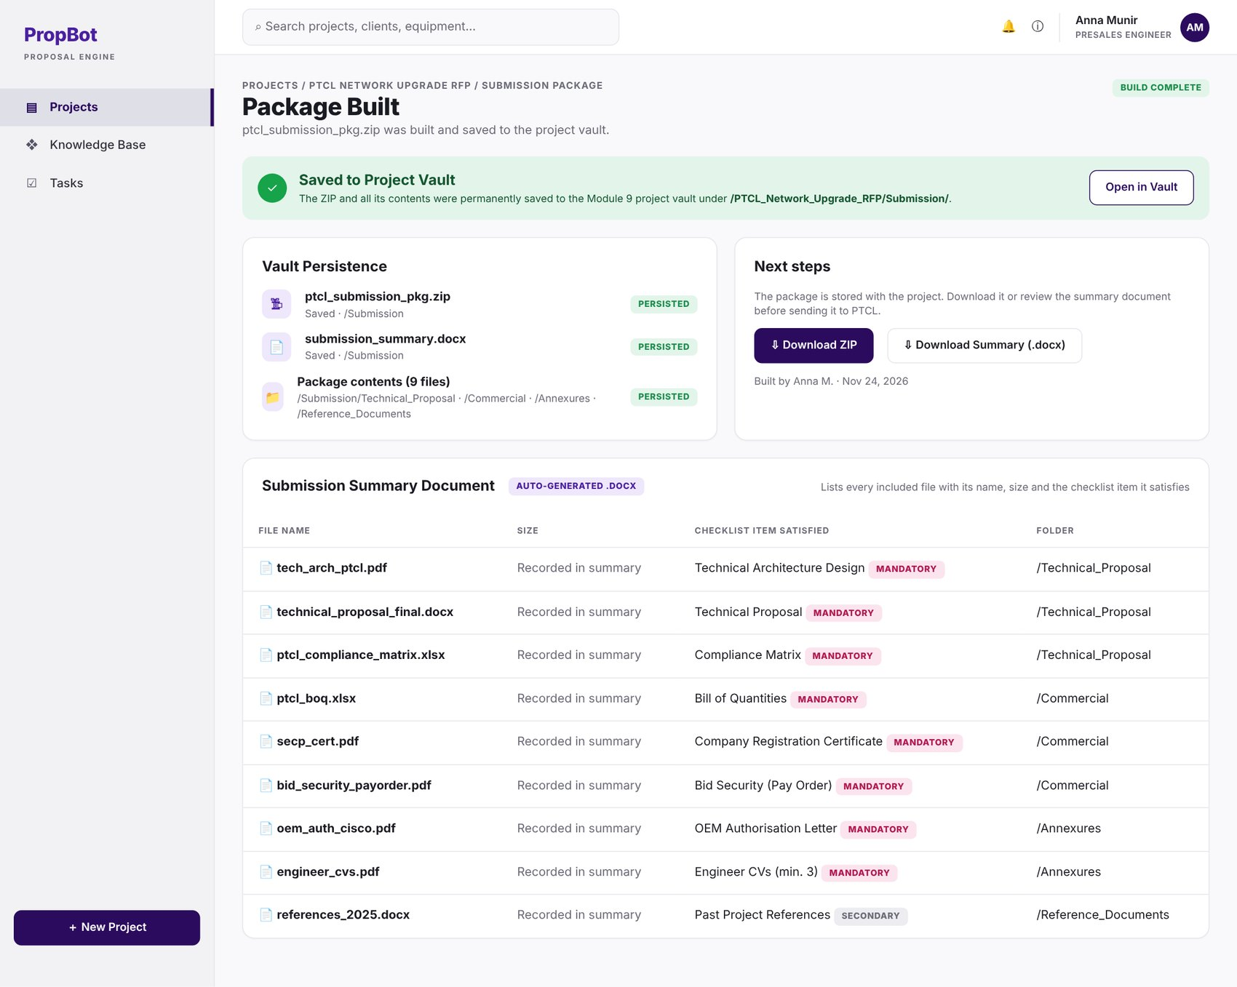
Figure 2.30: W-29 – Package Built & Submission Summary
Table 2.31: Requirements mapped to screen W-29
Feature (derived from UI) | Functional Requirement (FR-ID: Statement) | Business Rule
Vault Persistence | FR-10.5: The system shall permanently save the ZIP and all contents to the Module 9 project vault under the /Submission folder. | —
Submission Summary Document | FR-10.6: The system shall auto-generate a submission summary .docx listing every included file with its name, size, and the checklist item it satisfies. | —

W-30 – Knowledge Base Management
Application: Web · User role(s): Engineer, Org Admin
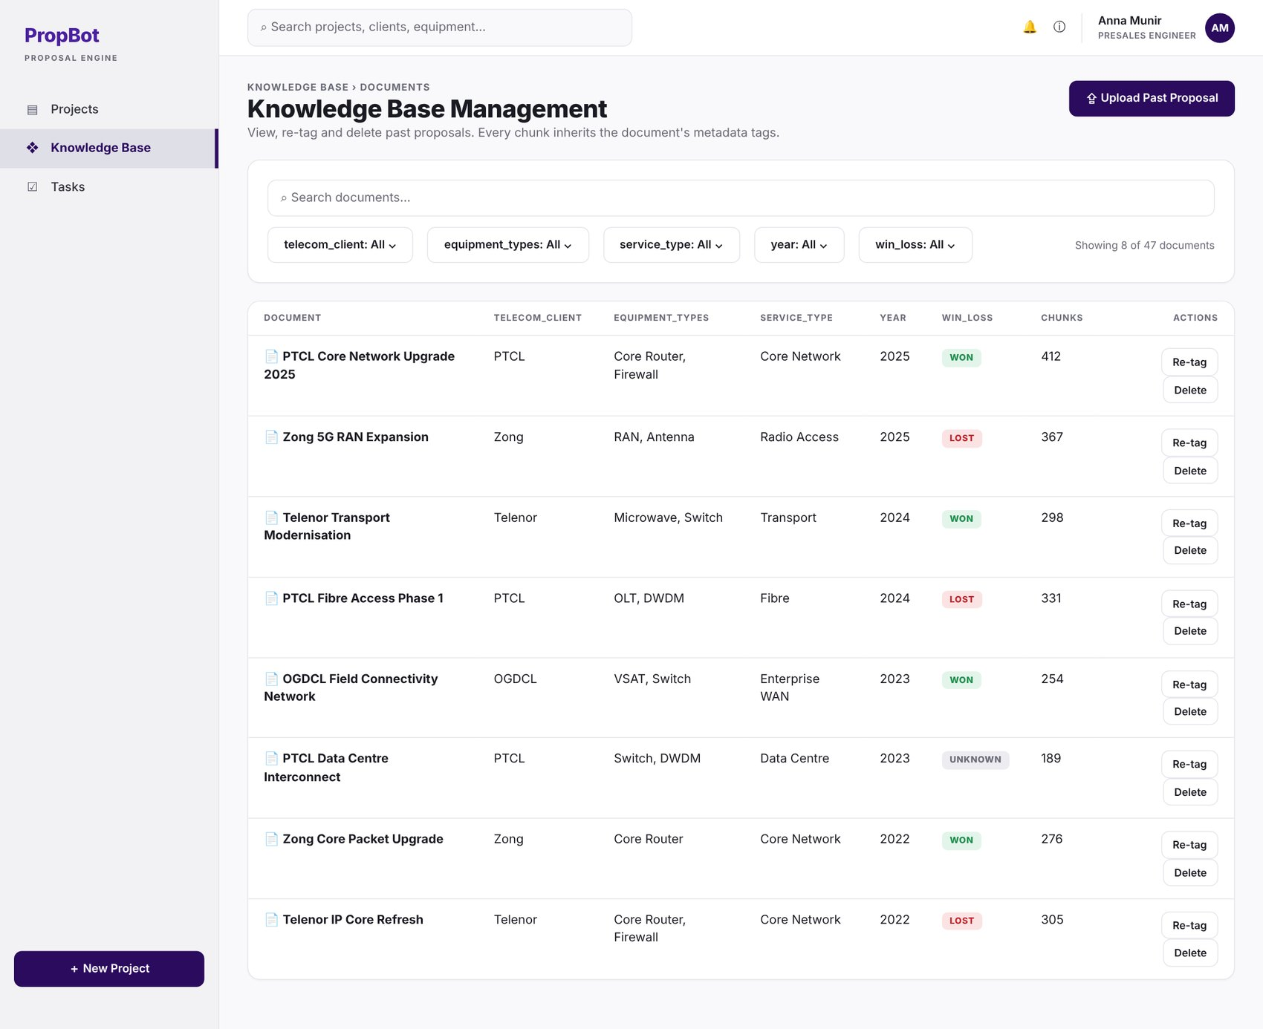
Figure 2.31: W-30 – Knowledge Base Management
Table 2.32: Requirements mapped to screen W-30
Feature (derived from UI) | Functional Requirement (FR-ID: Statement) | Business Rule
Metadata Tagging | FR-11.2: The system shall tag each ingested chunk with metadata: telecom_client, equipment_types, service_type, year, and win_loss. | —
Admin Knowledge-Base Management | FR-11.5: The Org Admin shall be able to view, re-tag, and delete knowledge base documents via the admin panel. | —

W-31 – Upload Past Proposal & Tag
Application: Web · User role(s): Engineer, Org Admin
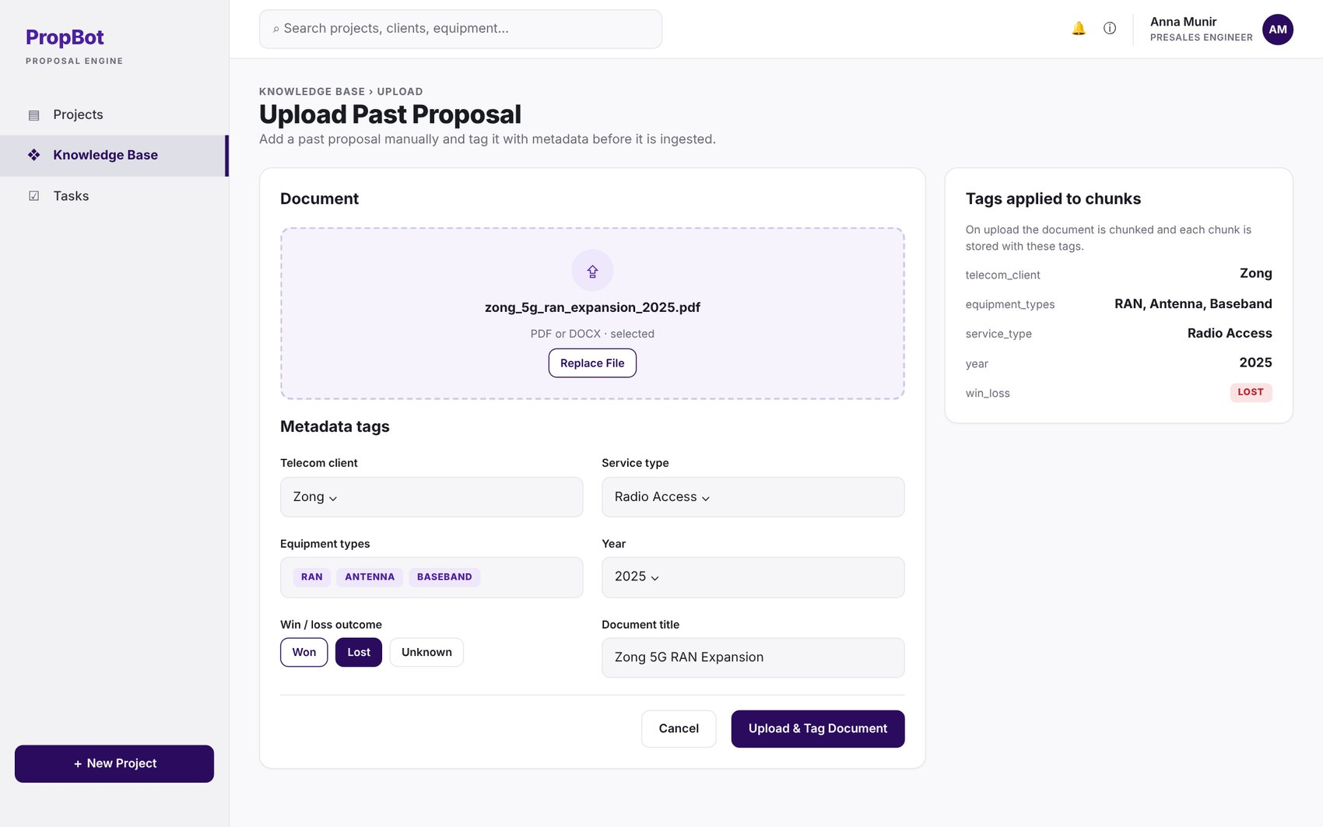
Figure 2.32: W-31 – Upload Past Proposal & Tag
Table 2.33: Requirements mapped to screen W-31
Feature (derived from UI) | Functional Requirement (FR-ID: Statement) | Business Rule
Manual Upload & Tagging | FR-11.4: The engineer shall be able to manually upload past proposals with manual metadata tagging via an upload form. | —

W-32 – Knowledge Base Ingestion Status (incl. win/loss boost)
Application: Web · User role(s): Org Admin
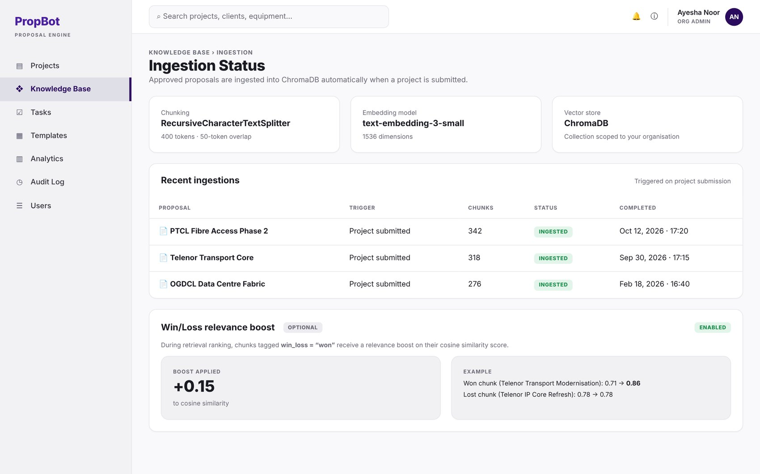
Figure 2.33: W-32 – Knowledge Base Ingestion Status (incl. win/loss boost)
Table 2.34: Requirements mapped to screen W-32
Feature (derived from UI) | Functional Requirement (FR-ID: Statement) | Business Rule
Automatic Ingestion | FR-11.1: The system shall automatically ingest the approved proposal into ChromaDB when the project status is changed to “submitted” (FR-9.6), chunked using RecursiveCharacterTextSplitter (400 tokens, 50-token overlap) and embedded using text-embedding-3-small (1536 dimensions). | —
Win/Loss Relevance Boost | FR-11.3: The system shall apply a relevance boost of +0.15 to cosine similarity scores of chunks tagged win_loss = “won” during Module 6 retrieval ranking. | Optional enhancement — implemented only if time permits.

W-33 – Knowledge Base Coverage Dashboard
Application: Web · User role(s): Org Admin
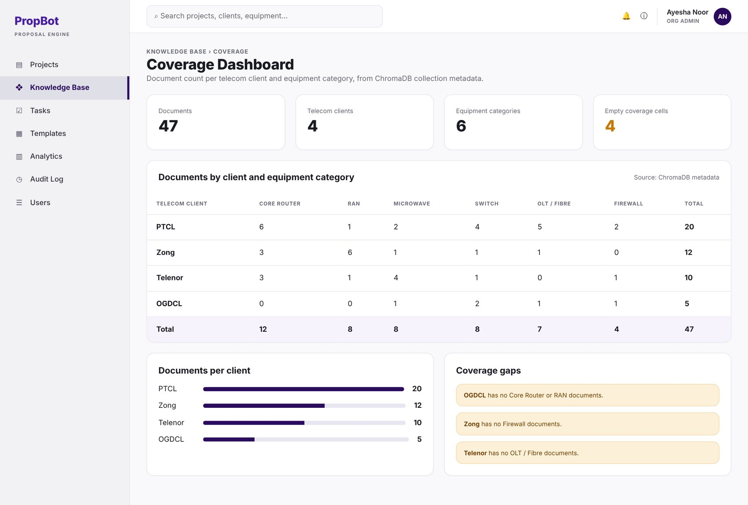
Figure 2.34: W-33 – Knowledge Base Coverage Dashboard
Table 2.35: Requirements mapped to screen W-33
Feature (derived from UI) | Functional Requirement (FR-ID: Statement) | Business Rule
Coverage Dashboard | FR-11.6: The system shall show a knowledge base coverage dashboard with document count per telecom client and equipment category, queried from ChromaDB collection metadata. | —

W-34 – Organisations List
Application: Web · User role(s): Super Admin
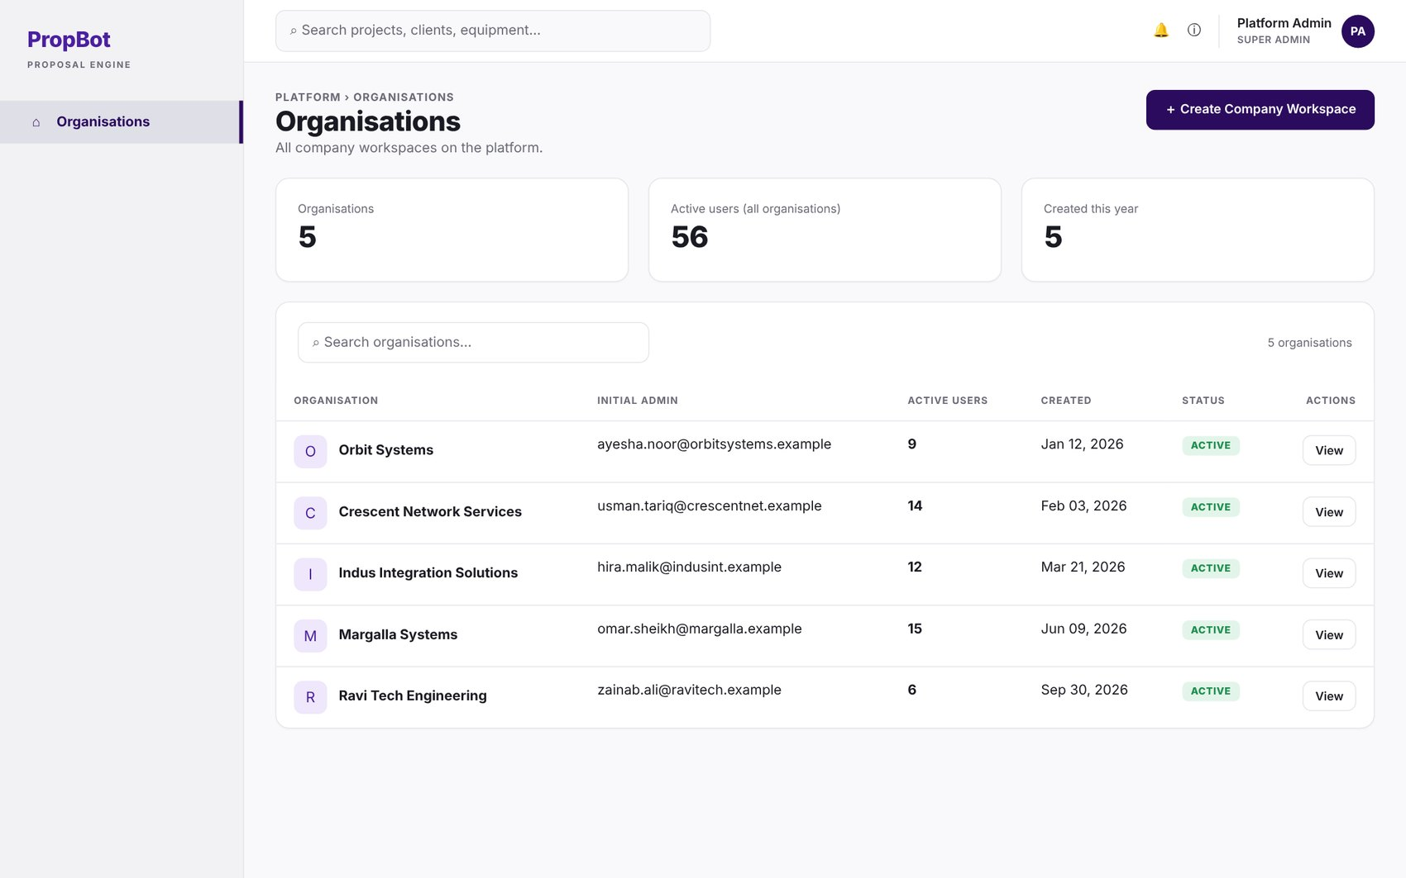
Figure 2.35: W-34 – Organisations List
Table 2.36: Requirements mapped to screen W-34
Feature (derived from UI) | Functional Requirement (FR-ID: Statement) | Business Rule
Organisation Listing | FR-12.3: The super admin shall view a list of all organisations with active user count. | —

W-35 – Create Company Workspace
Application: Web · User role(s): Super Admin
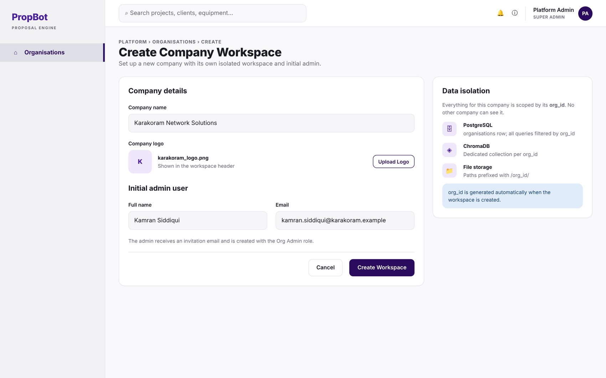
Figure 2.36: W-35 – Create Company Workspace
Table 2.37: Requirements mapped to screen W-35
Feature (derived from UI) | Functional Requirement (FR-ID: Statement) | Business Rule
Company Workspace Creation | FR-12.1: The super admin shall create company workspaces with name, logo, and initial admin user, stored as an organisations table row in PostgreSQL. | —
Multi-Tenant Data Isolation | FR-12.2: All database queries, ChromaDB collections, and file storage paths shall be scoped by org_id to ensure complete data isolation between companies. | —

W-36 – User Management
Application: Web · User role(s): Org Admin
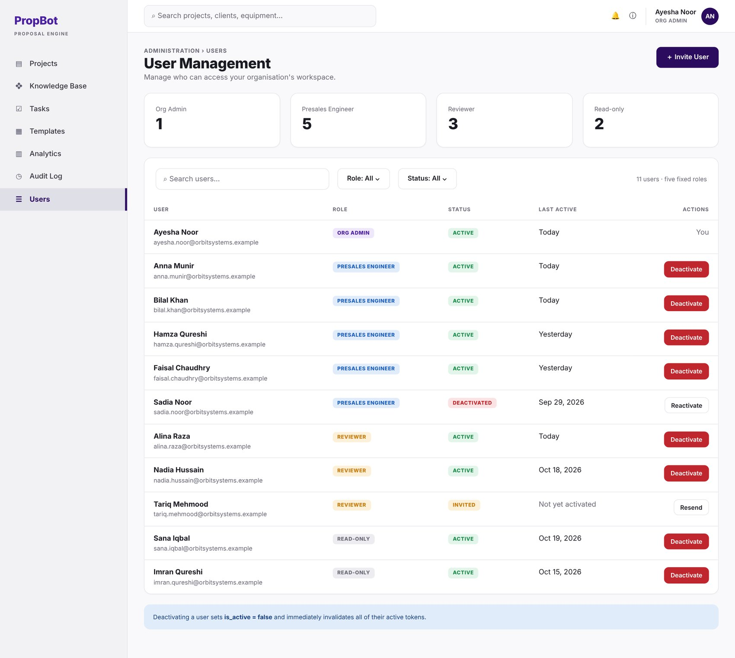
Figure 2.37: W-36 – User Management
Table 2.38: Requirements mapped to screen W-36
Feature (derived from UI) | Functional Requirement (FR-ID: Statement) | Business Rule
Role-Based Access Control | FR-13.1: The system shall support five roles — Super Admin, Org Admin, Presales Engineer, Reviewer, Read-only — enforced through a role-based access control (RBAC) middleware layer in FastAPI. | Exactly five fixed roles.
Account Deactivation | FR-13.5: The Org Admin shall be able to deactivate user accounts, immediately setting is_active = false and incrementing the user's token version, so that every previously issued token is rejected on its next use. | Takes effect on the next request; no token survives deactivation (FR-13.4).

W-37 – Invite User Modal
Application: Web · User role(s): Org Admin
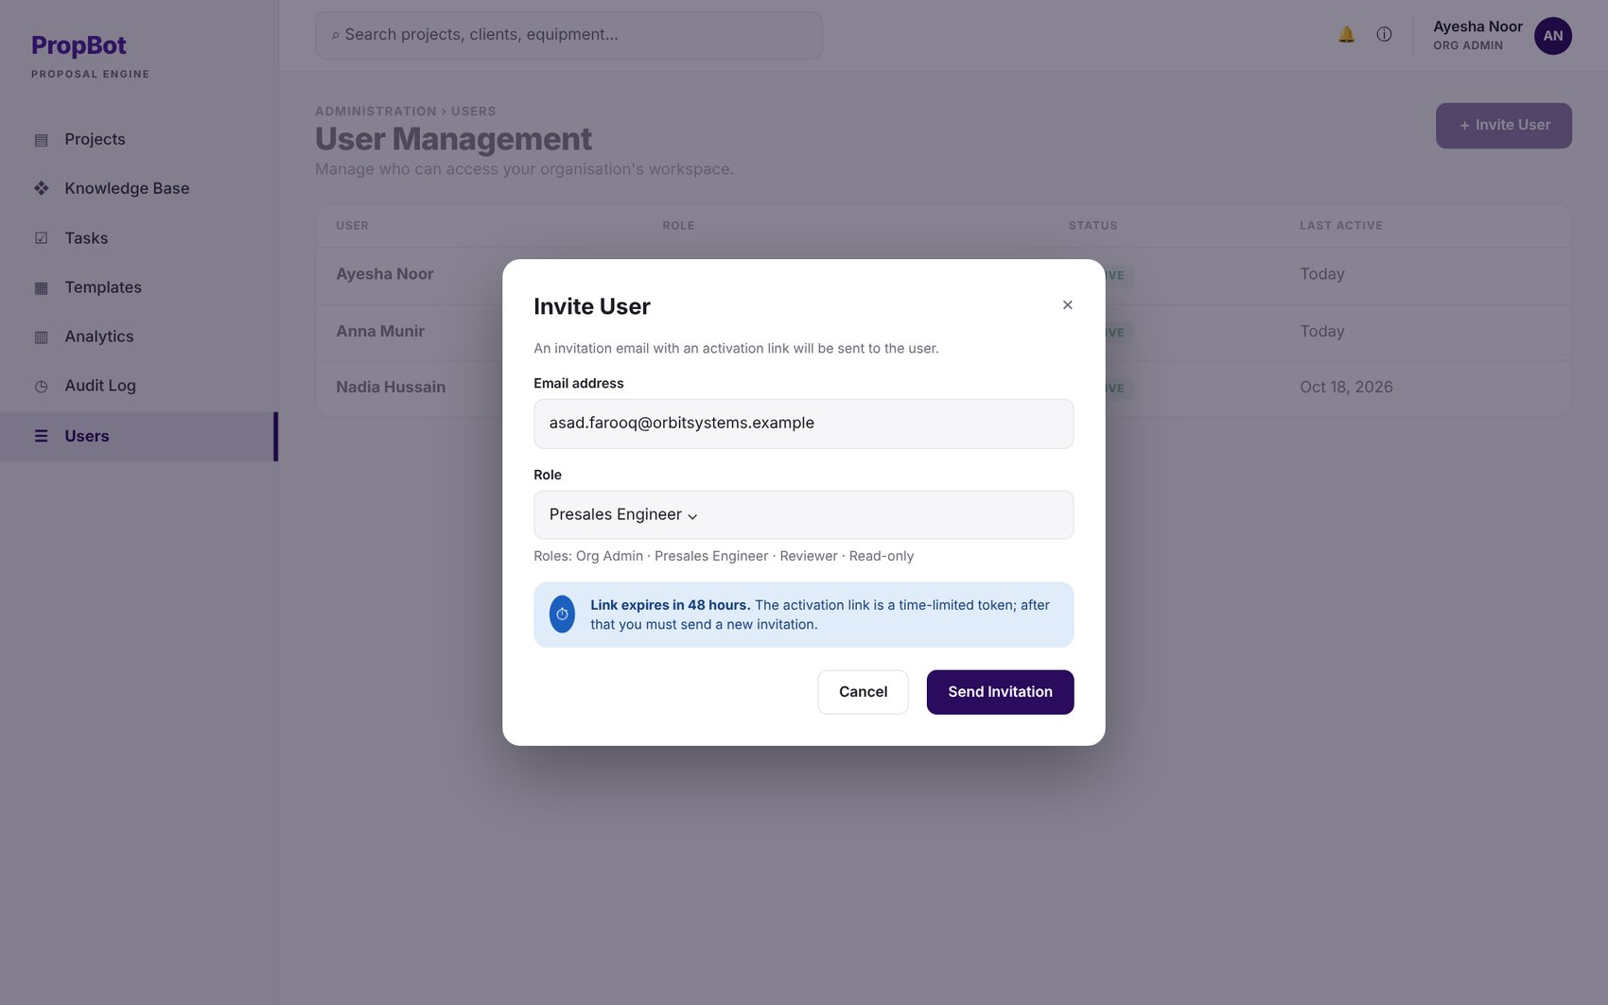
Figure 2.38: W-37 – Invite User Modal
Table 2.39: Requirements mapped to screen W-37
Feature (derived from UI) | Functional Requirement (FR-ID: Statement) | Business Rule
User Invitation | FR-13.2: The Org Admin shall invite users by email; the invitation shall generate a time-limited JWT token (expiry: 48 hours) for account activation. | Invitation token expires after 48 hours.

W-38 – Deactivate User Confirmation
Application: Web · User role(s): Org Admin
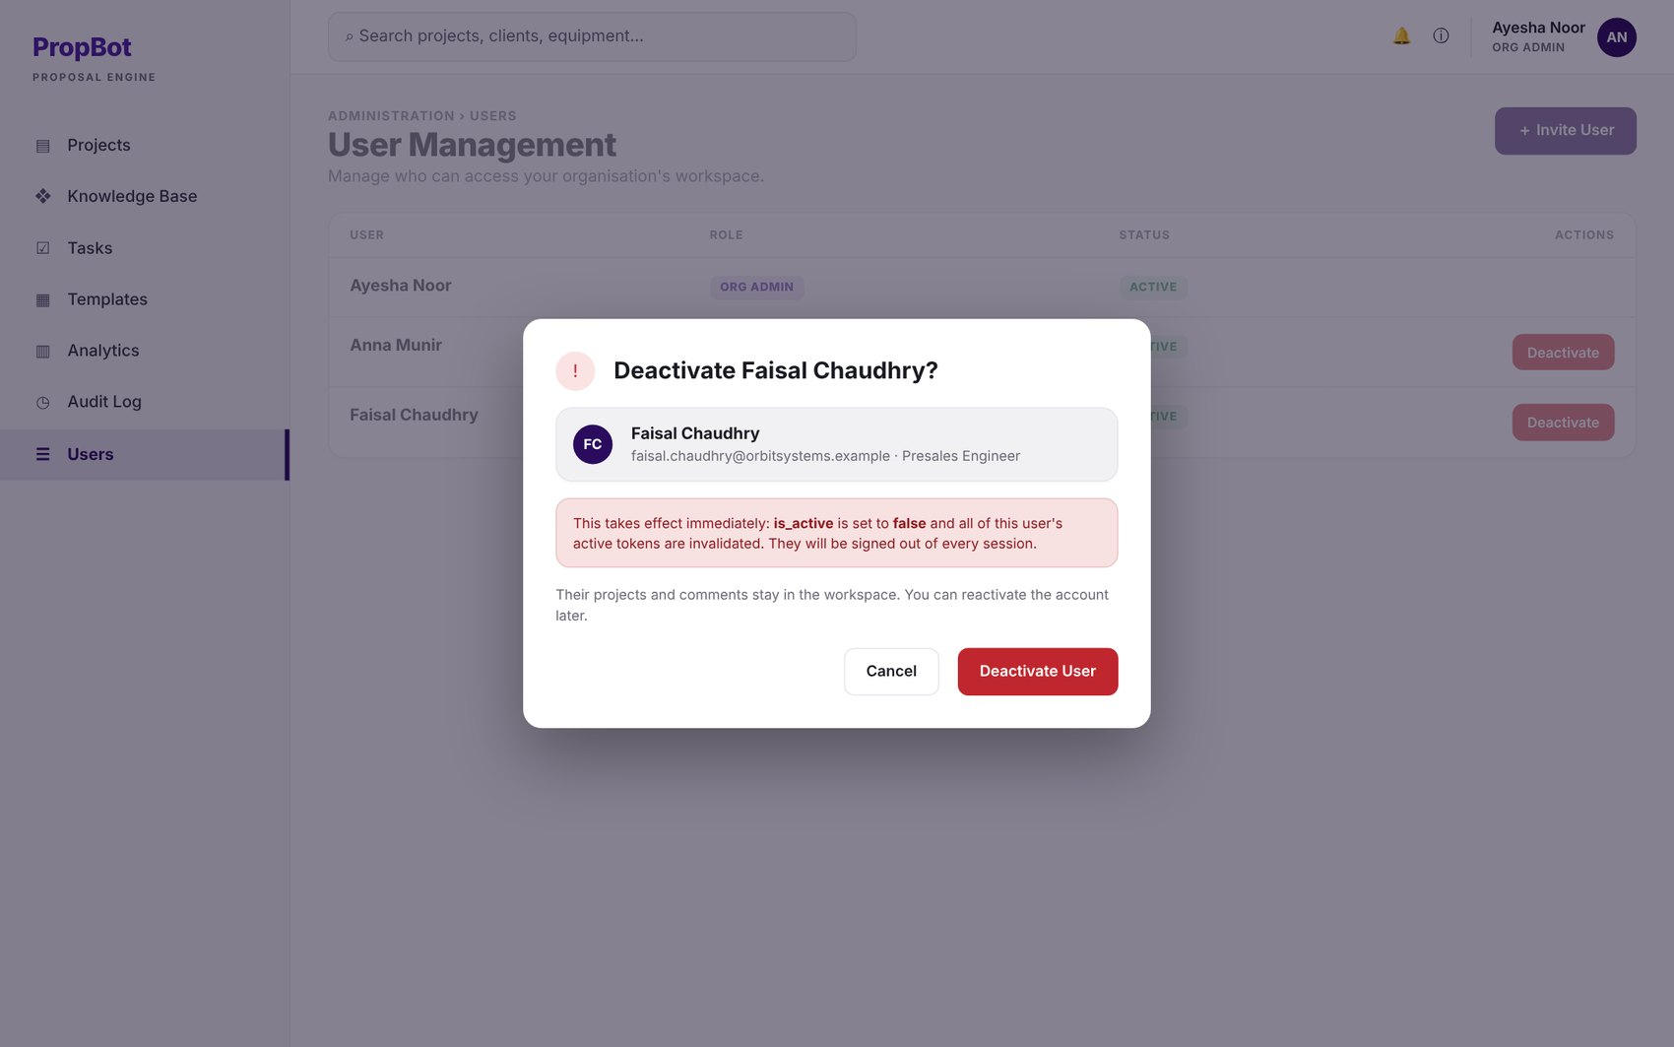
Figure 2.39: W-38 – Deactivate User Confirmation
Table 2.40: Requirements mapped to screen W-38
Feature (derived from UI) | Functional Requirement (FR-ID: Statement) | Business Rule
Account Deactivation | FR-13.5: The Org Admin shall be able to deactivate user accounts, immediately setting is_active = false and incrementing the user's token version, so that every previously issued token is rejected on its next use. | Takes effect on the next request; no token survives deactivation (FR-13.4).

W-39 – BOQ Template Library
Application: Web · User role(s): Org Admin
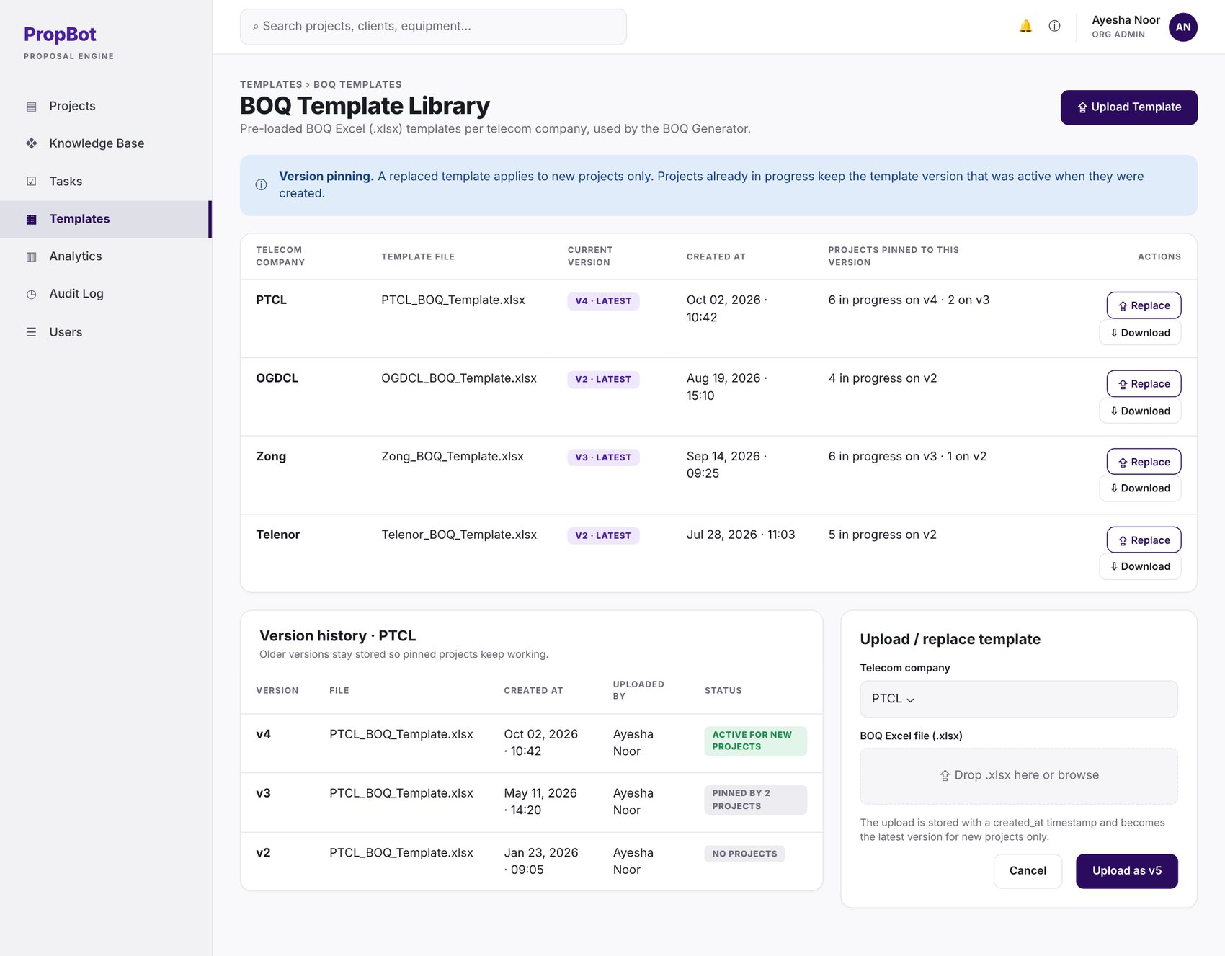
Figure 2.40: W-39 – BOQ Template Library
Table 2.41: Requirements mapped to screen W-39
Feature (derived from UI) | Functional Requirement (FR-ID: Statement) | Business Rule
BOQ Template Library | FR-7.1: The system shall maintain a library of pre-loaded BOQ Excel templates per telecom company (PTCL, OGDCL, Zong, Telenor), stored as .xlsx files managed through Module 14. | —
BOQ Template Upload | FR-14.1: The Org Admin shall upload and replace BOQ Excel templates per telecom company; each uploaded template shall be stored as a new version with a created_at timestamp. | The most recently uploaded version for each telecom company is the active template for new projects; earlier versions are kept for projects pinned to them (FR-14.3).
Version Pinning | FR-14.3: Template updates shall apply only to new projects; documents already in progress shall retain the template version active at their creation time. | —

W-40 – Responsibility Matrix Template Editor
Application: Web · User role(s): Org Admin
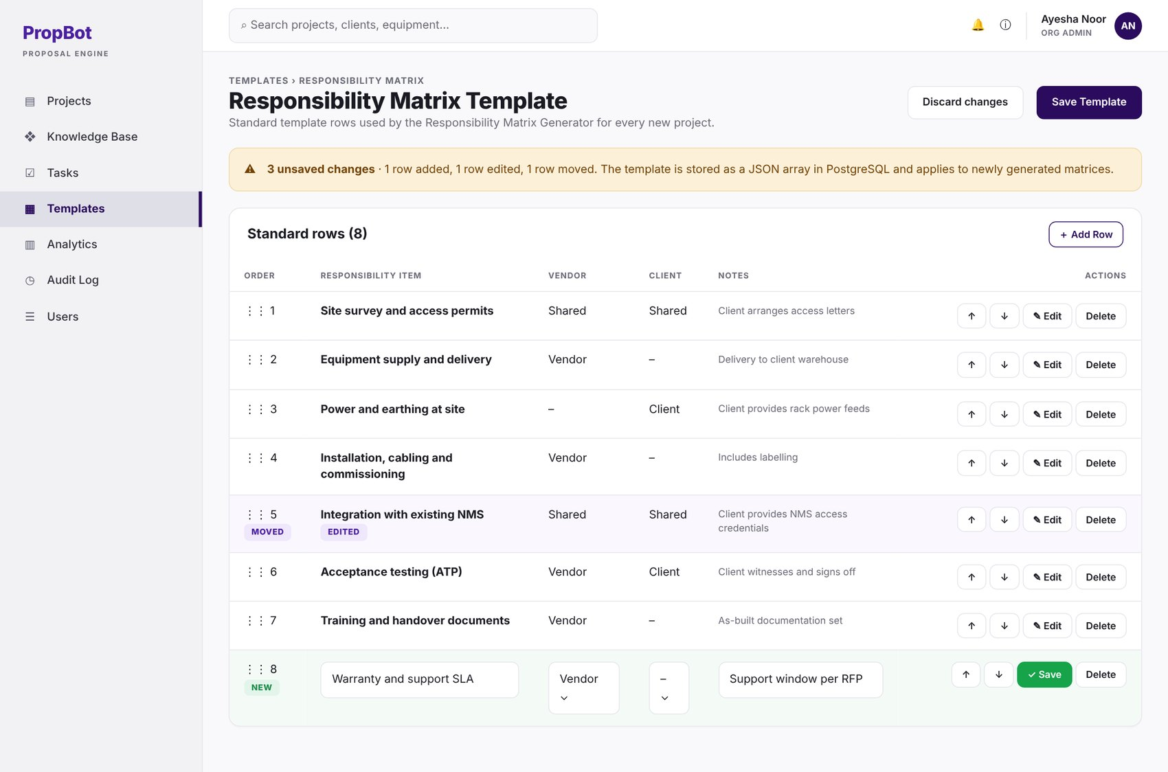
Figure 2.41: W-40 – Responsibility Matrix Template Editor
Table 2.42: Requirements mapped to screen W-40
Feature (derived from UI) | Functional Requirement (FR-ID: Statement) | Business Rule
Template Maintenance | FR-8.5: The Org Admin shall be able to update the standard template rows through Module 14. | —
Responsibility Matrix Template Editing | FR-14.2: The Org Admin shall add, edit, reorder, and delete rows in the responsibility matrix standard template, stored as a JSON array in PostgreSQL. | —

W-41 – Audit Log
Application: Web · User role(s): Org Admin
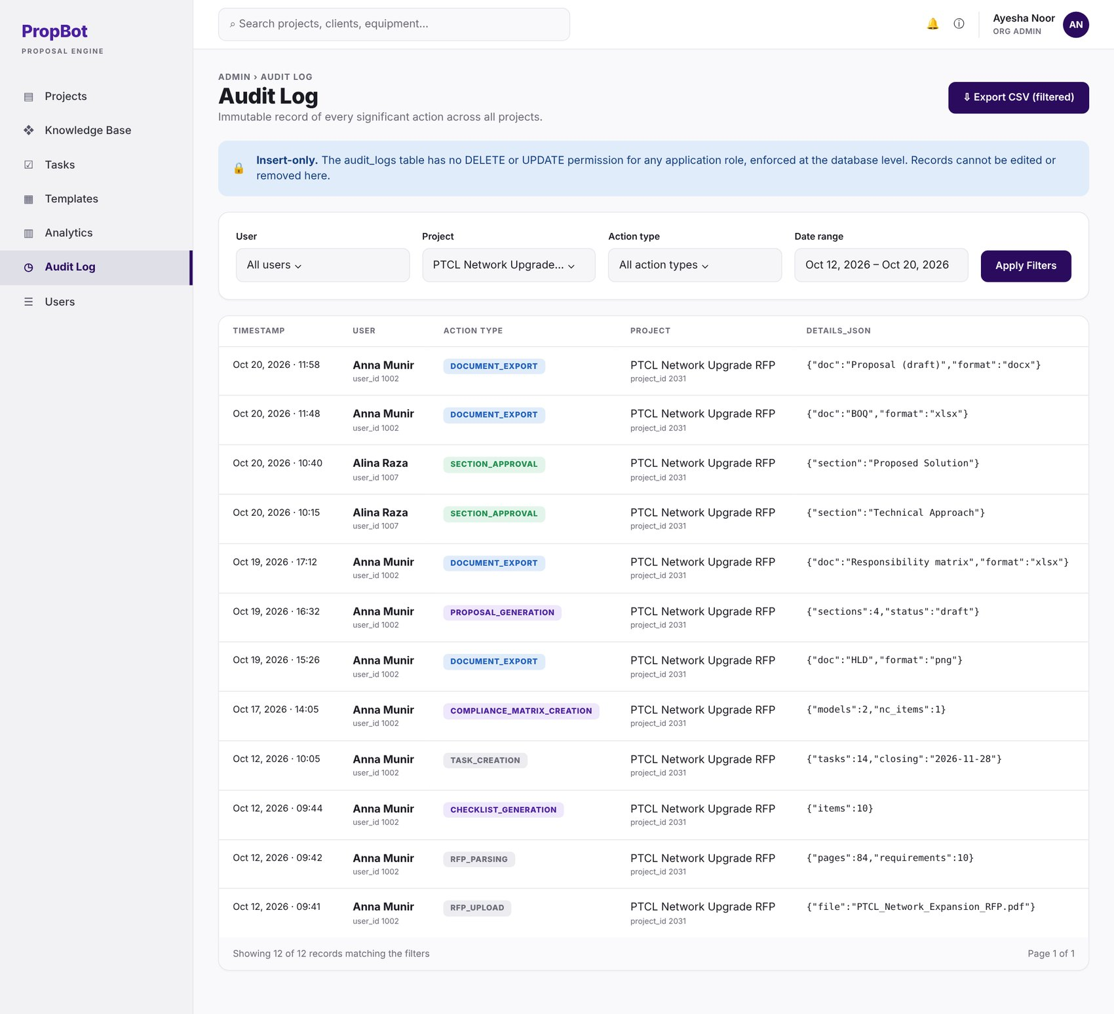
Figure 2.42: W-41 – Audit Log
Table 2.43: Requirements mapped to screen W-41
Feature (derived from UI) | Functional Requirement (FR-ID: Statement) | Business Rule
Immutable Audit Record | FR-15.1: The system shall write an immutable audit record to a dedicated audit_logs table for every significant action: RFP upload, parsing, checklist generation, compliance matrix creation, proposal generation, section approval, document export, and submission package build. | —
Audit Record Fields | FR-15.2: Each audit record shall contain user_id, user_name, action_type, project_id, project_name, timestamp, and details_json. | —
Audit Log Filtering | FR-15.3: The Org Admin shall be able to filter the audit log by user, project, action type, and date range via the admin dashboard. | —
Insert-Only Enforcement | FR-15.4: The audit_logs table shall have no DELETE or UPDATE permissions granted to any application role, enforced at the database level. | Insert-only access, enforced at the database level.
CSV Export | FR-15.5: The Org Admin shall be able to export the filtered audit log as a CSV file. | —

W-42 – Project Timeline
Application: Web · User role(s): Org Admin, Engineer
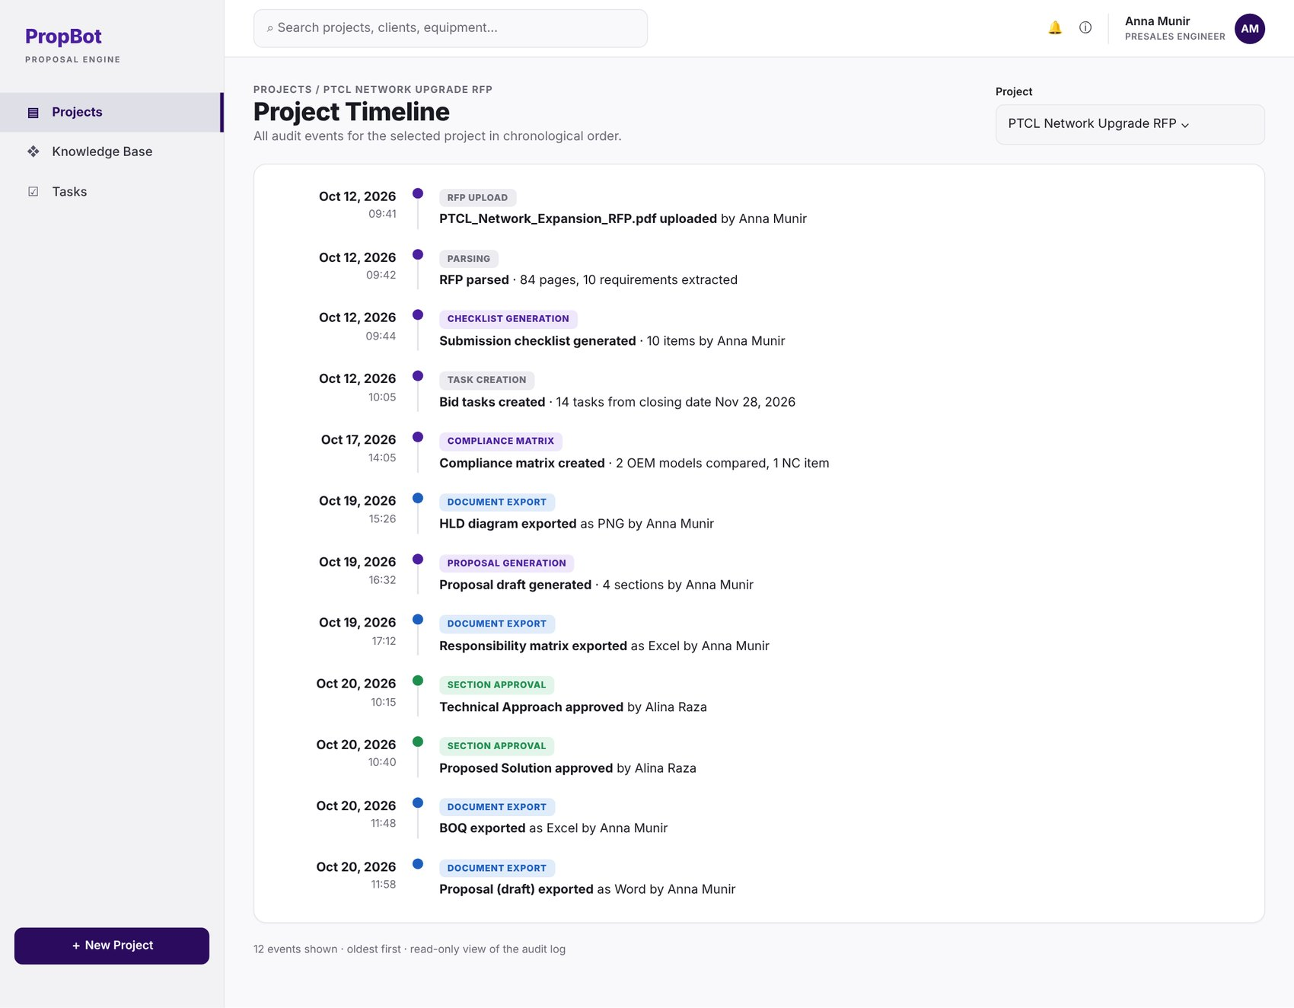
Figure 2.43: W-42 – Project Timeline
Table 2.44: Requirements mapped to screen W-42
Feature (derived from UI) | Functional Requirement (FR-ID: Statement) | Business Rule
Project Timeline View | FR-15.6: The system shall render a project timeline view showing all audit events for a selected project in chronological order. | —

W-43 – Analytics Dashboard
Application: Web · User role(s): Org Admin
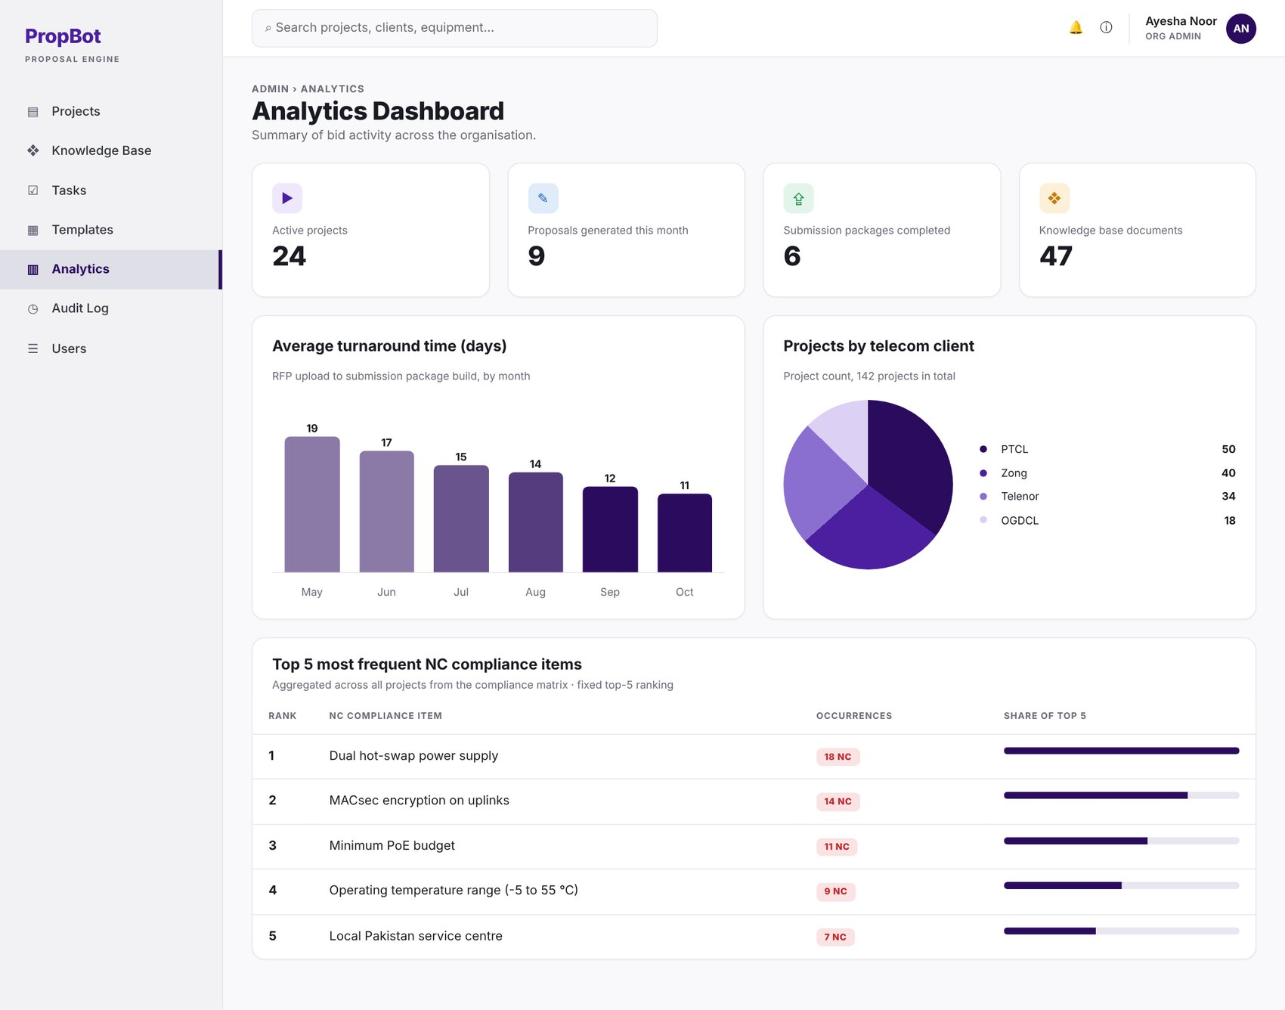
Figure 2.44: W-43 – Analytics Dashboard
Table 2.45: Requirements mapped to screen W-43
Feature (derived from UI) | Functional Requirement (FR-ID: Statement) | Business Rule
Summary Metrics | FR-16.1: The dashboard shall display summary metrics — active projects, proposals generated this month, submission packages completed, and total knowledge base document count — queried from PostgreSQL aggregations. | —
Turnaround Time Chart | FR-16.2: The dashboard shall display average project turnaround time (RFP upload timestamp to submission package build timestamp) as a monthly bar chart rendered using Recharts. | —
Client Breakdown Chart | FR-16.3: The dashboard shall display a pie chart of project count broken down by telecom client. | —
Top NC Items | FR-16.4: The dashboard shall display the top-5 most frequently occurring NC compliance items across all projects, aggregated from the compliance_matrix table. | Fixed top-5 ranking.

W-44 – Bid Tasks & Deadlines
Application: Web · User role(s): Engineer, Org Admin
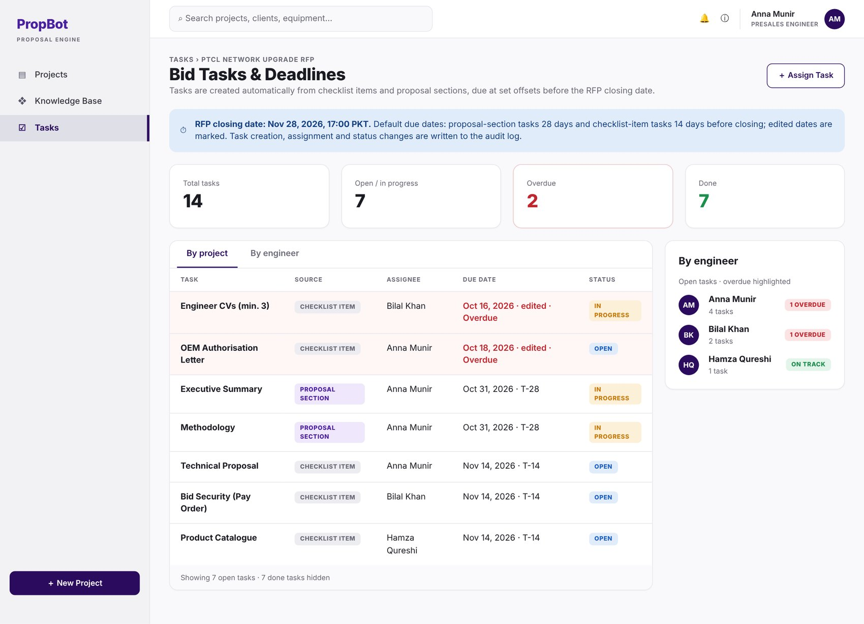
Figure 2.45: W-44 – Bid Tasks & Deadlines
Table 2.46: Requirements mapped to screen W-44
Feature (derived from UI) | Functional Requirement (FR-ID: Statement) | Business Rule
Automatic Task Creation | FR-17.1: The system shall automatically create tasks from checklist items and proposal sections, with due dates set at predefined offsets before the RFP closing date (FR-1.9). | Default offsets: proposal-section tasks are due 28 days and checklist-item tasks 14 days before the closing date; if a computed due date has already passed when the task is created, it is set to the midpoint between the creation date and the closing date; any due date can be edited (FR-17.2).
Task Views | FR-17.3: The system shall display tasks per project and per engineer, with overdue tasks highlighted. | —
Task Audit Logging | FR-17.5: Task creation, assignment and status changes shall be written to the audit log (Module 15). | —

W-45 – Assign / Edit Task Modal
Application: Web · User role(s): Engineer, Org Admin
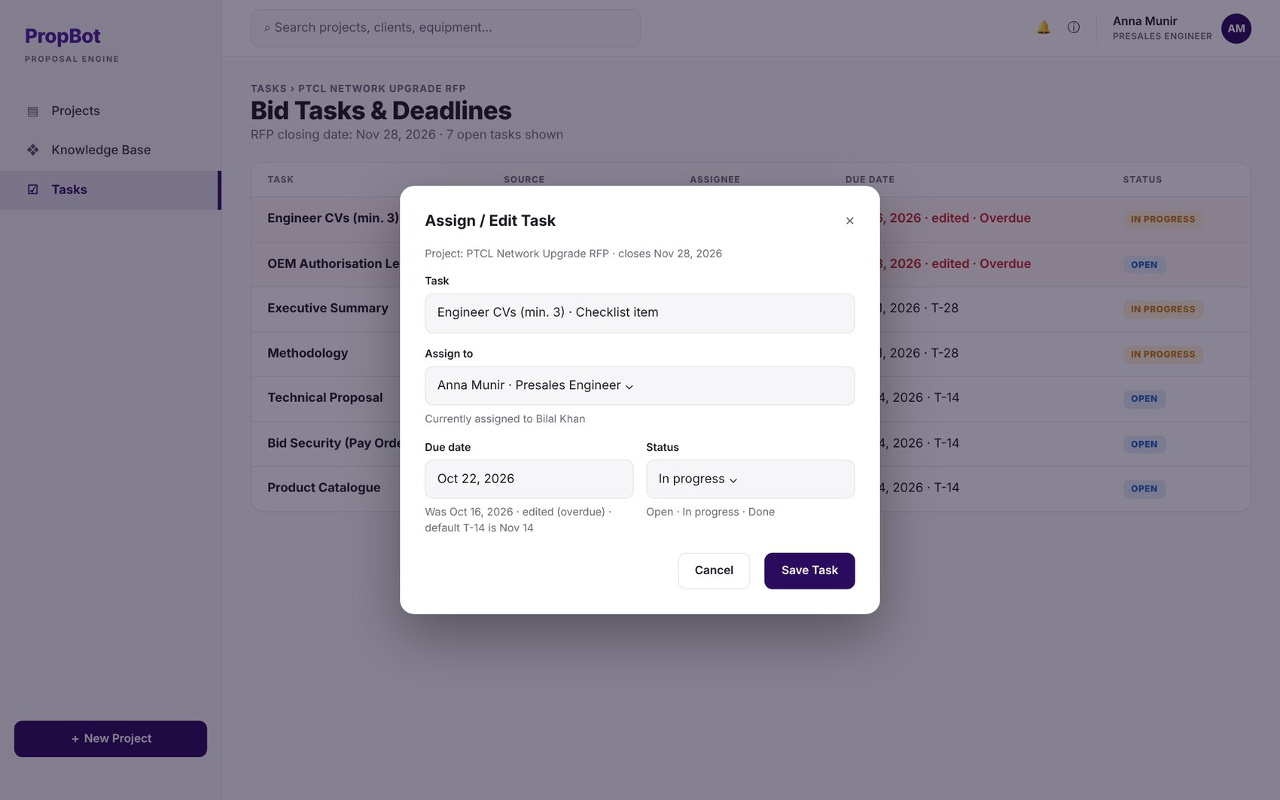
Figure 2.46: W-45 – Assign / Edit Task Modal
Table 2.47: Requirements mapped to screen W-45
Feature (derived from UI) | Functional Requirement (FR-ID: Statement) | Business Rule
Manual Task Assignment | FR-17.2: The engineer or Org Admin shall be able to assign tasks manually to users and edit task due dates and status. | —

W-46 – Notifications & Alerts Center
Application: Web · User role(s): All
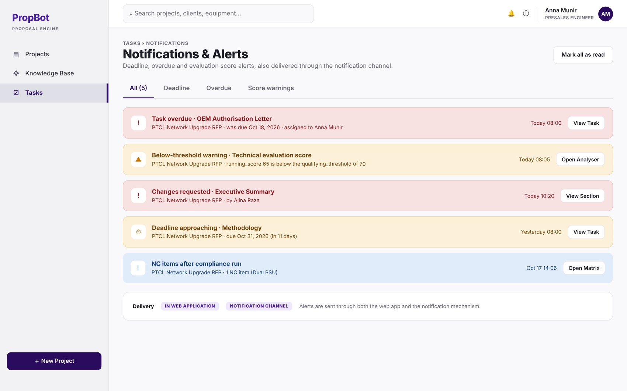
Figure 2.47: W-46 – Notifications & Alerts Center
Table 2.48: Requirements mapped to screen W-46
Feature (derived from UI) | Functional Requirement (FR-ID: Statement) | Business Rule
Below-Threshold Warning | FR-4.5: The system shall trigger a warning notification when running_score falls below the qualifying_threshold. | —
Deadline Alerts | FR-17.4: The system shall send deadline and overdue alerts through the Module 18 notification mechanism and in the web application. | —

W-47 – Read-only User Vault View
Application: Web · User role(s): Read-only
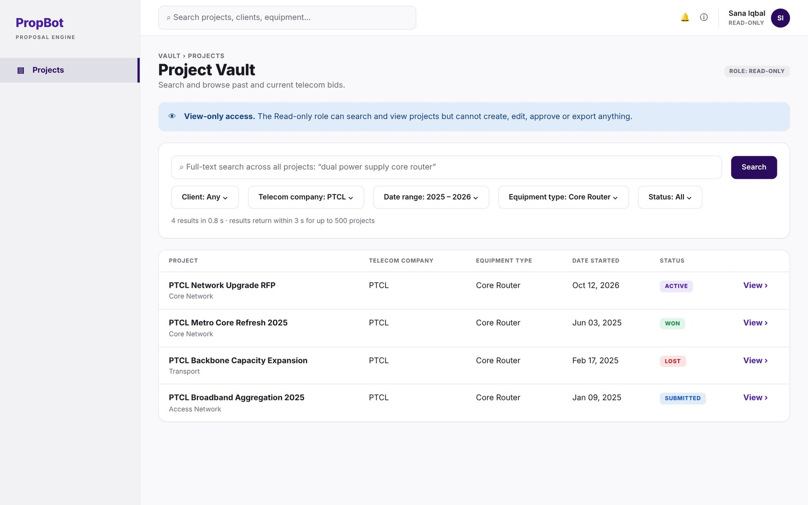
Figure 2.48: W-47 – Read-only User Vault View
Table 2.49: Requirements mapped to screen W-47
Feature (derived from UI) | Functional Requirement (FR-ID: Statement) | Business Rule
Full-Text Vault Search | FR-9.3: The system shall provide full-text search across all projects using PostgreSQL tsvector/tsquery indexing, filterable by client name, telecom company, date range, equipment type, and project status. | Results returned within 3 seconds (95th percentile) for up to 500 projects (PER-5).
Role-Based Access Control | FR-13.1: The system shall support five roles — Super Admin, Org Admin, Presales Engineer, Reviewer, Read-only — enforced through a role-based access control (RBAC) middleware layer in FastAPI. | Exactly five fixed roles.

B. Mobile Application Screens
M-01 – Mobile Login
Application: Mobile · User role(s): All
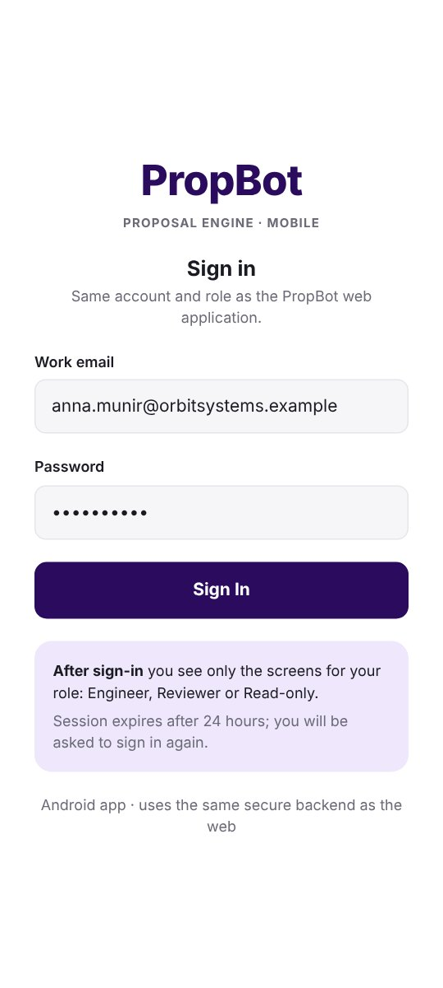  Figure 2.49: M-01 – Mobile Login | Requirements mapped to screen M-01  FR-13.4: All user sessions shall use JWT tokens signed with HS256, with a 24-hour expiry, validated on every protected API endpoint; validation shall also check that the user is still active and that the token version matches the user's current token version.  Feature: Session Token Management · Business rule: Token expiry: 24 hours; tokens with an outdated version are rejected.  FR-18.1: The system shall provide an Android-first mobile application built with React Native (Expo) that uses the same FastAPI backend, JWT authentication and role-based access control as the web application.  Feature: Mobile Platform & Auth · Business rule: Android-first; shares backend and RBAC with the web application.  FR-18.2: The mobile application shall support login and show screens according to the user's role.  Feature: Role-Based Screens · Business rule: —

M-02 – Mobile Projects List (role-based home)
Application: Mobile · User role(s): All
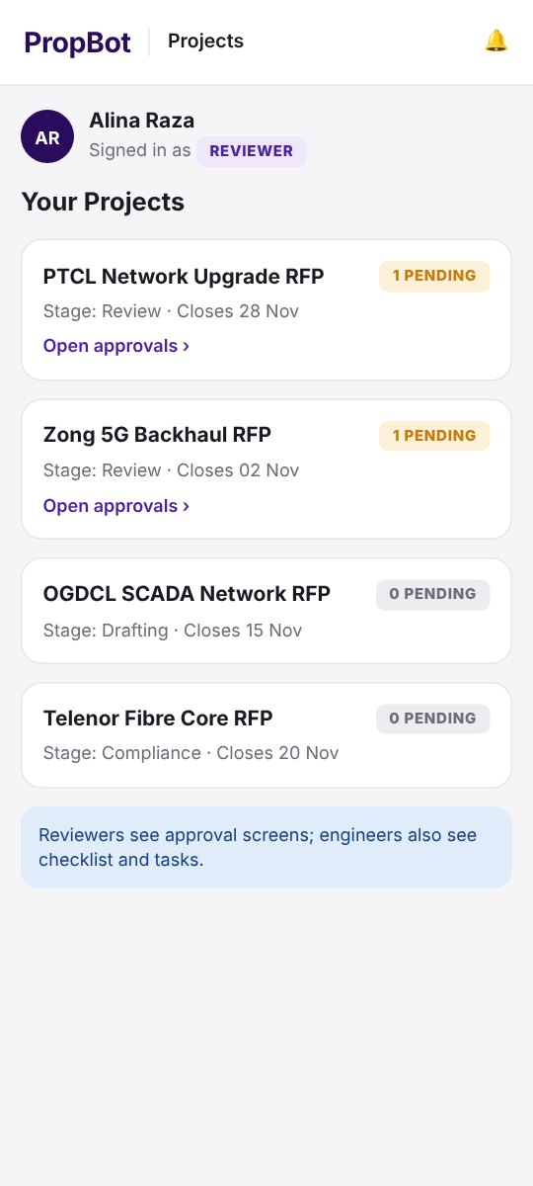  Figure 2.50: M-02 – Mobile Projects List (role-based home) | Requirements mapped to screen M-02  FR-18.2: The mobile application shall support login and show screens according to the user's role.  Feature: Role-Based Screens · Business rule: —

M-03 – Mobile Approvals
Application: Mobile · User role(s): Reviewer
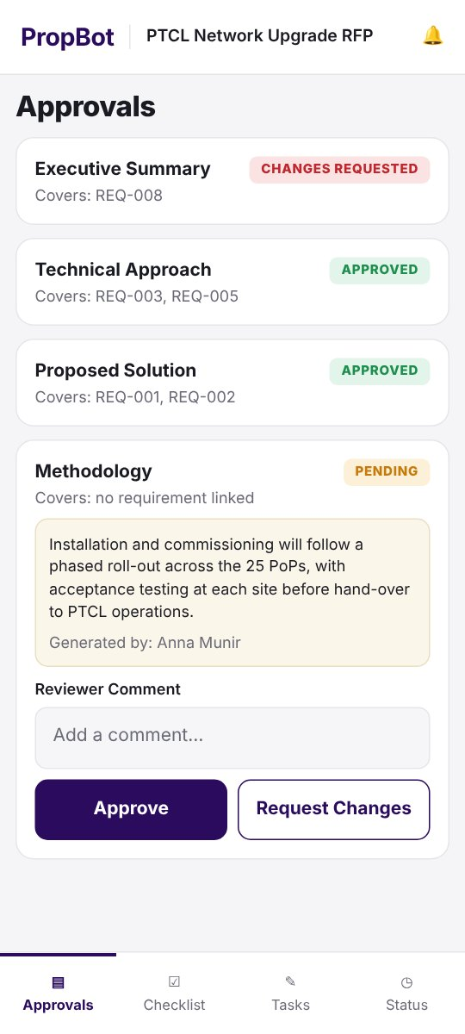  Figure 2.51: M-03 – Mobile Approvals | Requirements mapped to screen M-03  FR-18.3: A reviewer shall be able to read a proposal section and approve it or request changes with a comment; the rule that an engineer cannot approve a proposal they generated (FR-13.3) shall apply.  Feature: Mobile Proposal Review · Business rule: Self-approval prevention rule (FR-13.3) also applies on mobile.

M-04 – Mobile Request Changes Comment
Application: Mobile · User role(s): Reviewer
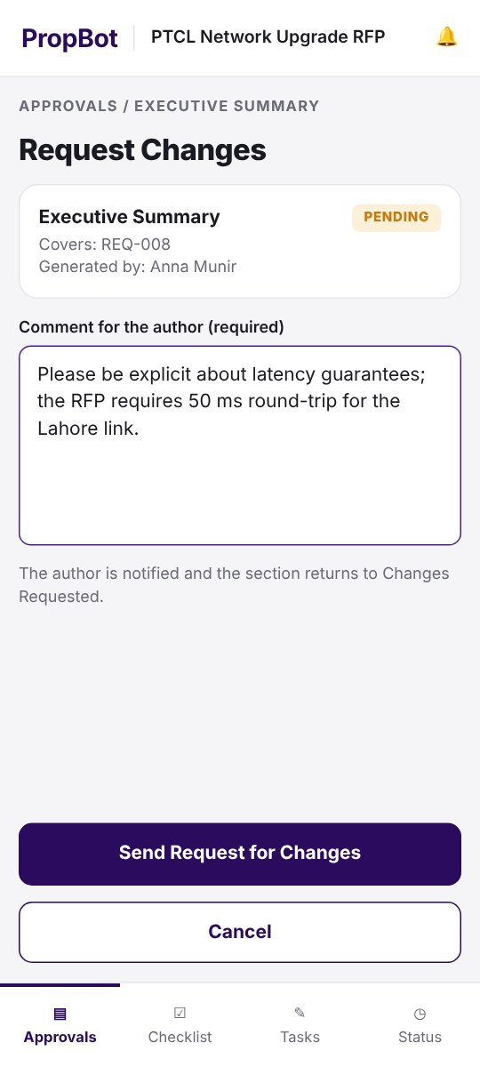  Figure 2.52: M-04 – Mobile Request Changes Comment | Requirements mapped to screen M-04  FR-18.3: A reviewer shall be able to read a proposal section and approve it or request changes with a comment; the rule that an engineer cannot approve a proposal they generated (FR-13.3) shall apply.  Feature: Mobile Proposal Review · Business rule: Self-approval prevention rule (FR-13.3) also applies on mobile.

M-05 – Mobile Self-Approval Blocked
Application: Mobile · User role(s): Engineer
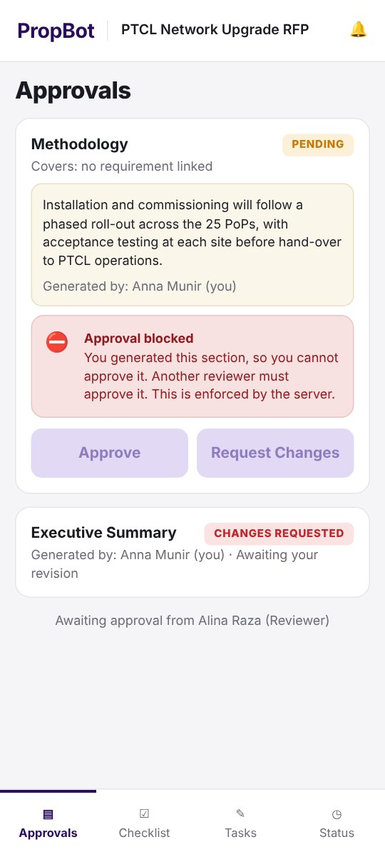  Figure 2.53: M-05 – Mobile Self-Approval Blocked | Requirements mapped to screen M-05  FR-13.3: The system shall prevent any engineer from approving a proposal they generated, enforced by comparing generated_by and approved_by fields at the API level.  Feature: Self-Approval Prevention · Business rule: Enforced server-side, not only in the UI.  FR-18.3: A reviewer shall be able to read a proposal section and approve it or request changes with a comment; the rule that an engineer cannot approve a proposal they generated (FR-13.3) shall apply.  Feature: Mobile Proposal Review · Business rule: Self-approval prevention rule (FR-13.3) also applies on mobile.

M-06 – Mobile Submission Checklist
Application: Mobile · User role(s): Engineer
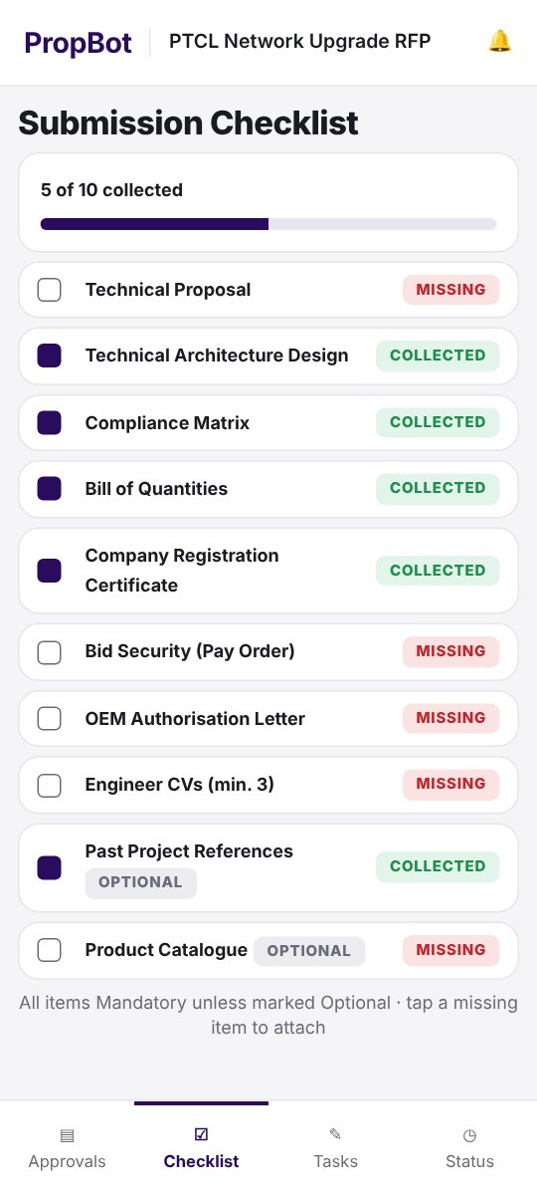  Figure 2.54: M-06 – Mobile Submission Checklist | Requirements mapped to screen M-06  FR-18.4: An engineer shall be able to view the submission checklist, tick items and attach a document by taking a photo with the phone camera or selecting a file; the file shall be stored in the project vault (Module 9).  Feature: Checklist Document Capture · Business rule: —

M-07 – Mobile Document Capture
Application: Mobile · User role(s): Engineer
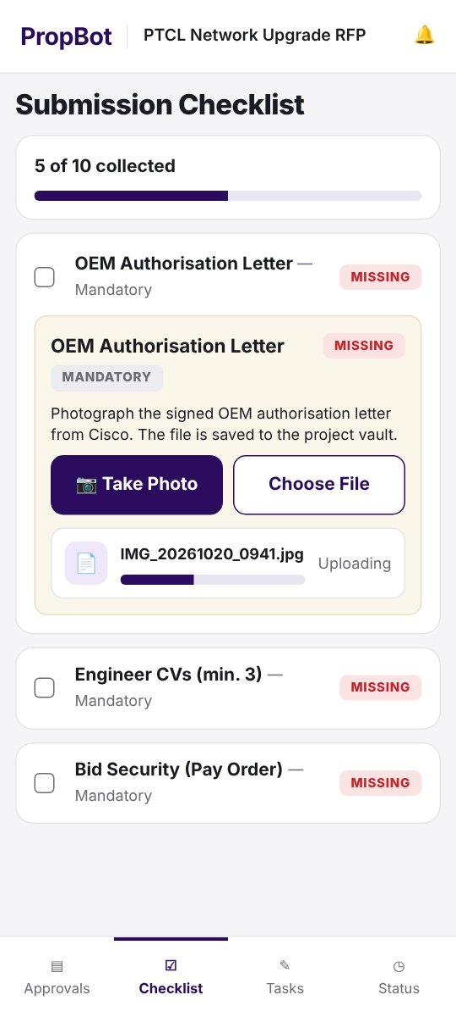  Figure 2.55: M-07 – Mobile Document Capture | Requirements mapped to screen M-07  FR-18.4: An engineer shall be able to view the submission checklist, tick items and attach a document by taking a photo with the phone camera or selecting a file; the file shall be stored in the project vault (Module 9).  Feature: Checklist Document Capture · Business rule: —

M-08 – Mobile Attach Confirmation (photo or file)
Application: Mobile · User role(s): Engineer
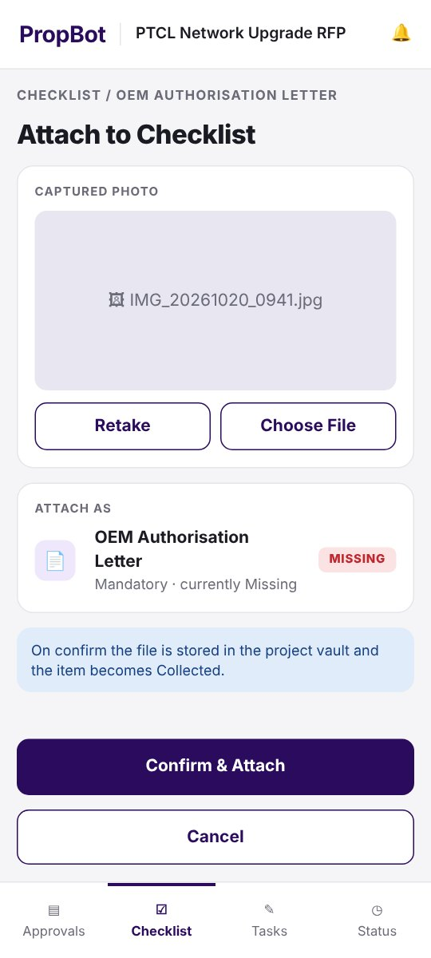  Figure 2.56: M-08 – Mobile Attach Confirmation (photo or file) | Requirements mapped to screen M-08  FR-18.4: An engineer shall be able to view the submission checklist, tick items and attach a document by taking a photo with the phone camera or selecting a file; the file shall be stored in the project vault (Module 9).  Feature: Checklist Document Capture · Business rule: —

M-09 – Mobile Tasks & Deadlines
Application: Mobile · User role(s): Engineer
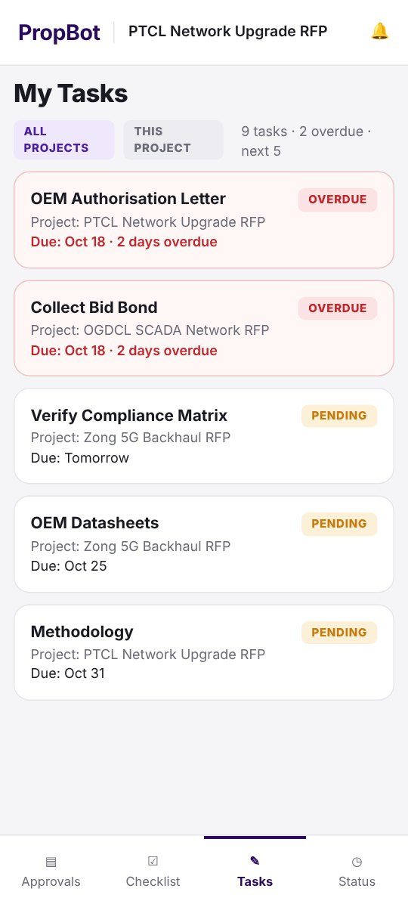  Figure 2.57: M-09 – Mobile Tasks & Deadlines | Requirements mapped to screen M-09  FR-17.3: The system shall display tasks per project and per engineer, with overdue tasks highlighted.  Feature: Task Views · Business rule: —  FR-18.5: The mobile application shall show the user's assigned tasks and deadlines (Module 17).  Feature: Mobile Tasks View · Business rule: —

M-10 – Mobile Task Detail
Application: Mobile · User role(s): Engineer
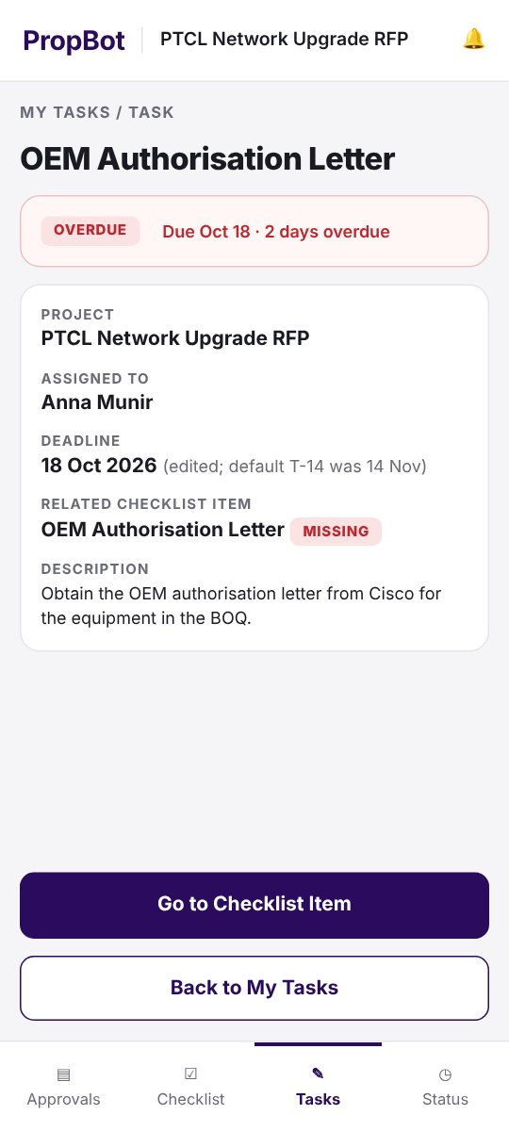  Figure 2.58: M-10 – Mobile Task Detail | Requirements mapped to screen M-10  FR-18.5: The mobile application shall show the user's assigned tasks and deadlines (Module 17).  Feature: Mobile Tasks View · Business rule: —

M-11 – Mobile Notifications List
Application: Mobile · User role(s): All
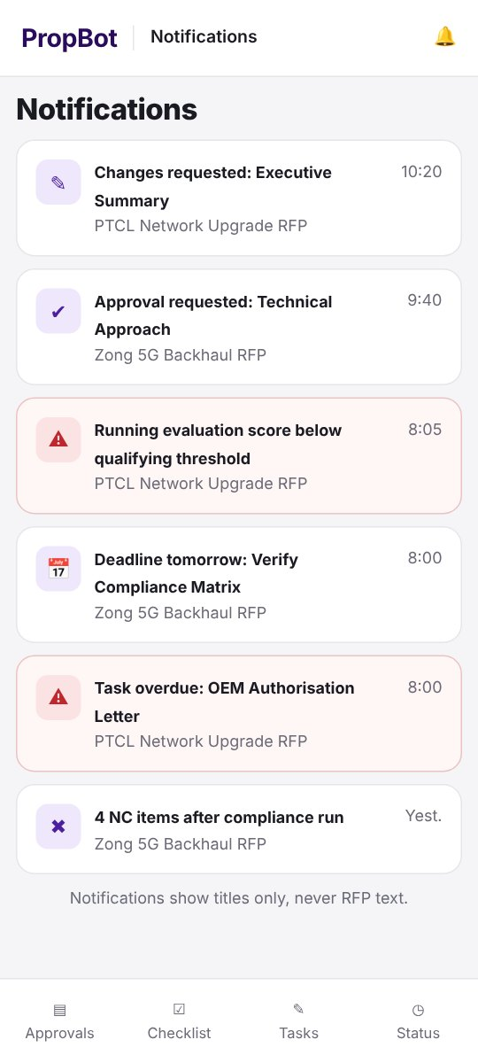  Figure 2.59: M-11 – Mobile Notifications List | Requirements mapped to screen M-11  FR-18.6: The system shall send push notifications for approval requests, upcoming and overdue deadlines, NC items after a compliance run, and a running evaluation score falling below the qualifying threshold.  Feature: Push Notifications · Business rule: Notification content shall be minimal and shall not include RFP text.

M-12 – Push Notification Examples (lock screen)
Application: Mobile · User role(s): All
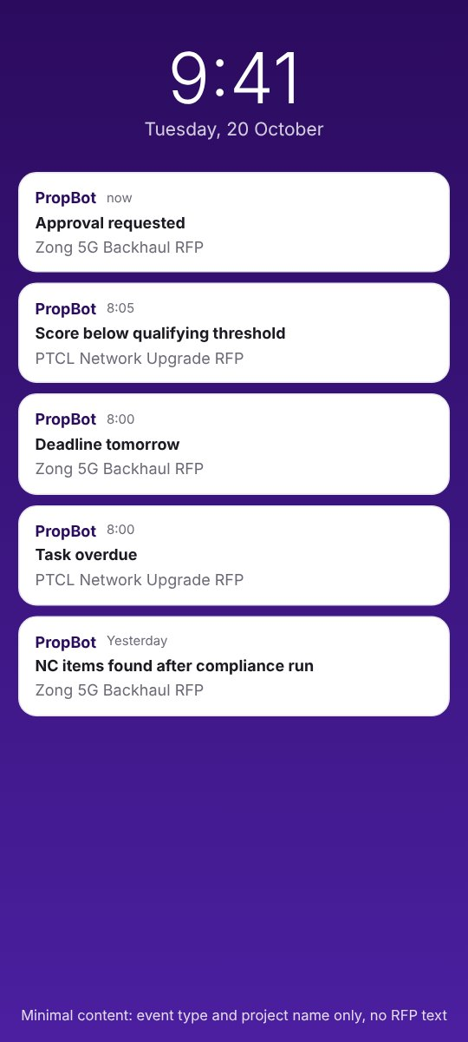  Figure 2.60: M-12 – Push Notification Examples (lock screen) | Requirements mapped to screen M-12  FR-18.6: The system shall send push notifications for approval requests, upcoming and overdue deadlines, NC items after a compliance run, and a running evaluation score falling below the qualifying threshold.  Feature: Push Notifications · Business rule: Notification content shall be minimal and shall not include RFP text.

M-13 – Mobile Project Status
Application: Mobile · User role(s): All
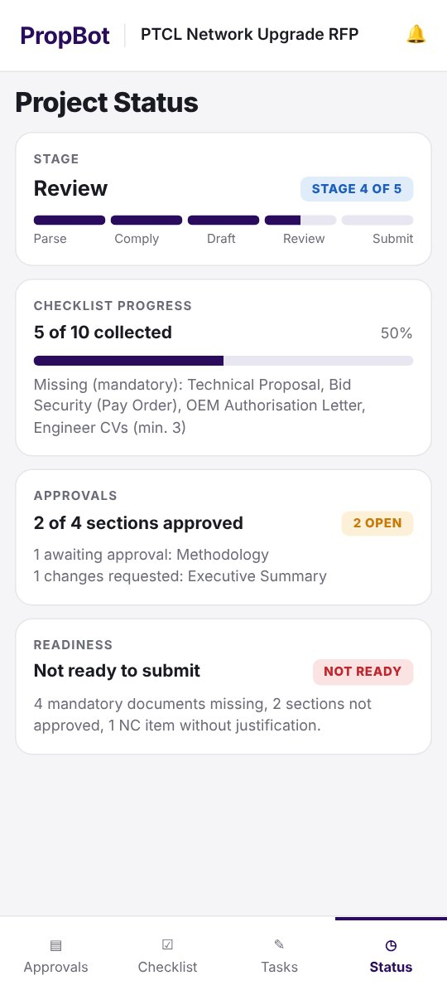  Figure 2.61: M-13 – Mobile Project Status | Requirements mapped to screen M-13  FR-18.7: The mobile application shall show a project status screen with stage, checklist progress, pending approvals and readiness status.  Feature: Project Status Screen · Business rule: —

M-14 – Web-only Function Notice
Application: Mobile · User role(s): All
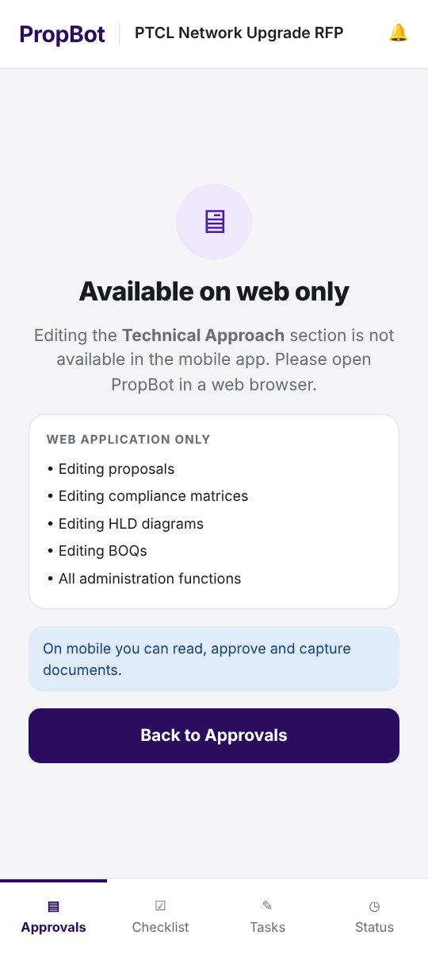  Figure 2.62: M-14 – Web-only Function Notice | Requirements mapped to screen M-14  FR-18.8: Editing of proposals, compliance matrices, HLD diagrams and BOQs, and all administration functions, shall remain on the web application only.  Feature: Web-Only Editing Scope · Business rule: Mobile app is read/approve/capture only for these artifacts.

2.5.2 Event–Response Table Technique
While mockups capture frontend interactions, several PropBot processes run entirely at the backend: session and token handling, audit-record writing, deadline-driven notifications, and the submission readiness check. The Event–Response Table technique documents each such process as a set of events, their triggers and sources, the system state before and after, the system's response, and exception handling. Following the template, the events are first listed, then tabulated, and the functional requirements derived from them are given in a separate table; the derived requirements reuse the FR identifiers of Section 2.6 so that no requirement is specified twice.
Event–Response Table for Account Security and Session Management (Module 13)
User authentication, invitation and session handling in Module 13 take place largely at the backend, with no single corresponding UI screen; the Event–Response Table technique below captures this behaviour.
Identified events:
- Invitation Issued — trigger: Org Admin submits a new-user invitation.
- Session Token Issued — trigger: User submits valid login credentials.
- Token Validation Request — trigger: Client calls a protected API endpoint.
- Password Reset Requested — trigger: User requests a password reset.
- Account Deactivated — trigger: Org Admin deactivates a user.
Table 2.50: Event–Response Table for Account Security and Session Management (Module 13)
Event Name | Trigger | Source | System State (Before) | Response | System State (After) | Exception Handling
Invitation Issued | Org Admin submits a new-user invitation | Org Admin (web UI) | User not yet registered | 1. Generate a 48-hour JWT activation token  2. Email the activation link  3. Create a pending user record | User record in “pending activation” state | Resend invitation if the token expires before activation
Session Token Issued | User submits valid login credentials | Authentication endpoint | No active session | 1. Validate credentials  2. Issue a JWT signed with HS256 (24-hour expiry)  3. Return the token to the client | User session active | Return an authentication error on invalid credentials; no token issued
Token Validation Request | Client calls a protected API endpoint | FastAPI RBAC middleware | Request pending | 1. Verify JWT signature and expiry  2. Check the user is active and the token version is current; load user role  3. Authorise or reject the request based on role | Request authorised or rejected (≤ 500 ms, NFR-13.1) | Reject with 401/403 and no data returned on an invalid or expired token
Password Reset Requested | User requests a password reset | Authentication endpoint | User account exists | 1. Generate a signed, time-limited (1-hour) reset link  2. Email the link to the registered address | Reset link active for 1 hour | Link expires silently after 1 hour; a new request must be made
Account Deactivated | Org Admin deactivates a user | Org Admin (web UI) | User account active | 1. Set is_active = false  2. Increment the user's token version so every previously issued token is rejected | User account inactive; all sessions terminated | Any in-flight request from the deactivated user's prior token is rejected

Table 2.51: Functional Requirements Derived from the Account Security and Session Management (Module 13) Events
Event | Functional Requirement (FR-ID: Statement) | Business Rule
Invitation Issued | FR-13.2: The Org Admin shall invite users by email; the invitation shall generate a time-limited JWT token (expiry: 48 hours) for account activation. | Invitation token expires after 48 hours.
Session Token Issued | FR-13.4: All user sessions shall use JWT tokens signed with HS256, with a 24-hour expiry, validated on every protected API endpoint; validation shall also check that the user is still active and that the token version matches the user's current token version. | Token expiry: 24 hours; tokens with an outdated version are rejected.
Token Validation Request | FR-13.1: The system shall support five roles — Super Admin, Org Admin, Presales Engineer, Reviewer, Read-only — enforced through a role-based access control (RBAC) middleware layer in FastAPI. | Exactly five fixed roles.
Token Validation Request | FR-13.4: All user sessions shall use JWT tokens signed with HS256, with a 24-hour expiry, validated on every protected API endpoint; validation shall also check that the user is still active and that the token version matches the user's current token version. | Token expiry: 24 hours; tokens with an outdated version are rejected.
Password Reset Requested | FR-13.6: The system shall handle password reset via a time-limited (1-hour) signed reset link sent by email. | Reset link expires after 1 hour.
Account Deactivated | FR-13.5: The Org Admin shall be able to deactivate user accounts, immediately setting is_active = false and incrementing the user's token version, so that every previously issued token is rejected on its next use. | Takes effect on the next request; no token survives deactivation (FR-13.4).

Event–Response Table for Audit Logging (Module 15)
Audit logging runs entirely in the background on every significant platform action and has no dedicated input screen, making it a direct candidate for the Event–Response Table technique.
Identified events:
- Significant Action Performed — trigger: Any of: RFP upload, parsing, checklist generation, compliance matrix creation, proposal generation, section approval, document export, submission package build.
- Audit Log Filter Applied — trigger: Org Admin applies a filter (user, project, action type, date range).
- Audit Log Export Requested — trigger: Org Admin requests a CSV export of the filtered log.
Table 2.52: Event–Response Table for Audit Logging (Module 15)
Event Name | Trigger | Source | System State (Before) | Response | System State (After) | Exception Handling
Significant Action Performed | Any of: RFP upload, parsing, checklist generation, compliance matrix creation, proposal generation, section approval, document export, submission package build | Originating module (Modules 1–10) | Action about to be committed | 1. Capture user_id, user_name, action_type, project_id, project_name, timestamp  2. Serialise action details to details_json  3. Insert an immutable record into audit_logs | New audit record persisted; visible in the project timeline | If the insert fails, the triggering action is not committed: the action and its audit record are saved together or not at all, and the user sees an error and can retry
Audit Log Filter Applied | Org Admin applies a filter (user, project, action type, date range) | Org Admin dashboard | Full or previously filtered audit log displayed | 1. Query audit_logs with the supplied filter conditions  2. Return matching records to the dashboard | Filtered audit log displayed | Display “no matching records” if the filter returns an empty result
Audit Log Export Requested | Org Admin requests a CSV export of the filtered log | Org Admin dashboard | Filtered audit log displayed | 1. Serialise the currently filtered record set to CSV  2. Stream the file to the Org Admin's browser | CSV file downloaded | —

Table 2.53: Functional Requirements Derived from the Audit Logging (Module 15) Events
Event | Functional Requirement (FR-ID: Statement) | Business Rule
Significant Action Performed | FR-15.1: The system shall write an immutable audit record to a dedicated audit_logs table for every significant action: RFP upload, parsing, checklist generation, compliance matrix creation, proposal generation, section approval, document export, and submission package build. | —
Significant Action Performed | FR-15.2: Each audit record shall contain user_id, user_name, action_type, project_id, project_name, timestamp, and details_json. | —
Audit Log Filter Applied | FR-15.3: The Org Admin shall be able to filter the audit log by user, project, action type, and date range via the admin dashboard. | —
Audit Log Export Requested | FR-15.5: The Org Admin shall be able to export the filtered audit log as a CSV file. | —

Event–Response Table for Bid Deadlines and Notifications (Modules 17 and 18)
Deadline tracking and the resulting mobile/web alerts are driven by scheduled and threshold-based backend events rather than direct user interaction, and are therefore documented using the Event–Response Table technique.
Identified events:
- Closing Date Extracted — trigger: Module 1 parses the RFP closing date (or engineer enters it manually).
- Task Becomes Overdue — trigger: Scheduled job detects a task's due date has passed with status ≠ complete.
- Evaluation Score Drops Below Threshold — trigger: Running score recomputed after a checklist tick-off falls below the qualifying threshold.
- NC Compliance Items Detected — trigger: Compliance run completes with one or more NC ratings.
Table 2.54: Event–Response Table for Bid Deadlines and Notifications (Modules 17 and 18)
Event Name | Trigger | Source | System State (Before) | Response | System State (After) | Exception Handling
Closing Date Extracted | Module 1 parses the RFP closing date (or engineer enters it manually) | RFP Parser (Module 1) | No tasks yet created for this RFP | 1. Create bid tasks from checklist items and proposal sections  2. Set each task's due date at a predefined offset before the closing date | Tasks created with due dates (FR-17.1) | If no closing date can be determined, task creation is deferred until the engineer supplies one
Task Becomes Overdue | Scheduled job detects a task's due date has passed with status ≠ complete | Scheduler | Task status = pending/in-progress | 1. Mark the task overdue in the task list  2. Trigger a push notification and in-app alert to the assigned engineer | Task shown as overdue in web and mobile task views (FR-17.3, FR-17.4) | No action if the task was completed before the scheduled check ran
Evaluation Score Drops Below Threshold | Running score recomputed after a checklist tick-off falls below the qualifying threshold | Technical Evaluation Criteria Analyser (Module 4) | Running score ≥ qualifying threshold | 1. Recompute running_score  2. Compare against qualifying_threshold  3. Trigger a warning notification (FR-4.5, FR-18.6) | Warning notification delivered to web and mobile | No notification if the score remains at or above the threshold
NC Compliance Items Detected | Compliance run completes with one or more NC ratings | Compliance Matrix Generator (Module 3) | Compliance run in progress | 1. Count NC items  2. Trigger a push notification summarising NC count to the assigned engineer | Notification delivered; NC items visible in the compliance matrix | No notification triggered if the compliance run yields zero NC items

Table 2.55: Functional Requirements Derived from the Bid Deadlines and Notifications (Modules 17 and 18) Events
Event | Functional Requirement (FR-ID: Statement) | Business Rule
Closing Date Extracted | FR-1.9: The system shall extract the bid closing date and time from the parsed RFP text; if it is not detected, the engineer shall enter it manually. | Manual entry required as fallback when automatic extraction fails.
Closing Date Extracted | FR-17.1: The system shall automatically create tasks from checklist items and proposal sections, with due dates set at predefined offsets before the RFP closing date (FR-1.9). | Default offsets: proposal-section tasks are due 28 days and checklist-item tasks 14 days before the closing date; if a computed due date has already passed when the task is created, it is set to the midpoint between the creation date and the closing date; any due date can be edited (FR-17.2).
Task Becomes Overdue | FR-17.3: The system shall display tasks per project and per engineer, with overdue tasks highlighted. | —
Task Becomes Overdue | FR-17.4: The system shall send deadline and overdue alerts through the Module 18 notification mechanism and in the web application. | —
Evaluation Score Drops Below Threshold | FR-4.5: The system shall trigger a warning notification when running_score falls below the qualifying_threshold. | —
NC Compliance Items Detected | FR-18.6: The system shall send push notifications for approval requests, upcoming and overdue deadlines, NC items after a compliance run, and a running evaluation score falling below the qualifying threshold. | Notification content shall be minimal and shall not include RFP text.

Event–Response Table for the Submission Readiness Check (Module 10)
The readiness check that gates submission packaging is a purely backend validation step with no screen of its own beyond displaying its result, and is therefore documented as an Event–Response Table.
Identified events:
- Packaging Attempt Initiated — trigger: Engineer requests submission package generation.
- Blocker Detected — trigger: One or more of: unfulfilled mandatory checklist item, unjustified NC item, unapproved proposal section.
- Warning Detected (Non-Blocking) — trigger: One or more of: running score below qualifying threshold, accepted requirement not linked to any output.
- Readiness Check Passed — trigger: No blockers remain.
Table 2.56: Event–Response Table for the Submission Readiness Check (Module 10)
Event Name | Trigger | Source | System State (Before) | Response | System State (After) | Exception Handling
Packaging Attempt Initiated | Engineer requests submission package generation | Submission Package Builder (web UI) | Final documents uploaded to the submission area | 1. Check all mandatory checklist items for fulfilment  2. Check all NC compliance items for a justification note  3. Check all proposal sections for approval status | Blocker/warning list computed | —
Blocker Detected | One or more of: unfulfilled mandatory checklist item, unjustified NC item, unapproved proposal section | Readiness Check logic | Blocker/warning list computed | 1. Add the item to the blocker list  2. Prevent ZIP package generation | Packaging blocked; blocker list displayed to the engineer (FR-10.7) | Engineer resolves each blocker and re-runs the readiness check
Warning Detected (Non-Blocking) | One or more of: running score below qualifying threshold, accepted requirement not linked to any output | Readiness Check logic | Blocker/warning list computed | 1. Add the item to the warning list  2. Continue to allow packaging | Packaging proceeds; warning list displayed for engineer awareness (FR-10.7) | —
Readiness Check Passed | No blockers remain | Readiness Check logic | Blocker/warning list computed, empty of blockers | 1. Allow ZIP archive generation  2. Proceed to Module 9 vault persistence | Submission package built and stored in the project vault (FR-10.4, FR-10.5) | —

Table 2.57: Functional Requirements Derived from the the Submission Readiness Check (Module 10) Events
Event | Functional Requirement (FR-ID: Statement) | Business Rule
Packaging Attempt Initiated | FR-10.7: The system shall run a readiness check before packaging and display the blocker and warning list. | Blockers (prevent packaging): unfulfilled mandatory checklist items; NC items without justification; unapproved proposal sections. Warnings (shown, non-blocking): running score below qualifying threshold; requirements not linked to any output.
Blocker Detected | FR-10.3: The system shall display a blocking error list for any unfulfilled mandatory checklist items before packaging is allowed. | —
Blocker Detected | FR-2.6: The system shall block submission package generation if any mandatory item remains uncollected, enforced at the API level in Module 10. | Blocking enforced server-side, not only in the UI.
Warning Detected (Non-Blocking) | FR-10.7: The system shall run a readiness check before packaging and display the blocker and warning list. | Blockers (prevent packaging): unfulfilled mandatory checklist items; NC items without justification; unapproved proposal sections. Warnings (shown, non-blocking): running score below qualifying threshold; requirements not linked to any output.
Readiness Check Passed | FR-10.4: The system shall generate a ZIP archive using the Python zipfile module with the standard folder structure /Technical_Proposal, /Commercial, /Annexures, /Reference_Documents. | —
Readiness Check Passed | FR-10.5: The system shall permanently save the ZIP and all contents to the Module 9 project vault under the /Submission folder. | —

2.5.3 Requirement-to-Screen Traceability Matrix
The matrix below maps every functional requirement of Section 2.6 to the screen(s) on which it is shown, so that each requirement can be traced from its statement to its user interface and back.
Table 2.58: Requirement-to-Screen Traceability Matrix (all 118 functional requirements)
FR-ID | Feature | Module | Screen ID(s)
FR-1.1 | RFP File Upload | 1. RFP Parser and Classifier | W-06, W-10
FR-1.2 | Raw Text Extraction | 1. RFP Parser and Classifier | W-06
FR-1.3 | Section Classification | 1. RFP Parser and Classifier | W-06
FR-1.4 | Entity Extraction (NER) | 1. RFP Parser and Classifier | W-06
FR-1.5 | Delivery Scope Detection | 1. RFP Parser and Classifier | W-06
FR-1.6 | Client Format Detection | 1. RFP Parser and Classifier | W-06
FR-1.7 | Parsing Turnaround | 1. RFP Parser and Classifier | W-06, W-10
FR-1.8 | Manual Re-classification | 1. RFP Parser and Classifier | W-06, W-07
FR-1.9 | Closing Date Extraction | 1. RFP Parser and Classifier | W-06, W-08
FR-1.10 | Requirement Registry | 1. RFP Parser and Classifier | W-06, W-09
FR-1.11 | Vague/Duplicate Requirement Flagging | 1. RFP Parser and Classifier | W-09
FR-2.1 | Checklist Item Extraction | 2. Submission Checklist Generator | W-11
FR-2.2 | Mandatory/Optional Classification | 2. Submission Checklist Generator | W-11
FR-2.3 | Responsible Team Assignment | 2. Submission Checklist Generator | W-11
FR-2.4 | Checklist Tick-Off | 2. Submission Checklist Generator | W-11
FR-2.5 | Collected/Outstanding Counter | 2. Submission Checklist Generator | W-11
FR-2.6 | Submission Blocking | 2. Submission Checklist Generator | W-11
FR-2.7 | Custom Checklist Items | 2. Submission Checklist Generator | W-12
FR-3.1 | Proposed Equipment Entry | 3. Compliance Matrix Generator | W-14
FR-3.2 | Specification Retrieval | 3. Compliance Matrix Generator | W-13
FR-3.3 | Rule-Based Compliance Evaluation | 3. Compliance Matrix Generator | W-14
FR-3.4 | Overall Compliance Percentage | 3. Compliance Matrix Generator | W-14
FR-3.5 | NC Highlighting | 3. Compliance Matrix Generator | W-14
FR-3.6 | Manual Override | 3. Compliance Matrix Generator | W-14, W-15
FR-3.7 | Matrix Export | 3. Compliance Matrix Generator | W-14
FR-3.8 | Multi-Model Comparison | 3. Compliance Matrix Generator | W-14
FR-3.9 | Descriptive Requirement Matching | 3. Compliance Matrix Generator | W-14
FR-3.10 | Evidence & Review Flagging | 3. Compliance Matrix Generator | W-14
FR-4.1 | Scoring Table Extraction | 4. Technical Evaluation Criteria Analyser | W-16
FR-4.2 | Marks Display | 4. Technical Evaluation Criteria Analyser | W-16
FR-4.3 | Threshold Display | 4. Technical Evaluation Criteria Analyser | W-16
FR-4.4 | Running Score Computation | 4. Technical Evaluation Criteria Analyser | W-16
FR-4.5 | Below-Threshold Warning | 4. Technical Evaluation Criteria Analyser | W-16, W-46
FR-4.6 | No-Criteria Message | 4. Technical Evaluation Criteria Analyser | W-16
FR-5.1 | Network Device Input Form | 5. HLD Diagram Generator | W-17
FR-5.2 | Proposed Equipment Import | 5. HLD Diagram Generator | W-17
FR-5.3 | Topology Diagram Rendering | 5. HLD Diagram Generator | W-18
FR-5.4 | Standard Icon Set | 5. HLD Diagram Generator | W-18
FR-5.5 | PNG Export | 5. HLD Diagram Generator | W-18
FR-5.6 | Editable draw.io Export | 5. HLD Diagram Generator | W-18
FR-5.7 | Connectivity Description | 5. HLD Diagram Generator | W-18
FR-6.1 | Knowledge-Base Chunking | 6. Technical Proposal Generator | W-19
FR-6.2 | Chunk Embedding & Storage | 6. Technical Proposal Generator | W-19
FR-6.3 | Semantic Retrieval | 6. Technical Proposal Generator | W-19
FR-6.4 | Reranking | 6. Technical Proposal Generator | W-19
FR-6.5 | Section Generation | 6. Technical Proposal Generator | W-19
FR-6.6 | Structured Output Schema | 6. Technical Proposal Generator | W-19
FR-6.7 | Section Editing | 6. Technical Proposal Generator | W-20
FR-6.8 | Reviewer Approval Gate | 6. Technical Proposal Generator | W-20
FR-6.9 | Proposal Export | 6. Technical Proposal Generator | W-21
FR-6.10 | Export Footer Stamp | 6. Technical Proposal Generator | W-21
FR-6.11 | Requirement Linking | 6. Technical Proposal Generator | W-20
FR-6.12 | Coverage Check | 6. Technical Proposal Generator | W-20
FR-7.1 | BOQ Template Library | 7. BOQ Generator | W-23, W-39
FR-7.2 | Auto-Population | 7. BOQ Generator | W-23
FR-7.3 | Costing Columns Left Blank | 7. BOQ Generator | W-23
FR-7.4 | Line-Item Editing | 7. BOQ Generator | W-23
FR-7.5 | BOQ Export | 7. BOQ Generator | W-23
FR-8.1 | Standard Template | 8. Responsibility Matrix Generator | W-24
FR-8.2 | Auto-Assignment | 8. Responsibility Matrix Generator | W-24
FR-8.3 | Row Editing | 8. Responsibility Matrix Generator | W-24
FR-8.4 | Matrix Export | 8. Responsibility Matrix Generator | W-24
FR-8.5 | Template Maintenance | 8. Responsibility Matrix Generator | W-40
FR-9.1 | Per-Project Folder Structure | 9. Project Vault and Centralised Storage | W-26
FR-9.2 | Automatic Vault Saving | 9. Project Vault and Centralised Storage | W-26
FR-9.3 | Full-Text Vault Search | 9. Project Vault and Centralised Storage | W-25, W-47
FR-9.4 | Similar Past Project Suggestion | 9. Project Vault and Centralised Storage | W-25
FR-9.5 | On-Premise Storage | 9. Project Vault and Centralised Storage | W-26
FR-9.6 | Project Status Field | 9. Project Vault and Centralised Storage | W-05, W-25
FR-9.7 | Requirement Traceability View | 9. Project Vault and Centralised Storage | W-27
FR-10.1 | Multi-File Upload | 10. Submission Package Builder | W-28
FR-10.2 | Cross-Checking Against Checklist | 10. Submission Package Builder | W-28
FR-10.3 | Blocking Error List | 10. Submission Package Builder | W-28
FR-10.4 | ZIP Package Generation | 10. Submission Package Builder | W-28
FR-10.5 | Vault Persistence | 10. Submission Package Builder | W-29
FR-10.6 | Submission Summary Document | 10. Submission Package Builder | W-29
FR-10.7 | Readiness Check | 10. Submission Package Builder | W-28
FR-11.1 | Automatic Ingestion | 11. Knowledge Base and Past Project Reuse | W-32
FR-11.2 | Metadata Tagging | 11. Knowledge Base and Past Project Reuse | W-30
FR-11.3 | Win/Loss Relevance Boost | 11. Knowledge Base and Past Project Reuse | W-32
FR-11.4 | Manual Upload & Tagging | 11. Knowledge Base and Past Project Reuse | W-31
FR-11.5 | Admin Knowledge-Base Management | 11. Knowledge Base and Past Project Reuse | W-30
FR-11.6 | Coverage Dashboard | 11. Knowledge Base and Past Project Reuse | W-33
FR-12.1 | Company Workspace Creation | 12. Company and Organisation Management | W-35
FR-12.2 | Multi-Tenant Data Isolation | 12. Company and Organisation Management | W-35
FR-12.3 | Organisation Listing | 12. Company and Organisation Management | W-34
FR-13.1 | Role-Based Access Control | 13. User and Role Management | W-01, W-36, W-47
FR-13.2 | User Invitation | 13. User and Role Management | W-04, W-37
FR-13.3 | Self-Approval Prevention | 13. User and Role Management | W-20, W-22, M-05
FR-13.4 | Session Token Management | 13. User and Role Management | W-01, M-01
FR-13.5 | Account Deactivation | 13. User and Role Management | W-36, W-38
FR-13.6 | Password Reset | 13. User and Role Management | W-02, W-03
FR-14.1 | BOQ Template Upload | 14. Template Library Management | W-39
FR-14.2 | Responsibility Matrix Template Editing | 14. Template Library Management | W-40
FR-14.3 | Version Pinning | 14. Template Library Management | W-39
FR-15.1 | Immutable Audit Record | 15. Audit Log and Activity Tracking | W-41
FR-15.2 | Audit Record Fields | 15. Audit Log and Activity Tracking | W-41
FR-15.3 | Audit Log Filtering | 15. Audit Log and Activity Tracking | W-41
FR-15.4 | Insert-Only Enforcement | 15. Audit Log and Activity Tracking | W-41
FR-15.5 | CSV Export | 15. Audit Log and Activity Tracking | W-41
FR-15.6 | Project Timeline View | 15. Audit Log and Activity Tracking | W-42
FR-16.1 | Summary Metrics | 16. Analytics Dashboard | W-43
FR-16.2 | Turnaround Time Chart | 16. Analytics Dashboard | W-43
FR-16.3 | Client Breakdown Chart | 16. Analytics Dashboard | W-43
FR-16.4 | Top NC Items | 16. Analytics Dashboard | W-43
FR-17.1 | Automatic Task Creation | 17. Bid Tasks and Deadlines | W-44
FR-17.2 | Manual Task Assignment | 17. Bid Tasks and Deadlines | W-45
FR-17.3 | Task Views | 17. Bid Tasks and Deadlines | W-05, W-44, M-09
FR-17.4 | Deadline Alerts | 17. Bid Tasks and Deadlines | W-46
FR-17.5 | Task Audit Logging | 17. Bid Tasks and Deadlines | W-44
FR-18.1 | Mobile Platform & Auth | 18. Mobile Application | M-01
FR-18.2 | Role-Based Screens | 18. Mobile Application | M-01, M-02
FR-18.3 | Mobile Proposal Review | 18. Mobile Application | M-03, M-04, M-05
FR-18.4 | Checklist Document Capture | 18. Mobile Application | M-06, M-07, M-08
FR-18.5 | Mobile Tasks View | 18. Mobile Application | M-09, M-10
FR-18.6 | Push Notifications | 18. Mobile Application | M-11, M-12
FR-18.7 | Project Status Screen | 18. Mobile Application | M-13
FR-18.8 | Web-Only Editing Scope | 18. Mobile Application | M-14

2.6 Functional Requirements
This section documents the complete set of functional requirements for all eighteen PropBot modules, derived from the mockups and event–response analysis above and from the finalised project scope. Each requirement carries a unique identifier (FR-x.y), a testable statement, a governing business rule where applicable, and the ID of the mockup screen(s) that show it. Four requirements — FR-1.11, FR-5.6, FR-9.4 and FR-11.3 — are optional enhancements to be implemented only if time permits; they are marked as such in the Business Rule column and are not part of the committed baseline.

2.6.1 Module 1: RFP Parser and Classifier
Table 2.59: Functional Requirements — Module 1 (RFP Parser and Classifier)
Feature (derived from UI/process) | Functional Requirement (FR-ID: Statement) | Business Rule | Screen ID(s)
RFP File Upload | FR-1.1: The system shall accept RFP files in .pdf and .docx formats up to 50 MB. | File formats limited to PDF/DOCX; maximum size 50 MB. | W-06, W-10
Raw Text Extraction | FR-1.2: The system shall extract raw text from uploaded PDFs using the PyMuPDF library and from Word files using python-docx. | — | W-06
Section Classification | FR-1.3: The system shall classify every extracted section into one of five categories (technical, commercial, financial, legal, presales) using a zero-shot classification pipeline built on the facebook/bart-large-mnli model. | Exactly five fixed classification categories. | W-06
Entity Extraction (NER) | FR-1.4: The system shall apply Named Entity Recognition using spaCy's en_core_web_trf model to extract equipment names, quantities, protocol names, and specification values from the technical section. | — | W-06
Delivery Scope Detection | FR-1.5: The system shall detect the delivery scope (supply, deploy, configure, migrate) using keyword pattern matching combined with dependency parsing on the extracted technical text. | — | W-06
Client Format Detection | FR-1.6: The system shall detect the telecom client format (PTCL, OGDCL, Zong, Telenor) using string matching against a pre-defined client format dictionary and apply the corresponding parsing rules; if no supported format is detected, the system shall apply generic parsing rules and show the notice “Client format not recognised — please review the classification”. | Supported client formats limited to PTCL, OGDCL, Zong and Telenor; any other client is parsed with the generic rules. | W-06
Parsing Turnaround | FR-1.7: For a text-based RFP of up to 100 pages, the system shall display the classified section output within 60 seconds of upload; entity extraction (FR-1.4, FR-1.5) may continue in the background with a visible progress indicator and shall complete within 180 seconds of upload. | Classified output ≤ 60 s; full extraction ≤ 180 s (95th percentile, reference server; PER-1). | W-06, W-10
Manual Re-classification | FR-1.8: The engineer shall be able to manually correct or re-label any misclassified section through the UI. | — | W-06, W-07
Closing Date Extraction | FR-1.9: The system shall extract the bid closing date and time from the parsed RFP text; if it is not detected, the engineer shall enter it manually. | Manual entry required as fallback when automatic extraction fails. | W-06, W-08
Requirement Registry | FR-1.10: The system shall assign a unique requirement ID to each extracted requirement and store it in a project-scoped requirement registry; the engineer shall be able to accept, edit, merge or reject extracted requirements. | — | W-06, W-09
Vague/Duplicate Requirement Flagging | FR-1.11: The system shall flag an extracted requirement as possibly vague (no measurable value or acceptance criterion) or as a possible duplicate of another requirement in the registry, for the engineer to review. | Optional enhancement — implemented only if time permits. Flags are advisory; the engineer decides (FR-1.10). | W-09
NFR-1.1: Section classification shall achieve at least 85% accuracy and a macro-averaged F1 score of at least 0.75 across the five categories on the labelled benchmark of at least 20 RFPs (QUA-1).

2.6.2 Module 2: Submission Checklist Generator
Table 2.60: Functional Requirements — Module 2 (Submission Checklist Generator)
Feature (derived from UI/process) | Functional Requirement (FR-ID: Statement) | Business Rule | Screen ID(s)
Checklist Item Extraction | FR-2.1: The system shall extract all submission document requirements from parsed RFP text using GPT-4o-mini with a structured JSON output prompt, returning document_name, mandatory (true/false), and responsible_team. | — | W-11
Mandatory/Optional Classification | FR-2.2: The system shall classify each item as mandatory or optional using modal verb detection via the spaCy en_core_web_trf dependency parser. | “shall” / “must” map to mandatory; “may” maps to optional; “should” maps to mandatory by default, because a missing expected document can cost marks or lead to rejection. The engineer can change the classification of any item. | W-11
Responsible Team Assignment | FR-2.3: The system shall assign a responsible team (presales, sales, finance) inferred from surrounding RFP section context using the Module 1 classifier output. | — | W-11
Checklist Tick-Off | FR-2.4: The system shall provide a live tick-off interface for engineers to mark items as collected and attach the corresponding document file. | — | W-11
Collected/Outstanding Counter | FR-2.5: The system shall display a real-time counter of collected vs. outstanding items, updated on every tick-off event. | — | W-11
Submission Blocking | FR-2.6: The system shall block submission package generation if any mandatory item remains uncollected, enforced at the API level in Module 10. | Blocking enforced server-side, not only in the UI. | W-11
Custom Checklist Items | FR-2.7: The engineer shall be able to manually add custom checklist items for requirements not detected automatically. | — | W-12

2.6.3 Module 3: Compliance Matrix Generator
Table 2.61: Functional Requirements — Module 3 (Compliance Matrix Generator)
Feature (derived from UI/process) | Functional Requirement (FR-ID: Statement) | Business Rule | Screen ID(s)
Proposed Equipment Entry | FR-3.1: The engineer shall input proposed OEM vendor names and model numbers for each equipment category extracted by Module 1. | — | W-14
Specification Retrieval | FR-3.2: The system shall obtain the specification of each proposed model as a structured parameter table, either from the internal specification database or from an uploaded OEM datasheet, whose extracted parameters the engineer shall confirm before use. | Engineer confirmation required for datasheet-extracted parameters. | W-13
Rule-Based Compliance Evaluation | FR-3.3: The system shall convert each numeric or boolean RFP requirement into a structured constraint (parameter, operator, value, unit) and evaluate it against the model's specification using rule-based comparison with unit normalisation, assigning FC, PC or NC. | FC if the constraint is fully satisfied. PC if a numeric value falls short of the required value by no more than a tolerance (default 10%, configurable in system settings), or if the requirement is met only through an optional module or licence. NC if unsatisfied beyond the tolerance or if the parameter is missing from the specification. | W-14
Overall Compliance Percentage | FR-3.4: The system shall calculate and display the overall compliance percentage for each proposed model as (FC count + 0.5 × PC count) / total compliance rows evaluated for that model × 100, where each evaluated requirement produces one compliance row. | Fixed scoring formula; calculated separately for each compared model (FR-3.8). | W-14
NC Highlighting | FR-3.5: All NC items shall be highlighted in red with a disqualification risk label. | — | W-14
Manual Override | FR-3.6: The engineer shall be able to manually override any compliance rating and enter a justification note. | Justification note mandatory on override. | W-14, W-15
Matrix Export | FR-3.7: The system shall export the completed matrix as a formatted .xlsx file using openpyxl. | — | W-14
Multi-Model Comparison | FR-3.8: The system shall support simultaneous comparison of up to three alternative OEM models for the same requirement set. | Maximum of three models compared at once. | W-14
Descriptive Requirement Matching | FR-3.9: For descriptive requirements that cannot be converted into constraints, the system shall retrieve candidate datasheet passages using text-embedding-3-small embeddings, rerank them with the cross-encoder, and assign a rating with the top-ranked passage as evidence. | — | W-14
Evidence & Review Flagging | FR-3.10: The system shall store, for every compliance row, a short reason and the evidence reference, and shall mark low-confidence rows as “needs review”. | A row is low-confidence when its rating comes from descriptive matching (FR-3.9) and the top-ranked passage scores below a threshold (default 0.5 on a 0–1 scale, configurable in system settings), or when no evidence passage is found. | W-14
NFR-3.1: Compliance comparison for up to 100 requirement rows per model and up to three models shall complete within 30 seconds (95th percentile) of the engineer submitting the confirmed specifications (PER-2).

2.6.4 Module 4: Technical Evaluation Criteria Analyser
Table 2.62: Functional Requirements — Module 4 (Technical Evaluation Criteria Analyser)
Feature (derived from UI/process) | Functional Requirement (FR-ID: Statement) | Business Rule | Screen ID(s)
Scoring Table Extraction | FR-4.1: The system shall extract the scoring table from the parsed RFP using GPT-4o-mini, returning structured JSON with criterion, marks_available, qualifying_threshold, and disqualification_threshold. | — | W-16
Marks Display | FR-4.2: The system shall display marks available per document category and per compliance requirement in a sortable table. | — | W-16
Threshold Display | FR-4.3: The system shall display the qualification threshold and disqualification score parsed directly from the RFP scoring section. | — | W-16
Running Score Computation | FR-4.4: The system shall link each scoring criterion extracted in FR-4.1 to the checklist item that evidences it (suggested automatically by name matching and confirmed or changed by the engineer), and shall compute a real-time running score, updated on every checklist tick-off event via WebSocket push. | Formula: running_score = Σ marks_available of every criterion whose linked checklist item is collected; criteria with no linked item are listed separately and not counted. | W-16
Below-Threshold Warning | FR-4.5: The system shall trigger a warning notification when running_score falls below the qualifying_threshold. | — | W-16, W-46
No-Criteria Message | FR-4.6: The system shall display the message “No technical evaluation criteria detected in this RFP” when no scoring table is found. | — | W-16

2.6.5 Module 5: HLD Diagram Generator
Table 2.63: Functional Requirements — Module 5 (HLD Diagram Generator)
Feature (derived from UI/process) | Functional Requirement (FR-ID: Statement) | Business Rule | Screen ID(s)
Network Device Input Form | FR-5.1: The system shall provide a structured JSON input form for existing network devices with fields device_type, vendor, model, and connections_to[]. | — | W-17
Proposed Equipment Import | FR-5.2: The system shall import proposed equipment from the Module 3 compliance matrix output or allow manual entry. | — | W-17
Topology Diagram Rendering | FR-5.3: The system shall convert device JSON into a Mermaid.js graph definition and render it as an HLD network topology diagram using the Mermaid rendering engine. | — | W-18
Standard Icon Set | FR-5.4: The system shall use one fixed, consistent standard icon for each device type: switch, router, firewall, server, storage. | — | W-18
PNG Export | FR-5.5: The system shall export the rendered diagram as a PNG using a Playwright headless-browser rendering pipeline. | — | W-18
Editable draw.io Export | FR-5.6: The system shall export an editable draw.io XML file generated from the same device graph JSON. | Optional enhancement — implemented only if time permits. | W-18
Connectivity Description | FR-5.7: The system shall generate a written connectivity description (2–4 paragraphs) using GPT-4o-mini, with the device graph JSON as input context. | — | W-18

2.6.6 Module 6: Technical Proposal Generator
Table 2.64: Functional Requirements — Module 6 (Technical Proposal Generator)
Feature (derived from UI/process) | Functional Requirement (FR-ID: Statement) | Business Rule | Screen ID(s)
Knowledge-Base Chunking | FR-6.1: The system shall chunk all knowledge base documents into segments of 400 tokens with 50-token overlap using LangChain's RecursiveCharacterTextSplitter. | Chunk size 400 tokens, overlap 50 tokens. | W-19
Chunk Embedding & Storage | FR-6.2: The system shall embed all chunks using OpenAI's text-embedding-3-small model (1536 dimensions) and store the vectors in ChromaDB with metadata: source_file, section_type, telecom_client, year, win_loss. | — | W-19
Semantic Retrieval | FR-6.3: At generation time, the system shall embed the engineer's input requirements and retrieve the top 5 most similar chunks from ChromaDB using cosine similarity search. | Top-5 chunks retrieved per generation request. | W-19
Reranking | FR-6.4: The system shall rerank the retrieved chunks using the cross-encoder/ms-marco-MiniLM-L-6-v2 model before passing them to the generator. | — | W-19
Section Generation | FR-6.5: The system shall generate each proposal section (Executive Summary, Technical Approach, Proposed Solution, Methodology) as a separate GPT-4o-mini call with a section-specific system prompt and the reranked chunks as context. | The four section calls are made concurrently (PER-3). | W-19
Structured Output Schema | FR-6.6: All generated sections shall conform to a Pydantic v2 output schema with fields section_name, content, word_count, and source_chunks_used. | — | W-19
Section Editing | FR-6.7: The engineer shall review and edit each section individually in the TipTap rich text editor before approval. | — | W-20
Reviewer Approval Gate | FR-6.8: A reviewer shall approve or request changes on each section from the web or mobile application; the proposal cannot be exported until all sections are approved. | Export blocked until every section is approved. | W-20
Proposal Export | FR-6.9: The system shall export the approved proposal as a formatted .docx file using python-docx with the company's branded template. | — | W-21
Export Footer Stamp | FR-6.10: Every exported document shall include the footer: “Generated using PropBot AI, Reviewed and approved by [approver name(s)] on [date].” | Approver name(s) = the reviewer(s) who approved the sections (FR-6.8); date = date of the final section approval. | W-21
Requirement Linking | FR-6.11: The system shall link each generated proposal section to the requirement IDs it addresses. | — | W-20
Coverage Check | FR-6.12: The system shall run a rule-based coverage check that lists any accepted requirement ID not linked to at least one proposal section. | — | W-20
NFR-6.1: A four-section proposal draft shall be generated within 60 seconds (95th percentile) of submission, with the four section calls made concurrently (PER-3).

2.6.7 Module 7: BOQ Generator
Table 2.65: Functional Requirements — Module 7 (BOQ Generator)
Feature (derived from UI/process) | Functional Requirement (FR-ID: Statement) | Business Rule | Screen ID(s)
BOQ Template Library | FR-7.1: The system shall maintain a library of pre-loaded BOQ Excel templates per telecom company (PTCL, OGDCL, Zong, Telenor), stored as .xlsx files managed through Module 14. | — | W-23, W-39
Auto-Population | FR-7.2: The system shall auto-populate the BOQ template with equipment model names, descriptions, and quantities extracted from the Module 3 compliance matrix output using openpyxl. | — | W-23
Costing Columns Left Blank | FR-7.3: All costing, margin, and formula columns shall remain blank in the exported file for manual completion. | — | W-23
Line-Item Editing | FR-7.4: The engineer shall be able to add, edit, or remove line items before export. | — | W-23
BOQ Export | FR-7.5: The system shall export the completed BOQ as a formatted .xlsx file. | — | W-23

2.6.8 Module 8: Responsibility Matrix Generator
Table 2.66: Functional Requirements — Module 8 (Responsibility Matrix Generator)
Feature (derived from UI/process) | Functional Requirement (FR-ID: Statement) | Business Rule | Screen ID(s)
Standard Template | FR-8.1: The system shall maintain a pre-loaded standard responsibility matrix template with at least 24 common rows covering kickoff, HLD sign-off, delivery, installation, configuration, testing, documentation, and handover. | Minimum 24 standard rows. | W-24
Auto-Assignment | FR-8.2: The system shall auto-assign each row to responsible parties (IT company, OEM vendor, customer, presales) using a rule-based mapping table stored in the database. | — | W-24
Row Editing | FR-8.3: The engineer shall be able to add project-specific rows and modify any responsibility assignment before export. | — | W-24
Matrix Export | FR-8.4: The system shall export the completed matrix as a formatted .xlsx file using openpyxl. | — | W-24
Template Maintenance | FR-8.5: The Org Admin shall be able to update the standard template rows through Module 14. | — | W-40

2.6.9 Module 9: Project Vault and Centralised Storage
Table 2.67: Functional Requirements — Module 9 (Project Vault and Centralised Storage)
Feature (derived from UI/process) | Functional Requirement (FR-ID: Statement) | Business Rule | Screen ID(s)
Per-Project Folder Structure | FR-9.1: The system shall maintain a permanent per-project folder structure on the company server (/RFP, /Drafts, /Approved, /Submission), with paths scoped by org_id/project_id. | — | W-26
Automatic Vault Saving | FR-9.2: The system shall automatically save all generated and uploaded documents to the correct vault folder on every export or upload event. | — | W-26
Full-Text Vault Search | FR-9.3: The system shall provide full-text search across all projects using PostgreSQL tsvector/tsquery indexing, filterable by client name, telecom company, date range, equipment type, and project status. | Results returned within 3 seconds (95th percentile) for up to 500 projects (PER-5). | W-25, W-47
Similar Past Project Suggestion | FR-9.4: The system shall surface similar past projects on new RFP upload using cosine similarity search (threshold ≥ 0.70) on text-embedding-3-small embeddings of past project summaries stored in ChromaDB, surfacing the top-3 results. | Optional enhancement — implemented only if time permits. | W-25
On-Premise Storage | FR-9.5: The system shall direct all file writes to local server paths for storage operations, with no external API calls for storage. | Applies to storage only; AI processing calls remain external (see LI-8). | W-26
Project Status Field | FR-9.6: The system shall maintain a project status field with values active, submitted, won, or lost, updated manually by the engineer or Org Admin. | — | W-05, W-25
Requirement Traceability View | FR-9.7: The system shall provide a traceability view showing, for each requirement ID, its linked checklist item, compliance row, proposal section and BOQ line, together with a list of requirements that have no link. | — | W-27

2.6.10 Module 10: Submission Package Builder
Table 2.68: Functional Requirements — Module 10 (Submission Package Builder)
Feature (derived from UI/process) | Functional Requirement (FR-ID: Statement) | Business Rule | Screen ID(s)
Multi-File Upload | FR-10.1: The system shall provide a multi-file upload interface for engineers to add all final submission documents to the project submission area. | — | W-28
Cross-Checking Against Checklist | FR-10.2: The system shall cross-check uploaded files against the Module 2 mandatory checklist using filename normalisation and document-type classification via GPT-4o-mini, marking matched items as fulfilled automatically. | — | W-28
Blocking Error List | FR-10.3: The system shall display a blocking error list for any unfulfilled mandatory checklist items before packaging is allowed. | — | W-28
ZIP Package Generation | FR-10.4: The system shall generate a ZIP archive using the Python zipfile module with the standard folder structure /Technical_Proposal, /Commercial, /Annexures, /Reference_Documents. | — | W-28
Vault Persistence | FR-10.5: The system shall permanently save the ZIP and all contents to the Module 9 project vault under the /Submission folder. | — | W-29
Submission Summary Document | FR-10.6: The system shall auto-generate a submission summary .docx listing every included file with its name, size, and the checklist item it satisfies. | — | W-29
Readiness Check | FR-10.7: The system shall run a readiness check before packaging and display the blocker and warning list. | Blockers (prevent packaging): unfulfilled mandatory checklist items; NC items without justification; unapproved proposal sections. Warnings (shown, non-blocking): running score below qualifying threshold; requirements not linked to any output. | W-28

2.6.11 Module 11: Knowledge Base and Past Project Reuse
Table 2.69: Functional Requirements — Module 11 (Knowledge Base and Past Project Reuse)
Feature (derived from UI/process) | Functional Requirement (FR-ID: Statement) | Business Rule | Screen ID(s)
Automatic Ingestion | FR-11.1: The system shall automatically ingest the approved proposal into ChromaDB when the project status is changed to “submitted” (FR-9.6), chunked using RecursiveCharacterTextSplitter (400 tokens, 50-token overlap) and embedded using text-embedding-3-small (1536 dimensions). | — | W-32
Metadata Tagging | FR-11.2: The system shall tag each ingested chunk with metadata: telecom_client, equipment_types, service_type, year, and win_loss. | — | W-30
Win/Loss Relevance Boost | FR-11.3: The system shall apply a relevance boost of +0.15 to cosine similarity scores of chunks tagged win_loss = “won” during Module 6 retrieval ranking. | Optional enhancement — implemented only if time permits. | W-32
Manual Upload & Tagging | FR-11.4: The engineer shall be able to manually upload past proposals with manual metadata tagging via an upload form. | — | W-31
Admin Knowledge-Base Management | FR-11.5: The Org Admin shall be able to view, re-tag, and delete knowledge base documents via the admin panel. | — | W-30
Coverage Dashboard | FR-11.6: The system shall show a knowledge base coverage dashboard with document count per telecom client and equipment category, queried from ChromaDB collection metadata. | — | W-33

2.6.12 Module 12: Company and Organisation Management
Table 2.70: Functional Requirements — Module 12 (Company and Organisation Management)
Feature (derived from UI/process) | Functional Requirement (FR-ID: Statement) | Business Rule | Screen ID(s)
Company Workspace Creation | FR-12.1: The super admin shall create company workspaces with name, logo, and initial admin user, stored as an organisations table row in PostgreSQL. | — | W-35
Multi-Tenant Data Isolation | FR-12.2: All database queries, ChromaDB collections, and file storage paths shall be scoped by org_id to ensure complete data isolation between companies. | — | W-35
Organisation Listing | FR-12.3: The super admin shall view a list of all organisations with active user count. | — | W-34

2.6.13 Module 13: User and Role Management
Table 2.71: Functional Requirements — Module 13 (User and Role Management)
Feature (derived from UI/process) | Functional Requirement (FR-ID: Statement) | Business Rule | Screen ID(s)
Role-Based Access Control | FR-13.1: The system shall support five roles — Super Admin, Org Admin, Presales Engineer, Reviewer, Read-only — enforced through a role-based access control (RBAC) middleware layer in FastAPI. | Exactly five fixed roles. | W-01, W-36, W-47
User Invitation | FR-13.2: The Org Admin shall invite users by email; the invitation shall generate a time-limited JWT token (expiry: 48 hours) for account activation. | Invitation token expires after 48 hours. | W-04, W-37
Self-Approval Prevention | FR-13.3: The system shall prevent any engineer from approving a proposal they generated, enforced by comparing generated_by and approved_by fields at the API level. | Enforced server-side, not only in the UI. | W-20, W-22, M-05
Session Token Management | FR-13.4: All user sessions shall use JWT tokens signed with HS256, with a 24-hour expiry, validated on every protected API endpoint; validation shall also check that the user is still active and that the token version matches the user's current token version. | Token expiry: 24 hours; tokens with an outdated version are rejected. | W-01, M-01
Account Deactivation | FR-13.5: The Org Admin shall be able to deactivate user accounts, immediately setting is_active = false and incrementing the user's token version, so that every previously issued token is rejected on its next use. | Takes effect on the next request; no token survives deactivation (FR-13.4). | W-36, W-38
Password Reset | FR-13.6: The system shall handle password reset via a time-limited (1-hour) signed reset link sent by email. | Reset link expires after 1 hour. | W-02, W-03
NFR-13.1: Authentication and token validation endpoints shall respond within 500 milliseconds (95th percentile) with up to 20 concurrent signed-in users (PER-4).

2.6.14 Module 14: Template Library Management
Table 2.72: Functional Requirements — Module 14 (Template Library Management)
Feature (derived from UI/process) | Functional Requirement (FR-ID: Statement) | Business Rule | Screen ID(s)
BOQ Template Upload | FR-14.1: The Org Admin shall upload and replace BOQ Excel templates per telecom company; each uploaded template shall be stored as a new version with a created_at timestamp. | The most recently uploaded version for each telecom company is the active template for new projects; earlier versions are kept for projects pinned to them (FR-14.3). | W-39
Responsibility Matrix Template Editing | FR-14.2: The Org Admin shall add, edit, reorder, and delete rows in the responsibility matrix standard template, stored as a JSON array in PostgreSQL. | — | W-40
Version Pinning | FR-14.3: Template updates shall apply only to new projects; documents already in progress shall retain the template version active at their creation time. | — | W-39

2.6.15 Module 15: Audit Log and Activity Tracking
Table 2.73: Functional Requirements — Module 15 (Audit Log and Activity Tracking)
Feature (derived from UI/process) | Functional Requirement (FR-ID: Statement) | Business Rule | Screen ID(s)
Immutable Audit Record | FR-15.1: The system shall write an immutable audit record to a dedicated audit_logs table for every significant action: RFP upload, parsing, checklist generation, compliance matrix creation, proposal generation, section approval, document export, and submission package build. | — | W-41
Audit Record Fields | FR-15.2: Each audit record shall contain user_id, user_name, action_type, project_id, project_name, timestamp, and details_json. | — | W-41
Audit Log Filtering | FR-15.3: The Org Admin shall be able to filter the audit log by user, project, action type, and date range via the admin dashboard. | — | W-41
Insert-Only Enforcement | FR-15.4: The audit_logs table shall have no DELETE or UPDATE permissions granted to any application role, enforced at the database level. | Insert-only access, enforced at the database level. | W-41
CSV Export | FR-15.5: The Org Admin shall be able to export the filtered audit log as a CSV file. | — | W-41
Project Timeline View | FR-15.6: The system shall render a project timeline view showing all audit events for a selected project in chronological order. | — | W-42

2.6.16 Module 16: Analytics Dashboard
Table 2.74: Functional Requirements — Module 16 (Analytics Dashboard)
Feature (derived from UI/process) | Functional Requirement (FR-ID: Statement) | Business Rule | Screen ID(s)
Summary Metrics | FR-16.1: The dashboard shall display summary metrics — active projects, proposals generated this month, submission packages completed, and total knowledge base document count — queried from PostgreSQL aggregations. | — | W-43
Turnaround Time Chart | FR-16.2: The dashboard shall display average project turnaround time (RFP upload timestamp to submission package build timestamp) as a monthly bar chart rendered using Recharts. | — | W-43
Client Breakdown Chart | FR-16.3: The dashboard shall display a pie chart of project count broken down by telecom client. | — | W-43
Top NC Items | FR-16.4: The dashboard shall display the top-5 most frequently occurring NC compliance items across all projects, aggregated from the compliance_matrix table. | Fixed top-5 ranking. | W-43
NFR-16.1: Summary metric cards shall auto-refresh at least every 5 minutes; detailed chart data shall refresh on page load and on manual user request (USE-6).

2.6.17 Module 17: Bid Tasks and Deadlines
Table 2.75: Functional Requirements — Module 17 (Bid Tasks and Deadlines)
Feature (derived from UI/process) | Functional Requirement (FR-ID: Statement) | Business Rule | Screen ID(s)
Automatic Task Creation | FR-17.1: The system shall automatically create tasks from checklist items and proposal sections, with due dates set at predefined offsets before the RFP closing date (FR-1.9). | Default offsets: proposal-section tasks are due 28 days and checklist-item tasks 14 days before the closing date; if a computed due date has already passed when the task is created, it is set to the midpoint between the creation date and the closing date; any due date can be edited (FR-17.2). | W-44
Manual Task Assignment | FR-17.2: The engineer or Org Admin shall be able to assign tasks manually to users and edit task due dates and status. | — | W-45
Task Views | FR-17.3: The system shall display tasks per project and per engineer, with overdue tasks highlighted. | — | W-05, W-44, M-09
Deadline Alerts | FR-17.4: The system shall send deadline and overdue alerts through the Module 18 notification mechanism and in the web application. | — | W-46
Task Audit Logging | FR-17.5: Task creation, assignment and status changes shall be written to the audit log (Module 15). | — | W-44

2.6.18 Module 18: Mobile Application
Table 2.76: Functional Requirements — Module 18 (Mobile Application)
Feature (derived from UI/process) | Functional Requirement (FR-ID: Statement) | Business Rule | Screen ID(s)
Mobile Platform & Auth | FR-18.1: The system shall provide an Android-first mobile application built with React Native (Expo) that uses the same FastAPI backend, JWT authentication and role-based access control as the web application. | Android-first; shares backend and RBAC with the web application. | M-01
Role-Based Screens | FR-18.2: The mobile application shall support login and show screens according to the user's role. | — | M-01, M-02
Mobile Proposal Review | FR-18.3: A reviewer shall be able to read a proposal section and approve it or request changes with a comment; the rule that an engineer cannot approve a proposal they generated (FR-13.3) shall apply. | Self-approval prevention rule (FR-13.3) also applies on mobile. | M-03, M-04, M-05
Checklist Document Capture | FR-18.4: An engineer shall be able to view the submission checklist, tick items and attach a document by taking a photo with the phone camera or selecting a file; the file shall be stored in the project vault (Module 9). | — | M-06, M-07, M-08
Mobile Tasks View | FR-18.5: The mobile application shall show the user's assigned tasks and deadlines (Module 17). | — | M-09, M-10
Push Notifications | FR-18.6: The system shall send push notifications for approval requests, upcoming and overdue deadlines, NC items after a compliance run, and a running evaluation score falling below the qualifying threshold. | Notification content shall be minimal and shall not include RFP text. | M-11, M-12
Project Status Screen | FR-18.7: The mobile application shall show a project status screen with stage, checklist progress, pending approvals and readiness status. | — | M-13
Web-Only Editing Scope | FR-18.8: Editing of proposals, compliance matrices, HLD diagrams and BOQs, and all administration functions, shall remain on the web application only. | Mobile app is read/approve/capture only for these artifacts. | M-14

2.7 Non-Functional Requirements
This section states the quality attributes of PropBot in measurable terms. Where a quality requirement was first stated with a module in Section 2.6 (NFR-x.y), the item below cites that identifier; both refer to the same requirement and use the same values.
Measurement conditions. Unless an item states otherwise: (a) time limits are 95th-percentile values, i.e. at least 95 of every 100 measured runs must meet the limit; (b) they are measured on the reference server — an x86-64 server with at least 8 CPU cores, 32 GB RAM and SSD storage, with no GPU required — on the company LAN with up to 20 concurrent signed-in users; (c) times for steps that call the OpenAI API exclude periods in which the API is unavailable or rate-limiting the account (handled by REL-5); and (d) accuracy targets are measured on the team's labelled benchmark set (BO-14) of at least 20 text-based RFPs from at least three telecom clients, labelled by one team member and checked by a second.

2.7.1 Reliability
- REL-1: The system shall be available at least 99% of business hours (Monday to Friday, 09:00–18:00 PKT), measured monthly, excluding planned maintenance announced at least 24 hours in advance and OpenAI API outages (REL-5). All containers shall use an automatic restart policy so that the service recovers from a process crash within 5 minutes without manual action.
- REL-2: Once written, an audit record shall never be lost or altered: the audit_logs table shall grant no DELETE or UPDATE permission to any application role (FR-15.4).
- REL-3: A technical proposal shall never be exportable while any of its sections remain unapproved, enforced at the API level and not only in the user interface (FR-6.8).
- REL-4: A submission package shall never be built while a readiness-check blocker (an unfulfilled mandatory checklist item, an unjustified NC item, or an unapproved proposal section) remains open (FR-10.7).
- REL-5: If the OpenAI API is unavailable or does not respond within 60 seconds, the affected AI step shall fail with a visible error message and a retry option, no previously saved project data shall be lost or overwritten, and functions that do not call the OpenAI API (vault search, checklist tick-off, tasks, approvals, exports of existing documents) shall remain available.
- REL-6: A failed or interrupted generation (proposal section, compliance run, HLD description) shall leave the last saved version of that output unchanged; partial output shall never replace a saved or approved section.
- REL-7: The PostgreSQL database, the ChromaDB data directory and the project vault files shall be backed up automatically once a day to a separate disk, and each daily backup shall be kept for at least 14 days. At most 24 hours of data may be lost in a failure (recovery point objective), and service shall be restorable from backup within 4 hours (recovery time objective). A full restore shall be tested at least once before the final demonstration.

2.7.2 Usability
- USE-1: The system shall allow an engineer to mark a submission checklist item as collected with a single tap or click (FR-2.4).
- USE-2: Non-Compliant (NC) items in the compliance matrix shall be visually highlighted in red with a disqualification risk label so they can be identified at a glance (FR-3.5).
- USE-3: Mobile application screens shall be filtered to show only the functions permitted for the signed-in user's role, minimising navigation steps for reviewers and engineers in the field (FR-18.2).
- USE-4: Every operation expected to take longer than 5 seconds (parsing, compliance run, proposal generation, HLD rendering, package build) shall show a progress indicator and shall not block the user from using other screens while it runs.
- USE-5: Colour shall never be the only way a status is shown: every compliance rating, checklist status, blocker and warning shall also carry a text label (for example FC/PC/NC, Collected/Missing, Blocker/Warning), so the status remains readable for colour-blind users and in greyscale print.
- USE-6: Analytics dashboard summary metric cards shall auto-refresh at least every 5 minutes; detailed charts shall refresh on page load and on manual request (NFR-16.1).

2.7.3 Performance
- PER-1: For a text-based (not scanned) RFP of up to 100 pages, the classified section output shall be displayed within 60 seconds of upload, and entity extraction shall complete within 180 seconds of upload (FR-1.7). Scanned RFPs are excluded (LI-2).
- PER-2: Compliance matrix comparison for up to 100 requirement rows per model and up to three models (FR-3.8) shall complete within 30 seconds of the engineer submitting the confirmed specifications (NFR-3.1).
- PER-3: A technical proposal draft of four sections (FR-6.5) shall be generated within 60 seconds of submission, with the four section calls made concurrently (NFR-6.1).
- PER-4: Authentication and token-validation API endpoints shall respond within 500 milliseconds with up to 20 concurrent signed-in users of one organisation, verified by a load test before the final demonstration (NFR-13.1).
- PER-5: Full-text search across the project vault shall return results within 3 seconds for a vault containing up to 500 projects, using a GIN index on the tsvector column (FR-9.3).
- PER-6: Every web screen that does not run an AI step shall display its data within 3 seconds of being opened, for an organisation with up to 500 projects.

2.7.4 Security
- SEC-1: Every platform function shall be available only to the roles permitted to use it, across exactly five roles — Super Admin, Org Admin, Presales Engineer, Reviewer, Read-only; a request from a role without permission shall be refused and shall return no data (implementation: FR-13.1).
- SEC-2: Every request to a protected function shall be authenticated; a session shall expire no later than 24 hours after sign-in, and a deactivated user's sessions shall stop working on their next request (implementation: FR-13.4, FR-13.5).
- SEC-3: A user of one organisation shall never be able to read, search or retrieve data, documents or knowledge-base content belonging to another organisation (implementation: FR-12.2).
- SEC-4: A password shall be reset only by the owner of the registered email address, and a reset authorisation shall remain valid for no more than 1 hour (implementation: FR-13.6).
- SEC-5: No user — Reviewer or Presales Engineer acting as peer reviewer — shall be able to approve a proposal they generated, on either the web or the mobile application, and the rule shall hold even when the user interface is bypassed (implementation: FR-13.3, FR-18.3).
- SEC-6: API keys and other secrets (including the OpenAI API key and the JWT signing key) shall never be stored in source code or source control (implementation constraint: environment variables).
- SEC-7: Passwords shall be at least 10 characters long and contain both letters and digits, and shall be stored only as salted hashes (bcrypt or Argon2), never in plain text. After 5 failed sign-in attempts within 15 minutes, the account shall be locked for 15 minutes and the lock shall be written to the audit log.
- SEC-8: The sign-in and password-reset endpoints shall accept no more than 10 requests per minute from one IP address, and the AI generation endpoints no more than 10 requests per minute from one user; excess requests shall be refused with a “try again later” message.
- SEC-9: Every uploaded file shall be checked by its content (file signature), not only its extension, against the allowed types (.pdf and .docx for RFPs, FR-1.1; .pdf, .docx, .xlsx, .jpg and .png for checklist and submission documents), shall not exceed 50 MB, and shall be scanned for malware (ClamAV) before it is stored; a rejected file shall not be stored and the rejection shall be shown to the user.
- SEC-10: All traffic between the web or mobile client and the server shall use HTTPS with TLS 1.2 or later, and the vault and backup directories shall be readable only by the PropBot service account.
- SEC-11: Project vault content shall be retained permanently (FR-9.1, FR-10.5) and shall never be deleted automatically; audit records shall be retained for the life of the organisation's workspace (REL-2). A knowledge-base document deleted by the Org Admin (FR-11.5) shall be removed from both the file store and ChromaDB in the same operation.
- SEC-12: Push notifications sent to the mobile application shall contain only the event type, the project name and a link into the application, and shall never include RFP text or proposal content, because they pass through an external notification service and appear on the lock screen (FR-18.6, LI-8).

2.7.5 AI Output Quality
The AI components produce results that are probabilistic rather than exact, so their quality is stated as measured targets on the labelled benchmark set described at the start of this section.
- QUA-1: RFP section classification shall achieve at least 85% accuracy and a macro-averaged F1 score of at least 0.75 across the five categories, reported together with the per-category recall and the number of sections tested (NFR-1.1). Misclassified sections are corrected by the engineer (FR-1.8).
- QUA-2: Submission checklist extraction shall find at least 90% of the documents listed in the answer key of each benchmark RFP (recall ≥ 0.90), and at least 80% of the items it extracts shall be genuine submission documents (precision ≥ 0.80) (BO-3).
- QUA-3: For numeric and boolean requirements evaluated by rules (FR-3.3), at least 90% of FC/PC/NC ratings shall match the engineer-labelled answer key, given correct specification data (LI-9).
- QUA-4: Generated proposal sections shall reach a mean RAGAS faithfulness score greater than 0.85 over a fixed evaluation set of at least 30 generated sections, with the RAGAS judge model and version recorded with the result (BO-5).

2.7.6 Maintainability and Operability
- OPS-1: The backend shall write structured application logs (JSON, with a request ID, user ID and duration per request), kept separately from the audit log for at least 30 days; logs shall never contain passwords, tokens or RFP text.
- OPS-2: The backend shall provide a health-check endpoint that reports the status of the API, PostgreSQL, ChromaDB and OpenAI API connectivity, and Docker shall use it to detect and restart unhealthy containers (REL-1).
- OPS-3: The system shall record the OpenAI tokens used by every call against its organisation, project and feature. A monthly token budget per organisation shall be set in the server configuration; the Org Admin shall receive an email when 80% of the budget is used, and at 100% new AI requests shall be refused with a clear message while non-AI functions remain available.
- OPS-4: The complete system shall be deployable on a clean reference server with a single docker compose up command and a documented environment file, with database migrations applied automatically by Alembic.
- OPS-5: Tuning values — the PC tolerance (FR-3.3), the low-confidence threshold (FR-3.10), the task offsets (FR-17.1), the rate limits (SEC-8) and the token budget (OPS-3) — shall be read from configuration and shall not be hard-coded.

2.8 External Interface Requirements

2.8.1 User Interfaces Requirements
The web application shall present a consistent interface built with TailwindCSS and the shadcn/ui component library, so that buttons, form controls, status badges, and navigation elements follow a single, consistent visual language across all eighteen modules. Compliance status shall use a fixed colour convention (green = Fully Compliant, amber = Partially Compliant, red = Non-Compliant) applied consistently wherever a compliance status is shown. Every web screen shall show the same top bar (search, notifications, signed-in user and role) and a sidebar that lists only the sections permitted for the signed-in role. Messages shall follow one convention: blocking errors in red, warnings in amber and confirmations in green, with Non-Compliant items carrying a red disqualification-risk label (FR-3.5, FR-10.7); a disabled action shall show the reason it is disabled. Proposal section editing shall use the TipTap rich-text editor, giving engineers familiar word-processor-style controls. The mobile application shall mirror the web application's role-based navigation structure while limiting each screen to the subset of actions relevant to approvals, checklist capture, and task tracking. Sixty-one annotated UI mockups (47 web and 14 mobile screens) are provided as the basis of the Mockup-Based Requirement Analysis in Section 2.5.1; these mockups illustrate, but do not finally commit, the exact screen layouts.

2.8.2 Software interfaces
ID | Interface | Description
SI-1 | OpenAI API (GPT-4o-mini, text-embedding-3-small) | The system shall communicate with the OpenAI API over HTTPS for structured extraction, generation and embedding calls used in Modules 2, 3, 4, 5, 6, 9, 10 and 11.
SI-2 | PostgreSQL 15 | The system shall use PostgreSQL 15, accessed through SQLAlchemy and Alembic, as the system of record for all relational data (users, organisations, projects, requirement registry, audit logs).
SI-3 | ChromaDB | The system shall use ChromaDB as the vector store for embedding-based semantic search of proposal and knowledge-base content in Modules 6, 9 and 11.
SI-4 | Expo Push Notifications / Firebase Cloud Messaging | The system shall use Expo Push Notifications or Firebase Cloud Messaging to deliver push alerts to the mobile application (FR-18.6).
SI-5 | Local NLP models — Hugging Face Transformers (facebook/bart-large-mnli), spaCy (en_core_web_trf), sentence-transformers (cross-encoder/ms-marco-MiniLM-L-6-v2) | The system shall run these models locally on the company server for section classification (FR-1.3), entity extraction and modal-verb parsing (FR-1.4, FR-2.2) and reranking (FR-3.9, FR-6.4); no RFP text is sent outside the server for these steps.

2.8.3 Hardware interfaces
ID | Interface | Description
HI-1 | On-premises server hardware | The backend, database and vector store shall run as Docker containers on company-owned server hardware hosted on the company's own premises (FR-9.5, CON-7).
HI-2 | Mobile device camera | The mobile application shall use the device camera to capture checklist documents for upload to the project vault (FR-18.4).

2.8.4 Communications interfaces
ID | Interface | Description
CI-1 | HTTPS REST API | The React web client and the React Native mobile client shall communicate with the FastAPI backend over HTTPS REST endpoints, authenticated with a JWT bearer token on every protected request.
CI-2 | Email | The system shall send user-invitation emails (FR-13.2) and password-reset emails (FR-13.6) containing time-limited, signed links.
CI-3 | WebSocket | The system shall push real-time running-score updates to the Technical Evaluation Criteria Analyser over a WebSocket connection on every checklist tick-off event (FR-4.4).
CI-4 | Push notification service | The system shall send push notifications to the mobile application for approval requests, deadline alerts, NC items, and below-threshold evaluation scores (FR-18.6).

References
The works cited in Chapters 1 and 2 are listed below; in the complete report this list forms Chapter 7 (References).
[1] P. Lewis, E. Perez, A. Piktus, F. Petroni, V. Karpukhin, N. Goyal, H. Küttler, M. Lewis, W.-t. Yih, T. Rocktäschel, S. Riedel, and D. Kiela, “Retrieval-Augmented Generation for Knowledge-Intensive NLP Tasks,” in Advances in Neural Information Processing Systems (NeurIPS), vol. 33, pp. 9459–9474, 2020.
[2] S. Es, J. James, L. Espinosa-Anke, and S. Schockaert, “RAGAS: Automated Evaluation of Retrieval Augmented Generation,” arXiv preprint arXiv:2309.15217, Sept. 2023. [Online]. Available: https://arxiv.org/abs/2309.15217
[3] O. Amaral, M. I. Azeem, S. Abualhaija, and L. C. Briand, “NLP-based Automated Compliance Checking of Data Processing Agreements against GDPR,” IEEE Transactions on Software Engineering, 2023. Preprint: arXiv:2209.09722. [Online]. Available: https://arxiv.org/abs/2209.09722
[4] W. Yin, J. Hay, and D. Roth, “Benchmarking Zero-shot Text Classification: Datasets, Evaluation and Entailment Approach,” in Proc. 2019 Conf. Empirical Methods in Natural Language Processing and 9th Int. Joint Conf. Natural Language Processing (EMNLP-IJCNLP), Hong Kong, China, 2019, pp. 3914–3923, doi: 10.18653/v1/D19-1404.
[5] R. Nogueira and K. Cho, “Passage Re-ranking with BERT,” arXiv preprint arXiv:1901.04085, 2019. [Online]. Available: https://arxiv.org/abs/1901.04085
[6] LangChain Team, “LangChain Documentation.” [Online]. Available: https://python.langchain.com/docs [Accessed: Apr. 2026].
[7] Chroma Team, “ChromaDB Documentation.” [Online]. Available: https://docs.trychroma.com [Accessed: Apr. 2026].
[8] OpenAI, “GPT-4o-mini and text-embedding-3-small API Documentation.” [Online]. Available: https://platform.openai.com/docs [Accessed: Apr. 2026].
[9] S. Ramírez (Tiangolo), “FastAPI Documentation.” [Online]. Available: https://fastapi.tiangolo.com [Accessed: Apr. 2026].
[10] PostgreSQL Global Development Group, “PostgreSQL 15 Documentation.” [Online]. Available: https://www.postgresql.org/docs/15 [Accessed: Apr. 2026].
[11] shadcn, “shadcn/ui Documentation.” [Online]. Available: https://ui.shadcn.com [Accessed: Apr. 2026].
[12] TipTap Team, “TipTap Documentation.” [Online]. Available: https://tiptap.dev/docs [Accessed: Apr. 2026].

